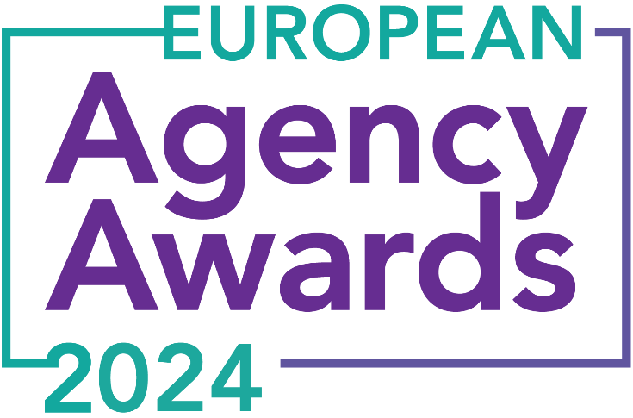

**European Agency Awards 2024 Entry Form**

**Please complete this entry form and upload it via the online entry portal** [**here**](https://europeanagencyawards.com/entry-form) **along with any supporting files.**

**Please note all documents must be under 2MB.**

* You can upload multiple entries via the online entry portal. You will need to fill out a separate entry form for each entry e.g., five entries = five individual entry forms
* If you are uploading the same entry into another category, you will need to edit your entry form appropriately to match the category criteria.
* Please make sure the correct category is checked in section B. If the correct category is not checked, your entry may be classed as void and therefore not judged.
* Entry questions are dependent on your chosen category, so please take care when filling out each entry. Please delete any sections of the entry form not required for your category.
* If your entry form does not match your online submission and category selection, your entry may be classed as a duplication error and may not be judged.
* **All entries must not exceed 1000 words.** The word count does not include the company information/summary in section A or the questions already within the form.
* All entries should relate to work carried out between **March 2023 - July 2024**
* Please follow the format and order of the criteria within this form. If you do not use the entry form below or miss information from your submission you may be penalized by the judges.
* All judges are bound by our terms and conditions and are required to acknowledge these prior to logging into their judging portals. Our judging T&C’s can be found here: <https://europeanagencyawards.com/terms>
* For more information on how to enter, entry fees and the deadline date, visit <https://europeanagencyawards.com/how-to-enter>
* Payment for all entries must be made at the time of submission.
* Please read the [Terms & Conditions](https://europeanagencyawards.com/terms)before submitting your entry.

|  |  |
| --- | --- |
| **SECTION A – YOUR DETAILS** | |
| **Organisation Name** | Roots Network |
| **Contact Name** | Alex Pepermans |

By submitting this form, you agree to the terms and conditions and declare that all facts and figures contained within are accurate and true, and that permission to enter has been given by all involved parties.

|  |
| --- |
| **SECTION B – SELECT YOUR CATEGORY**  Please select your category carefully and insert an X in the second column. Entry questions are dependent on chosen category – please complete section C, D, E or F as indicated. |

|  |  |  |
| --- | --- | --- |
| **21. Best New Agency** |  | Please complete section E |

|  |
| --- |
| **SECTION E – AGENCY / TEAM / RISING AGENCY STAR AWARDS**  Please complete the following sections providing details of the agency / team / individual that you are entering. Please note entries can be self-nominated or nominated by a third party and must not exceed a total word count of 1000 words.  All information provided will remain confidential to the judges before and after the event and will not be shared with anyone outside of the judging panel allocated to review your entry. |
| **Name of Nominee - Agency / Team / Rising Agency Star**  Please keep this concise as it will appear on the website if you are shortlisted. |
| Roots Network |
| **Overview of the Agency**  Please include numbers, staff turnover, roles etc for agency and team nominations or current and previous job roles etc for Rising Star nominations |
| Roots Network: - Services: only Paid Search - Staff members: 5 - Staff roles:  - Marcel Smal, 10+ years experience, Co-Founder   - Alex Pepermans, 10+ years experience, Co-Founder  - Kasper Spanjer, 10+ years experience, Sr. SEA Strategist  - Emanuela Saturnino, 1.5 years experience, SEA Specialist  - Dianne Abeen, 1 year experience, Junior SEA Specialist - Staff turnover: 0 - Dutch Awards: #2 Digital Agency in FONK150 - Dutch Nominations: SAN Accents New Kids on The Block |
| **Agency objectives (1-10 points)**  Tell us what you were looking to achieve and any targets that have been set within the agency or team to help achieve your goals. We recommend showing targets as quantifiable metrics e.g., ‘Increase conversions from 150 to 300 a month’ rather than ‘Increase conversions by 10%’. |
| Our ultimate goal is to be the best Paid Search agency, because we stand for quality, innovation and hard results to back it up. To reach this goal we set multiple targets: 1) Win a minimum of 2 pitches per year to serve large (inter)national known advertisers with complex challenges and large budgets 2) Yearly client satisfaction score >9/10 3) A sustainable agency revenue growth of +35% per year  4) Share min. 1x per year our knowledge and innovations at SMX (or similar conferences)  5) Receive recognition within the Dutch industry for our achievements within 2 years 6) Have fun and stay enthusiastic every day |
| **Recent work example(s**) **(1-10 points)**  Please include details of recent client or campaign work. How does your recent work display creativity and make your team or agency stand out amongst others? |
| ASICS: fully automating and restructuring 17 countries (with 14 languages), while adjusting the measurement towards CLV and profitability.  Otrium Fashion Outlet: automation of a highly complex retailer, active in 10 markets, with 300.000 products and 300 brands, with each brand having specific wishes and restrictions (increase in sales of +98%).  Faire: using AI and the Keyword Planner API to automatically advertise on a massive product offering (2+ million products). This approach results in highly specific ads, while reducing the size of the account (by not creating ad groups for keywords that do not get impressions in the keyword planner API).  SportCity (Gym): using automation, local targeting and competitor data, to have a localized strategy at scale. With this strategy we only advertise on the specific service offering of each local gym (130+), within a specific radius. The aggressiveness of advertising is then determined by the pressure of competitors in those locations.  G-Star: developed a new strategy for Branded keywords based on incrementality, with a script that automatically bids towards the right CPC that gets the sweetspot of impression share while not paying too much (something that is not possible with automated bidding). The costs decreased by about 35% while clicks and conversions stayed stable. |
| **Details of any recent achievements (1-10 points)**  What makes your team or agency stand out? Please include details of any achievements you feel make your agency, team or rising star award worthy. What are you proud of? |
| In the last 2 years we: 1) Won 6 large pitches incl. ASICS EMEA, G-Star, Otrium, Faire, Trainline and SportCity, beating large international agencies 2) Got a client satisfaction score of 9.7 at the FONK150 awards  3) Reached a +50% revenue growth from 2022 -> 2023 4) Presented at HeroConf in London (2022) and at SMX Advanced (2023) 5) Are nominated for the SAN Accents awards in The Netherlands (still ongoing) 6) Enjoyed every second of the work with a small team of very experienced specialists |
| **Details of any challenges faced and how these were overcome (1-10 points)**  What challenges were unique to you and how have you overcome them. What was the end result of overcoming these challenges? |
| There is a tension between our growth ambitions and the quality and innovation we stand for. We believe it’s impossible to keep the quality levels as high and grow too fast. That’s why we have sustainable growth targets and make time to train our new colleagues, to bring them to the next level. This meant that we had a client stop several times in our short history. This resulted in keeping our quality standards at a high level, but the great thing was: the new clients wanted to wait for us. So we didn’t have to compromise our quality standards, and were still able to have strong growth. |
| **Why should your Agency / Team / Rising Agency Star win? (1-10 points)**  Please detail what you feel makes you stand out amongst others and why you feel your entry is award winning. What makes you unique? What gives you the competitive edge? |
| We are truly and deeply passionate about Paid Search. We are one of the few exclusively Paid Search agencies in the Netherlands. This was born from a passion for Paid Search, in which we worked for over 10 years before founding Roots Network in 2022. While other agencies often go for a broader scope of services (multiple channels), we went deeper into the Paid Search rabbit hole. Our philosophy: do more with less. We breathe automation, which means that we can serve large international clients with only a team of 5 people. And we keep pushing the performance of clients with AI- and CLV-implementations, profit steering and incrementality strategies: the stuff that makes our friends and family call us nerds for, but which we are super proud of. |
| **URLs** |
| https://www.roots-network.com/en/ |
| **Please detail any supporting documents you are including as part of your submission**  Optional – please upload to online entry portal when submitting this entry form |
|  |