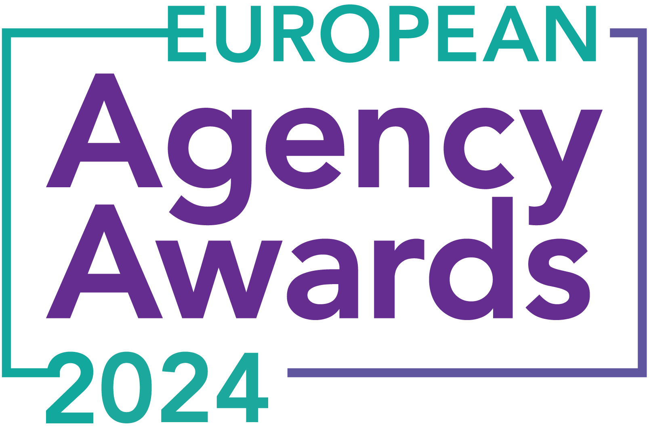

**European Agency Awards 2024 Entry Form**

**Please complete this entry form and upload it via the online entry portal** [**here**](https://europeanagencyawards.com/entry-form) **along with any supporting files.**

**Please note all documents must be under 2MB.**

* You can upload multiple entries via the online entry portal. You will need to fill out a separate entry form for each entry e.g., five entries = five individual entry forms
* If you are uploading the same entry into another category, you will need to edit your entry form appropriately to match the category criteria.
* Please make sure the correct category is checked in section B. If the correct category is not checked, your entry may be classed as void and therefore not judged.
* Entry questions are dependent on your chosen category, so please take care when filling out each entry. Please delete any sections of the entry form not required for your category.
* If your entry form does not match your online submission and category selection, your entry may be classed as a duplication error and may not be judged.
* **All entries must not exceed 1000 words.** The word count does not include the company information/summary in section A or the questions already within the form.
* All entries should relate to work carried out between **March 2023 - July 2024**
* Please follow the format and order of the criteria within this form. If you do not use the entry form below or miss information from your submission you may be penalized by the judges.
* All judges are bound by our terms and conditions and are required to acknowledge these prior to logging into their judging portals. Our judging T&C’s can be found here: <https://europeanagencyawards.com/terms>
* For more information on how to enter, entry fees and the deadline date, visit <https://europeanagencyawards.com/how-to-enter>
* Payment for all entries must be made at the time of submission.
* Please read the [Terms & Conditions](https://europeanagencyawards.com/terms)before submitting your entry.

| **SECTION A – YOUR DETAILS** | |
| --- | --- |
| **Organisation Name** | Curious PR Ltd |
| **Contact Name** | Hannah Kapff |

By submitting this form, you agree to the terms and conditions and declare that all facts and figures contained within are accurate and true, and that permission to enter has been given by all involved parties.

| **SECTION B – SELECT YOUR CATEGORY**  Please select your category carefully and insert an X in the second column. Entry questions are dependent on chosen category – please complete section C, D, E or F as indicated. |
| --- |

| **1. Best Social Media Campaign** |  | Please complete section C |
| --- | --- | --- |
| **2. Best SEO Campaign** |  | Please complete section C |
| **3. Best PPC Campaign** |  | Please complete section C |
| **4. Best PR Campaign** |  | Please complete section C |
| **5. Best Not-for-Profit Campaign** |  | Please complete section C |
| **6. Best Marketing Campaign** |  | Please complete section C |
| **7. Best Integrated Campaign** |  | Please complete section C |
| **8. Best Event** |  | Please complete section C |
| **9. Best New Business Campaign** |  | Please complete section C |
| **10. Best Crisis Communications or Response Campaign** |  | Please complete section C |
| **11. Campaign Effectiveness Award** |  | Please complete section C |
| **12. Best Pan European Campaign** |  | Please complete section C |
| **13. Best Use of AI in Client Campaign** |  | Please complete section C |
| **14. Best AI Agency Software Solution** |  | Please complete section C |
| **15. Best Agency Culture** | Y | Please complete section D |
| **16. Best Charitable/Corporate Social Response Initiative** |  | Please complete section D |
| **17. Best Culture Transformation Initiative** |  | Please complete section D |
| **18. Best Flexible Working Policy** |  | Please complete section D |
| **19. Best Inclusion and Diversity Initiative** |  | Please complete section D |
| **20. Rising Agency Star Award** |  | Please complete section E |
| **21. Best New Agency** |  | Please complete section E |
| **22. Digital Agency of the Year** |  | Please complete section E |
| **23. Media Buying Agency of the Year** |  | Please complete section E |
| **24. B2B Agency of the Year** |  | Please complete section E |
| **25. B2C Agency of the Year** |  | Please complete section E |
| **26. eCommerce Agency of the Year** |  | Please complete section E |
| **27. SEO Agency of the Year** |  | Please complete section E |
| **28. PPC Agency of the Year** |  | Please complete section E |
| **29. Integrated Search Agency of the Year** |  | Please complete section E |
| **30. Social Media Agency of the Year** |  | Please complete section E |
| **31. Marketing Agency of the Year** |  | Please complete section E |
| **32. Creative/Design Agency of the Year** |  | Please complete section E |
| **33. Advertising Agency of the Year** |  | Please complete section E |
| **34. CRO Agency of the Year** |  | Please complete section E |
| **35. UX Agency of the Year** |  | Please complete section E |
| **36. Independent Agency of the Year** |  | Please complete section E |
| **37. PR Agency of the Year** |  | Please complete section E |
| **38. Innovative Agency of the Year** |  | Please complete section E |
| **39. Integrated Agency of the Year** |  | Please complete section E |
| **40. Best Small Agency of the Year** |  | Please complete section E |
| **41. Best Large Agency of the Year** |  | Please complete section E |

| **SECTION D – CULTURE & CONTINUITY AWARDS**  Please complete the following sections providing details of the culture of the agency. Detail investment in training, support, and development of the agency’s team and how this has helped to win new business and grow existing accounts. How your business has operated during the COVID-19 pandemic along with challenges faced and any initiatives you have had to develop to adapt. Please note entries must not exceed a total word count of 1000 words in this section.  All information provided will remain confidential to the judges before and after the event and will not be shared with anyone outside of the judging panel allocated to review your entry. |
| --- |
| **Name of Team / Agency**  Please keep this concise as it will appear on the website if you are shortlisted. |
| Curious PR Limited |
| **Team / Agency Overview**  Give details of number of employees, structure etc. Judges will be looking for clarity and context to help understand more about your agency or team. |
| Curious PR was founded by former broadcast journalist, Hannah Kapff, as an agency that would go the extra mile for clients - based on in-depth questioning of the issues or concepts at play in order to tell the client’s story ‘better’. With a background in environmental science, she ensured ‘sustainability’ was baked into all our values and behaviours.  She works as Managing Director with 2 full-time staff in account management, a part-time finance director, and uses superlative consultants for additional support.  We are particularly strong on media relations, including use of filmed content, graphics and the written word to help translate what may be gnarly, tricky-to-understand technical information into meaningful messages - for a broad spectrum of audiences. Since 2018, we’ve achieved a global media audience of over 14Bn for clients.    All bar one of our clients has been with us for years, proving we offer all-round ‘value’: expert counsel, adaptability, consistent results – plus financial value. |
| **Details of company culture initiatives & budget allocated (1-10 points)**  e.g. flexible working, holiday schemes, training and development, incentive schemes, rewards packages, CSR and volunteering initiatives |
| Our founder believes in hiring, training and nurturing staff rather than relying on freelancers - even in tough times such as downturns or the pandemic. This gives clients consistency, but it is also based on a belief in giving job security - in particular to young people living in London who face a bleak future versus the cost-of-living crisis.  This is also informed by her personal experience of being a freelancer for 15+years whilst raising 3 children, paying single-handedly for expensive childcare (the costliest in Europe).  For all staff we have awarded **annual bonuses,** promotions and **pay rises** over the past 4 years. Only rarely are they asked to work extra hours: if this happens, time is taken off in lieu, when it suits them. We believe healthy work-life balance is key to productivity and, importantly, to creative thinking.  Furthermore, we give considerable time to *pro bono* projects, lending expertise for environmental and social-justice initiatives. Such work with United Nations SDG Hub in NY during the pandemic was [**highly commended.**](https://www.thedrum.com/news/2021/01/01/the-united-nations-its-open-brief-the-drum-editorial-team-s-best-2020)  We offer staff 21 days a year of **holiday** (plus public holidays) and celebrate our successes in full (e.g. media coverage, client wins). We do several outings a year e.g. art galleries in UK and Europe, (Royal Academy of Art, Royal Museums of Fine Art Belgium), music festivals/gigs (Cross The Tracks, Khruangbin, Sister Sledge). Likewise, we throw a Christmas party and provide birthday/anniversary treats. |
| **Evidence positive impact / results of any initiatives (1-10 points)**  e.g., increased productivity, staff retention, staff promotion and development |
| Feedback concerning our **nurture** and **support** is consistently strong (especially if staff face family, health or personal pressures). As a result, we **retain staff** members for longer than industry average, helping provide stability for them and for clients.  Our founder likes to nurture team members' passions, encouraging them to do more of what they love or are talented at, wherever it fits wider strategic objectives and personal S.M.A.R.T. goals (which are agreed at 3 or 6 monthly appraisals).  Likewise, she likes to have a ‘smart’ working culture that does not value ‘overtime for the sake of it’. We credit this for having a lower-than-average **staff sickness** rate.  Testament to our culture is having had former team members **return to Curious PR**, having gone to work elsewhere in the interim.  A major focus on **staff training and development** has led to increases in productivity, enabling us to grow our client base and budgets internationally, despite uncertain economic and political environments.  We continue to **reduce over-servicing** across our client accounts to focus more on **new business** and to **PR ourselves** (for a change!) hence this submission! |
| **Why you think you should win (1-10 points)**  What do you think sets your culture apart from other agencies/teams being judges?  Judges will be looking for the thing that makes your culture different to the others, what is unique? |
| The overall **value and holistic support we offer clients** is, we believe, unrivaled. One [client](https://www.curiouspr.com/testimonials) – ex chief of staff, Aston Martin - said the following about a global launch project:  *"Your creative, dedicated, passionate team have performed, reacted and proactively been responsible for bringing an unknown name into a global arena - re-launching it to get it where it is today. Your individual and collective skills created the ‘dream team’. I have loved every moment of working with you, and am proud of what we have all achieved."*  ​  The former Chair of a charity client wrote to Hannah :  *“Professionally, I would like to thank you and your Team at Curious PR for all you have done, and done so well… you certainly ‘walk the walk’, especially as we have not been the easiest of clients! To work with, you are a joy! Articulate, engaging, forthright, knowledgeable and diplomatic(!), with a great ‘little black book’, where you so kindly introduced me to those that could (and maybe still can) help us.”*  Our dedication to clients is matched by the fact we go the **extra mile for our own people** - as reflected in our [‘Curious Values & Behaviours’](https://docs.google.com/document/d/1S6sV__fXNfY08awsK6OnUKXvHgdGqgVH/edit?usp=sharing&ouid=108574839100780977085&rtpof=true&sd=true) statement, which is proudly hung on our office wall, and included as part of our comprehensive New Starter Packs. Curious PR is a highly nurturing environment in which to learn and grow, which is important, as many of our new hires are entirely new to the world of PR. In July, one of our departed SAEs wrote:    *”Working at Curious PR was nothing short of a pleasure. Hannah is a supremely experienced manager and mentor - she exposed me to a wide range of clients, many of which I worked with closely. Looking back, I worked on some truly incredible projects, from AI health platforms, panels at NY Climate Week, to launching the first ever UK Soils Awareness Week. Hannah is genuinely driven to support those trying to deliver real change, which shows throughout the company’s work and ethos. I would not have got anywhere near this level of experience anywhere else - Curious PR really is a one-of-a-kind company.”*  Our founder continually strives to be a genuinely ‘excellent boss and employer’. This feels all the more relevant in today’s insecure world which needs equal support for people and planet - as well as profit. |
| **URLs** |
|  |
| **Please detail any supporting documents you are including as part of your submission**  Optional – please upload to online entry portal when submitting this entry form |
|  |