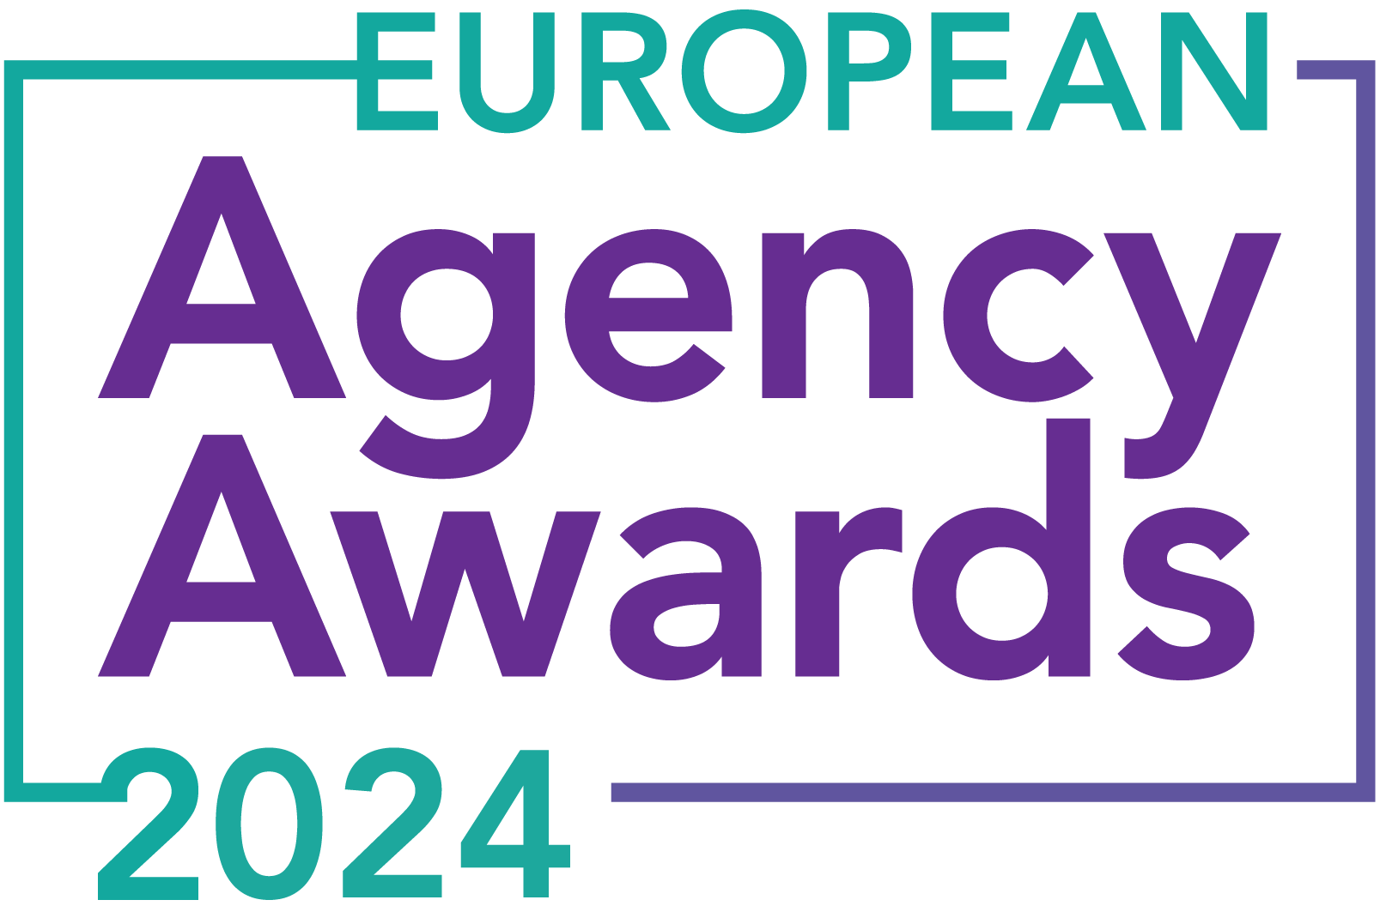

**European Agency Awards 2024 Entry Form**

**Please complete this entry form and upload it via the online entry portal** [**here**](https://europeanagencyawards.com/entry-form) **along with any supporting files.**

**Please note all documents must be under 2MB.**

* You can upload multiple entries via the online entry portal. You will need to fill out a separate entry form for each entry e.g., five entries = five individual entry forms
* If you are uploading the same entry into another category, you will need to edit your entry form appropriately to match the category criteria.
* Please make sure the correct category is checked in section B. If the correct category is not checked, your entry may be classed as void and therefore not judged.
* Entry questions are dependent on your chosen category, so please take care when filling out each entry. Please delete any sections of the entry form not required for your category.
* If your entry form does not match your online submission and category selection, your entry may be classed as a duplication error and may not be judged.
* **All entries must not exceed 1000 words.** The word count does not include the company information/summary in section A or the questions already within the form.
* All entries should relate to work carried out between **March 2023 - July 2024**
* Please follow the format and order of the criteria within this form. If you do not use the entry form below or miss information from your submission you may be penalized by the judges.
* All judges are bound by our terms and conditions and are required to acknowledge these prior to logging into their judging portals. Our judging T&C’s can be found here: <https://europeanagencyawards.com/terms>
* For more information on how to enter, entry fees and the deadline date, visit <https://europeanagencyawards.com/how-to-enter>
* Payment for all entries must be made at the time of submission.
* Please read the [Terms & Conditions](https://europeanagencyawards.com/terms)before submitting your entry.

|  |  |
| --- | --- |
| **SECTION A – YOUR DETAILS** | |
| **Organisation Name** | Each&Other |
| **Contact Name** | Peter Keane |

By submitting this form, you agree to the terms and conditions and declare that all facts and figures contained within are accurate and true, and that permission to enter has been given by all involved parties.

|  |
| --- |
| **SECTION B – SELECT YOUR CATEGORY**  Please select your category carefully and insert an X in the second column. Entry questions are dependent on chosen category – please complete section C, D, E or F as indicated. |

|  |  |  |
| --- | --- | --- |
| **35. UX Agency of the Year** | **X** | Please complete section E |

|  |
| --- |
| **SECTION E – AGENCY / TEAM / RISING AGENCY STAR AWARDS**  Please complete the following sections providing details of the agency / team / individual that you are entering. Please note entries can be self-nominated or nominated by a third party and must not exceed a total word count of 1000 words.  All information provided will remain confidential to the judges before and after the event and will not be shared with anyone outside of the judging panel allocated to review your entry. |
| **Name of Nominee - Agency / Team / Rising Agency Star**  Please keep this con/cise as it will appear on the website if you are shortlisted. |
| Each&Other | European UX Specialists |
| **Overview of the Agency / Team / Rising Agency Star nominee**  Please include numbers, staff turnover, roles etc for agency and team nominations or current and previous job roles etc for Rising Star nominations |
| Each&Other is a global product and User Experience (UX) design company – focused on the Digital space. We design products and services that focus on user needs, make complex systems brilliantly easy to use, helping companies transform their customer experience. UX research and design is our specialist niche. Our purpose “Competitive advantage by Design” says it all – if you invest in UX you will reap the rewards.  We’re trusted by big players in tech and exciting startups to drive product design, unlock innovation and deliver growth. Current clients include: Google, BNP Paribas, Salesforce, Primark, Aviva, Zurich, Santander, Enterprise Ireland.  This is not just an impressive list of logos – these organisations have engaged us, many over multiple years, to help them digitally transform. And what they all have in common is a deep-seated commitment to user experience.  Our focus is UX but what about technology? Well, it’s critical too. That’s why we work very closely with whomever is delivering the tech. We push the boundaries of design, the art of the possible, tempered by technical constraints so that we can deliver the best solutions possible.  We deliver our services globally, from our HQ in Dublin. We’re a full time team of 16 plus a wide pool of trusted Associates. Team turnover has been negligible over the last year – testament to the great culture that we’ve nurtured. |
| **Agency / Team / Rising Agency Star objectives (1-10 points)**  Tell us what you were looking to achieve and any targets that have been set within the agency or team to help achieve your goals. We recommend showing targets as quantifiable metrics e.g., ‘Increase conversions from 150 to 300 a month’ rather than ‘Increase conversions by 10%’. |
| Our main objective over the next 3 years is to grow revenue to €5M and increase headcount to 25 – whilst remaining profitable – we’re currently at €3.2M and 16 people. But why? Well we believe this is the right size for the company for it to be a sustainable business into the future.  We also want to remain the brilliant company we are already are, capable of attracting the best of UX talent whom are drawn to us because of the great work we do, the clients we attract, the excellent benefits and the culture.  What are we doing to get there?  The owners of the business (5 of us) all work in the business. We know when we need to ask for help so in 2023 we got external advice to develop a sales and marketing plan to get us to €5M turnover by 2026. And this year we’ve gotten further external help at board level to help drive the business forward. |
| **Recent work example(s**) **(1-10 points)**  Please include details of recent client or campaign work. How does your recent work display creativity and make your team or agency stand out amongst others? |
| The strange thing about the majority of the work we do is that much of it is hidden! That’s because most of it is software, backend systems or customer portals behind logins.  However, you can look at [our own website which was designed by ourselves](https://www.eachandother.com/) for an excellent example of our creativity and the attached supporting decks with further examples.  As mentioned earlier, it’s the calibre of clients we work with that makes Each&Other stand out – global brands committed to user experience. |
| **Details of any recent achievements (1-10 points)**  What makes your team or agency stand out? Please include details of any achievements you feel make your agency, team or rising star award worthy. What are you proud of? |
| The last year was a big year for Each&Other – this was against the backdrop of a challenging business environment globally.  In terms of tangible project results we got some great news earlier in the year from Zurich Middle East. They had targeted savings of $3.1 million over five years for a project we delivered in 2022. That was based on a forecast of 30% adoption in year one and 80% adoption by year three. By the end of the first year, adoption was 40% ahead of that original goal. Results like these underscore the benefits of UX and how we deliver it.  In addition to that, in 2023 we expanded our research services with Google; we’re working globally with them now from Europe to the Americas to Asia in many local markets on their Google Ads platforms.  We hired a new Principal UX Consultant, Chris Donnelly and continued our much sought after graduate programme, taking on Charlotte Bourke who has since been made permanent.  We had some great new customer wins, the big ones being Salesforce, Primark, and HSBC. |
| **Details of any challenges faced and how these were overcome (1-10 points)**  What challenges were unique to you and how have you overcome them. What was the end result of overcoming these challenges? |
| Our biggest challenge is sales. That’s why we enlisted external help in 2023 and why we’ve bolstering our board.  On the sales side we’ve started to push into two major areas: Team Augmentation and Partnerships. We’ve never been proactive about them and we believe the potential for growth in them is significant.  We also developed a new proposition: UX & AI. There’s a lot of hype around AI over the last 2 years. We’re grounding that with a really practical approach to AI that puts the user at the centre – as you’d expect from a UX Agency…  AI itself is a medium to long-term threat to our business model. That is, to what extent could AI replace work that our consultants do? We don’t have an answer for this and we’re keeping a watching brief on it. |
| **Why should your Agency / Team / Rising Agency Star win? (1-10 points)**  Please detail what you feel makes you stand out amongst others and why you feel your entry is award winning. What makes you unique? What gives you the competitive edge? |
| It’s a cliché, but we punch above our weight. How many small companies can boast of a client list like ours? Our competition, from many quarters, is stiff, but we compete and win successfully – one reason we do is that we have a very unique, pragmatic and practitioner lead approach to new business. Our work also delivers stellar results such as that Zurich project detailed earlier.  However, it’s not just about clients – none of this is possible without the brilliant and dedicated team that we have. We are a highly sought after place to work if you want a career in UX. We win interesting projects with fantastic clients and we’ve nurtured a great culture – people want to work for us – what better accolade is there than that.  But let’s be realistic here. It’s not all sunshine and apple pie! We struggle with sales. We’re not unique in that – it’s hard no matter what business you’re in. However, we stand out because we keep at it – like we do for our clients, day in, day out.  For these reasons we believe we’re deserving of the European UX Agency of the year award. It would help us on our path, elevate our brand and give a huge fillip to our team. So here’s hoping! |
| **URLs** |
| <https://www.eachandother.com>  https://www.linkedin.com/company/theothershq |
| **Please detail any supporting documents you are including as part of your submission**  Optional – please upload to online entry portal when submitting this entry form |
| Overview and Sample work decks |