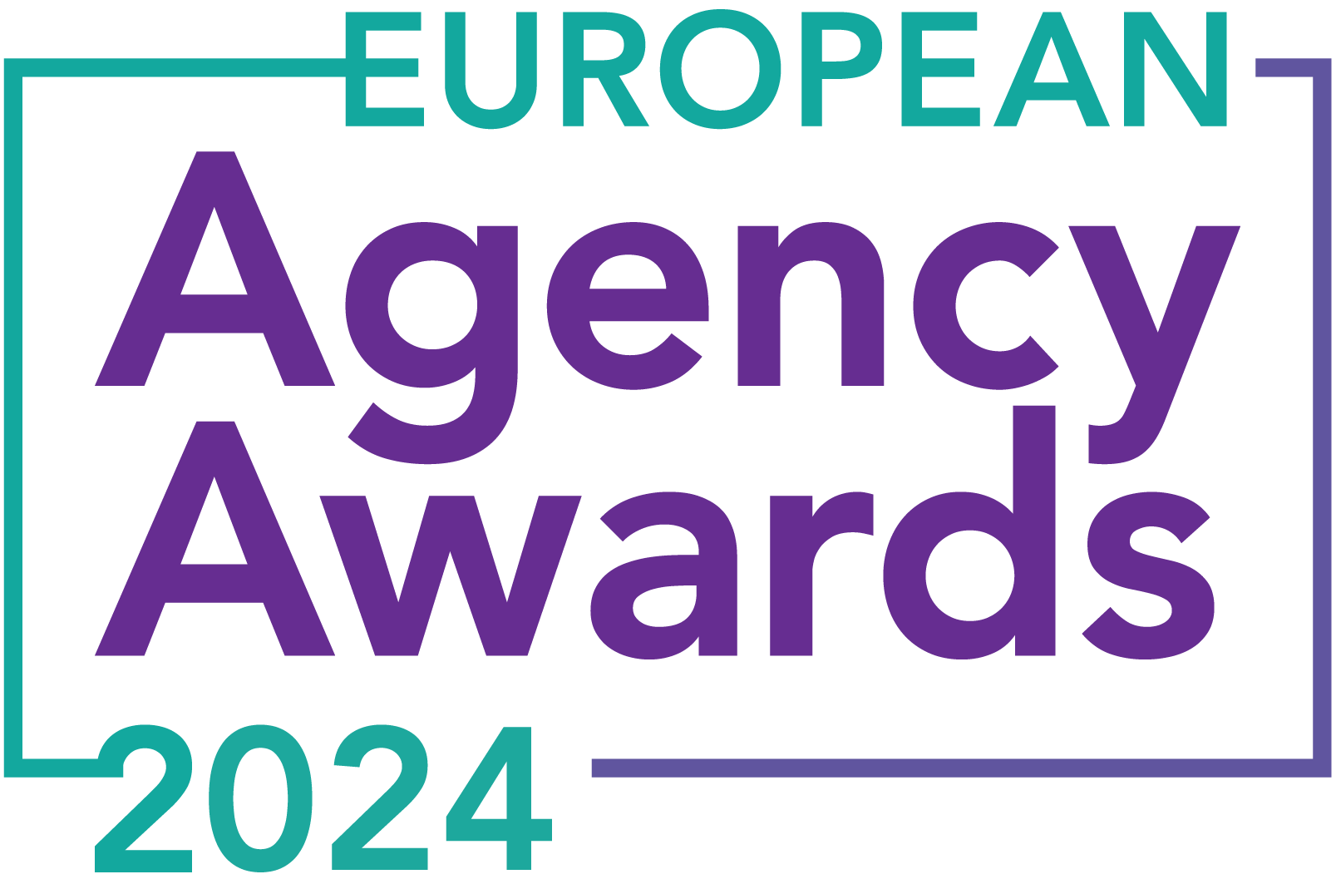

**European Agency Awards 2024 Entry Form**

**Please complete this entry form and upload it via the online entry portal** [**here**](https://europeanagencyawards.com/entry-form) **along with any supporting files.**

**Please note all documents must be under 2MB.**

* You can upload multiple entries via the online entry portal. You will need to fill out a separate entry form for each entry e.g., five entries = five individual entry forms
* If you are uploading the same entry into another category, you will need to edit your entry form appropriately to match the category criteria.
* Please make sure the correct category is checked in section B. If the correct category is not checked, your entry may be classed as void and therefore not judged.
* Entry questions are dependent on your chosen category, so please take care when filling out each entry. Please delete any sections of the entry form not required for your category.
* If your entry form does not match your online submission and category selection, your entry may be classed as a duplication error and may not be judged.
* **All entries must not exceed 1000 words.** The word count does not include the company information/summary in section A or the questions already within the form.
* All entries should relate to work carried out between **March 2023 - July 2024**
* Please follow the format and order of the criteria within this form. If you do not use the entry form below or miss information from your submission you may be penalized by the judges.
* All judges are bound by our terms and conditions and are required to acknowledge these prior to logging into their judging portals. Our judging T&C’s can be found here: <https://europeanagencyawards.com/terms>
* For more information on how to enter, entry fees and the deadline date, visit <https://europeanagencyawards.com/how-to-enter>
* Payment for all entries must be made at the time of submission.
* Please read the [Terms & Conditions](https://europeanagencyawards.com/terms)before submitting your entry.

|  |  |
| --- | --- |
| **SECTION A – YOUR DETAILS** | |
| **Organisation Name** | TrunkBBI |
| **Contact Name** | Adam Britton |

By submitting this form, you agree to the terms and conditions and declare that all facts and figures contained within are accurate and true, and that permission to enter has been given by all involved parties.

|  |
| --- |
| **SECTION B – SELECT YOUR CATEGORY**  Please select your category carefully and insert an X in the second column. Entry questions are dependent on chosen category – please complete section C, D, E or F as indicated. |

|  |  |  |
| --- | --- | --- |
| **1. Best Social Media Campaign** |  | Please complete section C |
| **2. Best SEO Campaign** |  | Please complete section C |
| **3. Best PPC Campaign** |  | Please complete section C |
| **4. Best PR Campaign** |  | Please complete section C |
| **5. Best Not-for-Profit Campaign** |  | Please complete section C |
| **6. Best Marketing Campaign** |  | Please complete section C |
| **7. Best Integrated Campaign** |  | Please complete section C |
| **8. Best Event** |  | Please complete section C |
| **9. Best New Business Campaign** |  | Please complete section C |
| **10. Best Crisis Communications or Response Campaign** |  | Please complete section C |
| **11. Campaign Effectiveness Award** |  | Please complete section C |
| **12. Best Pan European Campaign** |  | Please complete section C |
| **13. Best Use of AI in Client Campaign** |  | Please complete section C |
| **14. Best AI Agency Software Solution** |  | Please complete section C |
| **15. Best Agency Culture** | x | Please complete section D |
| **16. Best Charitable/Corporate Social Response Initiative** |  | Please complete section D |
| **17. Best Culture Transformation Initiative** |  | Please complete section D |
| **18. Best Flexible Working Policy** |  | Please complete section D |
| **19. Best Inclusion and Diversity Initiative** |  | Please complete section D |
| **20. Rising Agency Star Award** |  | Please complete section E |
| **21. Best New Agency** |  | Please complete section E |
| **22. Digital Agency of the Year** |  | Please complete section E |
| **23. Media Buying Agency of the Year** |  | Please complete section E |
| **24. B2B Agency of the Year** |  | Please complete section E |
| **25. B2C Agency of the Year** |  | Please complete section E |
| **26. eCommerce Agency of the Year** |  | Please complete section E |
| **27. SEO Agency of the Year** |  | Please complete section E |
| **28. PPC Agency of the Year** |  | Please complete section E |
| **29. Integrated Search Agency of the Year** |  | Please complete section E |
| **30. Social Media Agency of the Year** |  | Please complete section E |
| **31. Marketing Agency of the Year** |  | Please complete section E |
| **32. Creative/Design Agency of the Year** |  | Please complete section E |
| **33. Advertising Agency of the Year** |  | Please complete section E |
| **34. CRO Agency of the Year** |  | Please complete section E |
| **35. UX Agency of the Year** |  | Please complete section E |
| **36. Independent Agency of the Year** |  | Please complete section E |
| **37. PR Agency of the Year** |  | Please complete section E |
| **38. Innovative Agency of the Year** |  | Please complete section E |
| **39. Integrated Agency of the Year** |  | Please complete section E |
| **40. Best Small Agency of the Year** |  | Please complete section E |
| **41. Best Large Agency of the Year** |  | Please complete section E |

|  |
| --- |
| **SECTION C – CAMPAIGN AWARDS**  Please complete the following sections providing details of the campaign that you are entering. Please note entries must not exceed a total word count of 1000 words.  All information provided will remain confidential to the judges before and after the event and will not be shared with anyone outside of the judging panel allocated to review your entry. |
| **Entrant Name(s), Client Name & Campaign Title**  How you wish for the campaign to be credited including your organisation name, any partners / clients you want to credit & the title of your campaign.  Please structure your title in the following format:  ***"Entrant Name & Client Name - Campaign Name"***  Please keep this concise as it will appear on the website if you are shortlisted. |
|  |
| **Objective(s) & budget (1-10 points)**  Tell us what you were looking to achieve from the campaign and any targets that were set. We recommend showing targets as quantifiable metrics e.g., ‘Increase conversions from 150 to 300 a month’ rather than ‘Increase conversions by 10%’.  Please include a breakdown of implementation costs, staffing costs, agency fees etc. All elements of the entry form are confidential, and judges will not share this information. If you are unable to provide a detailed budget breakdown, please include the financial band your budget is within along with the percentage budget allocated for staffing costs, agency fees and media spend etc. |
|  |
| **Target audience & strategy (1-10 points)**  Please provide us with details around the audience you were targeting and your overall strategy to reach them as well as the strategy to meet the overall objectives. |
|  |
| **Implementation & creativity (1-10 points)**  Please give us a detailed explanation of your implementation for the campaign. Include screenshots to help us visualize campaigns. Provide information on the creativity of the campaign. |
|  |
| **Details of any challenges faced and how these were overcome (1-10 points)**  What challenges were unique to you and how have you overcome them. What was the end result of overcoming these challenges? |
|  |
| **Results & evaluation (1-10 points)**  Please relate these to the objectives and targets stated above. Provide actual numbers rather than percentages wherever possible. |
|  |
| **Why should your campaign win? (1-10 points)**  What do you think sets your campaign apart from the other campaigns being judged? Judges will in particular be looking for the thing that makes this campaign different to the others, what is unique? |
|  |
| **URLs** |
|  |
| **Please detail any supporting documents you are including as part of your submission**  Optional – please upload to online entry portal when submitting this entry form |
|  |

|  |
| --- |
| **SECTION D – CULTURE & CONTINUITY AWARDS**  Please complete the following sections providing details of the culture of the agency. Detail investment in training, support, and development of the agency’s team and how this has helped to win new business and grow existing accounts. Please note entries must not exceed a total word count of 1000 words in this section.  All information provided will remain confidential to the judges before and after the event and will not be shared with anyone outside of the judging panel allocated to review your entry. |
| **Name of Team / Agency**  Please keep this concise as it will appear on the website if you are shortlisted. |
| TrunkBBI |
| **Team / Agency Overview**  Give details of number of employees, structure etc. Judges will be looking for clarity and context to help understand more about your agency or team. |
| Based in Manchester and Leeds, our agency boasts over 70 creative, performance, and strategy experts, with a current voluntary staff turnover of 8%.  Our board consists of 4 members: Jon (CEO and founder, 15 years), Tim (Operations Director, Jon’s first employee), Adam (Chief Creative Officer, formerly Creative Director and MD, 10 years), and Hannah (MD, previously Client Services Director, 5 years).  We also have a Board+ team of 8 senior leaders running departments and reporting directly to the board, with an average tenure of 5.2 years.  Specialists in their fields, we operate collaboratively, aligning to shared values and behaviours, akin to a co-operative.  Over the past year, every employee contributed to reshaping our mission, vision, and values, culminating in our "North Star": “To be globally recognized for our work and culture,” rooted in responsible business practices and driven by our pursuit of excellence.  Committed to developing our people, we embrace challenges, produce successful campaigns, and positively influence society and our workforce. Our values emphasise collective success, valuing every team member, passion for our work, accountability, honesty, and a ceaseless curiosity for new opportunities and technologies. |
| **Details of company culture initiatives & budget allocated (1-10 points)**  e.g., flexible working, holiday schemes, training and development, incentive schemes, rewards packages, CSR and volunteering initiatives |
| **DEI Panel**: Launched in 2022, this group embodies our team ethic, driving positive change through diverse perspectives and life experiences. By promoting inclusive language and awareness of unconscious biases, we’ve created a platform for learning and dialogue. Initiatives like Speak Up (anonymous reporting tool), guest speakers, safe spaces, lunch & learns, personalized 'About Me' profiles, and the “In My Shoes” series empower every voice to be heard.  **Leadership Programme**: In 2023, recognising the need to develop future leaders, we launched a comprehensive program for all 27 line managers. This initiative enhances both practical and behavioural leadership skills and is officially rolling out in the 2024/25 financial year.  **BCORP & Green Team**: As of June 2024, we are BCORP certified, thanks to a two-year journey led by our Green Team. This team spearheaded changes in energy, waste management, ecological practices, HR policies, and fair compensation, sharing their progress via lunch & learn sessions to foster wider agency education and implementation.  **IPA Gold & CPD Commitment**: Proudly retaining our IPA Gold status for the second consecutive year, we logged 3,691 hours of training, supported by a £72,000 budget for practical training costs. This badge represents our commitment to continuous professional development, integrated into our daily operations.  **Life-Balance Days**: Valuing work-life balance, we offer 12 half-day “life balance” days annually, on top of an enhanced leave allowance, for staff to use as they see fit.  **AdUnlocked & DEI Training**: Partnering with AdUnlocked and ACAS for DEI training underlines our dedication to fostering a diverse and inclusive workforce.  **Reward & Recognition Programme**: Our comprehensive programme equips line managers with resources to link rewards (financial and otherwise) to individual and business objectives, highlighting development and success.  **TrunkBBI+ Panel**: This diverse, dynamic group drives innovation and initiatives like 'Viewpoint', leveraging collective agency knowledge for valuable insights that shape decision-making processes.  **CultureAmp**: Since 2022, we’ve utilised anonymous employee engagement surveys to pinpoint improvement areas and measure the impact of changes, integrating feedback into our daily practices. |
| **Evidence positive impact / results of any initiatives (1-10 points)**  e.g., increased productivity, staff retention, staff promotion and development |
| One of our goals a year ago was to earn a “great place to work” accolade, and by May 2024, we landed at number 20 on Campaign’s Best Places to Work list.  Using CultureAmp engagement surveys, we measure the impact of our initiatives with impressive results:   * **94%** of our team recommends TrunkBBI as a “great place to work.” * Company confidence rose from **61%** to **71%**. * Communication of a motivating vision improved from **65%** to **73%**, putting us **8%** points ahead of the competition.   Compared to 'The Marketing & Advertising Industry United Kingdom, July 2023’ data:   * **24%** points ahead in social connection at **84%** * **12%** ahead in work-life balance at **91%** * **11%** ahead in innovation at **84%**   Our DEI initiatives have driven an **81%** inclusivity score.  Operational statistics highlight our success:   * Voluntary staff turnover reduced from **16%** to **8%** in 2 years * Over **30%** of staff promoted in the last 12 months * **85%** of line managers enrolled in our leadership programme   These metrics demonstrate our unwavering commitment to creating an exceptional workplace. We’ve fostered a supportive and innovative environment where employees thrive, driving our agency’s sustained growth and success. By continuously investing in our team’s development and well-being, we ensure our people are motivated and equipped to deliver outstanding results for our clients. |
| **Why you think you should win (1-10 points)**  What do you think sets your culture apart from other agencies/teams being judges? Judges will be looking for the thing that makes your culture different to the others, what is unique? |
| At TrunkBBI, we relentlessly strive to improve, creating a better environment for our people, our clients, and the planet. One initiative we purposely haven't mentioned yet is our “Culture Club” – a group of 10 people with a £2k monthly budget for team-building events. This is where culture begins, but for us, it runs much deeper than karaoke nights and a familial atmosphere.  Despite the global challenges of the past few years, we've not just weathered the storm – we've charged into it with an army of loyal, committed talent. This resilience speaks volumes about the business and environment we've created.  We proudly emphasise our commitment to developing our people. It's a core part of our client pitches and is reflected in our updated values. "Constantly Curious" stands strong among our six values, symbolizing our dedication to ongoing learning.  Ambition propels us forward. We shun ready-made solutions and easy options, never constrained by budgets or deadlines. We always explore new opportunities and embrace fresh technologies. Our best idea is always our next idea. This isn't just our work ethos – it's who we are.  We're never comfortable standing still, and neither are our people. That's why our team members stay with us for the long haul.  Our unique culture of nurturing growth, fostering inclusivity, innovation, and social consciousness where everyone feels empowered truly sets us apart. With concrete data and heartfelt employee testimonials (supporting documents), we present a compelling case for this award. |
| **URLs** |
| [https://trunkbbi.com/](http://www.trunkbbi.com/)  This link is to a first draft of episode one of the “In my shoes” series that’s referenced under the DEI initiative : <https://madebytrunk.ftrackapp.com/review/c9ae8393-9e29-4f7d-9f9b-888b7c46ebd7?signature=9d27eaa04b5fde8fbfc671390b4809aa9b1dcfb0decbbf13e3f6e5ea77625438> |
| **Please detail any supporting documents you are including as part of your submission**  Optional – please upload to online entry portal when submitting this entry form |
| Proof of increase of engagement score as well as all comments from our people |

|  |
| --- |
| **SECTION E – AGENCY / TEAM / RISING AGENCY STAR AWARDS**  Please complete the following sections providing details of the agency / team / individual that you are entering. Please note entries can be self-nominated or nominated by a third party and must not exceed a total word count of 1000 words.  All information provided will remain confidential to the judges before and after the event and will not be shared with anyone outside of the judging panel allocated to review your entry. |
| **Name of Nominee - Agency / Team / Rising Agency Star**  Please keep this concise as it will appear on the website if you are shortlisted. |
|  |
| **Date of Birth** (Rising Agency Star nominees only)  ***Please note that nominee must be under 30 on October 19, 2023*** |
|  |
| **Contact email address of nominee** (Rising Agency Star nominees only) |
|  |
| **Contact phone number of nominee** (Rising Agency Star nominees only) |
|  |
| **Overview of the Agency / Team / Rising Agency Star nominee**  Please include numbers, staff turnover, roles etc for agency and team nominations or current and previous job roles etc for Rising Star nominations |
|  |
| **Agency / Team / Rising Agency Star objectives (1-10 points)**  Tell us what you were looking to achieve and any targets that have been set within the agency or team to help achieve your goals. We recommend showing targets as quantifiable metrics e.g., ‘Increase conversions from 150 to 300 a month’ rather than ‘Increase conversions by 10%’. |
|  |
| **Recent work example(s**) **(1-10 points)**  Please include details of recent client or campaign work. How does your recent work display creativity and make your team or agency stand out amongst others? |
|  |
| **Details of any recent achievements (1-10 points)**  What makes your team or agency stand out? Please include details of any achievements you feel make your agency, team or rising star award worthy. What are you proud of? |
|  |
| **Details of any challenges faced and how these were overcome (1-10 points)**  What challenges were unique to you and how have you overcome them. What was the end result of overcoming these challenges? |
|  |
| **Why should your Agency / Team / Rising Agency Star win? (1-10 points)**  Please detail what you feel makes you stand out amongst others and why you feel your entry is award winning. What makes you unique? What gives you the competitive edge? |
|  |
| **URLs** |
|  |
| **Please detail any supporting documents you are including as part of your submission**  Optional – please upload to online entry portal when submitting this entry form |
|  |