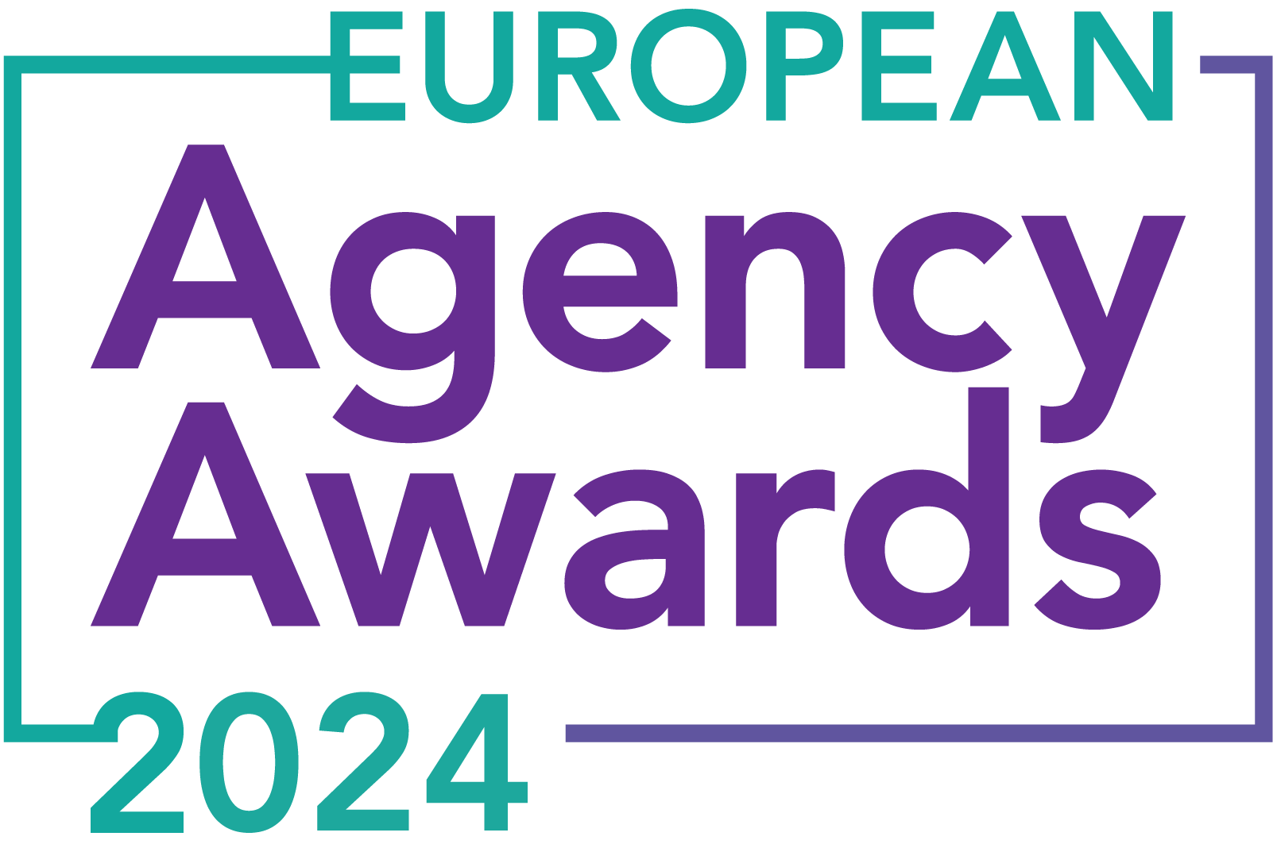

**European Agency Awards 2024 Entry Form**

**Please complete this entry form and upload it via the online entry portal** [**here**](https://europeanagencyawards.com/entry-form) **along with any supporting files.**

**Please note all documents must be under 2MB.**

* You can upload multiple entries via the online entry portal. You will need to fill out a separate entry form for each entry e.g., five entries = five individual entry forms
* If you are uploading the same entry into another category, you will need to edit your entry form appropriately to match the category criteria.
* Please make sure the correct category is checked in section B. If the correct category is not checked, your entry may be classed as void and therefore not judged.
* Entry questions are dependent on your chosen category, so please take care when filling out each entry. Please delete any sections of the entry form not required for your category.
* If your entry form does not match your online submission and category selection, your entry may be classed as a duplication error and may not be judged.
* **All entries must not exceed 1000 words.** The word count does not include the company information/summary in section A or the questions already within the form.
* All entries should relate to work carried out between **March 2023 - July 2024**
* Please follow the format and order of the criteria within this form. If you do not use the entry form below or miss information from your submission you may be penalized by the judges.
* All judges are bound by our terms and conditions and are required to acknowledge these prior to logging into their judging portals. Our judging T&C’s can be found here: <https://europeanagencyawards.com/terms>
* For more information on how to enter, entry fees and the deadline date, visit <https://europeanagencyawards.com/how-to-enter>
* Payment for all entries must be made at the time of submission.
* Please read the [Terms & Conditions](https://europeanagencyawards.com/terms)before submitting your entry.

|  |  |
| --- | --- |
| **SECTION A – YOUR DETAILS** | |
| **Organisation Name** | MONSOON Agency |
| **Contact Name** | Monika Siwek |

By submitting this form, you agree to the terms and conditions and declare that all facts and figures contained within are accurate and true, and that permission to enter has been given by all involved parties.

|  |
| --- |
| **SECTION B – SELECT YOUR CATEGORY**  Please select your category carefully and insert an X in the second column. Entry questions are dependent on chosen category – please complete section C, D, E or F as indicated. |

|  |  |  |
| --- | --- | --- |
| **1. Best Social Media Campaign** |  | Please complete section C |
| **2. Best SEO Campaign** |  | Please complete section C |
| **3. Best PPC Campaign** |  | Please complete section C |
| **4. Best PR Campaign** |  | Please complete section C |
| **5. Best Not-for-Profit Campaign** |  | Please complete section C |
| **6. Best Marketing Campaign** |  | Please complete section C |
| **7. Best Integrated Campaign** |  | Please complete section C |
| **8. Best Event** |  | Please complete section C |
| **9. Best New Business Campaign** |  | Please complete section C |
| **10. Best Crisis Communications or Response Campaign** |  | Please complete section C |
| **11. Campaign Effectiveness Award** |  | Please complete section C |
| **12. Best Pan European Campaign** |  | Please complete section C |
| **13. Best Use of AI in Client Campaign** |  | Please complete section C |
| **14. Best AI Agency Software Solution** |  | Please complete section C |
| **15. Best Agency Culture** | **X** | Please complete section D |
| **16. Best Charitable/Corporate Social Response Initiative** |  | Please complete section D |
| **17. Best Culture Transformation Initiative** |  | Please complete section D |
| **18. Best Flexible Working Policy** |  | Please complete section D |
| **19. Best Inclusion and Diversity Initiative** |  | Please complete section D |
| **20. Rising Agency Star Award** |  | Please complete section E |
| **21. Best New Agency** |  | Please complete section E |
| **22. Digital Agency of the Year** |  | Please complete section E |
| **23. Media Buying Agency of the Year** |  | Please complete section E |
| **24. B2B Agency of the Year** |  | Please complete section E |
| **25. B2C Agency of the Year** |  | Please complete section E |
| **26. eCommerce Agency of the Year** |  | Please complete section E |
| **27. SEO Agency of the Year** |  | Please complete section E |
| **28. PPC Agency of the Year** |  | Please complete section E |
| **29. Integrated Search Agency of the Year** |  | Please complete section E |
| **30. Social Media Agency of the Year** |  | Please complete section E |
| **31. Marketing Agency of the Year** |  | Please complete section E |
| **32. Creative/Design Agency of the Year** |  | Please complete section E |
| **33. Advertising Agency of the Year** |  | Please complete section E |
| **34. CRO Agency of the Year** |  | Please complete section E |
| **35. UX Agency of the Year** |  | Please complete section E |
| **36. Independent Agency of the Year** |  | Please complete section E |
| **37. PR Agency of the Year** |  | Please complete section E |
| **38. Innovative Agency of the Year** |  | Please complete section E |
| **39. Integrated Agency of the Year** |  | Please complete section E |
| **40. Best Small Agency of the Year** |  | Please complete section E |
| **41. Best Large Agency of the Year** |  | Please complete section E |

|  |
| --- |
| **SECTION D – CULTURE & CONTINUITY AWARDS**  Please complete the following sections providing details of the culture of the agency. Detail investment in training, support, and development of the agency’s team and how this has helped to win new business and grow existing accounts. Please note entries must not exceed a total word count of 1000 words in this section.  All information provided will remain confidential to the judges before and after the event and will not be shared with anyone outside of the judging panel allocated to review your entry. |
| **Name of Team / Agency**  Please keep this concise as it will appear on the website if you are shortlisted. |
| **MONSOON Agency** |
| **Team / Agency Overview**  Give details of number of employees, structure etc. Judges will be looking for clarity and context to help understand more about your agency or team. |
| MONSOON is a team of 19 marketing experts with extensive experience working with both local and international brands, ranging from large corporations to small businesses. We offer a wide range of services for digital marketing across platforms such as Google, YouTube, Meta, TikTok, LinkedIn, Pinterest, Quora, Reddit, and App Advertising.  Additionally, we provide content creation services, including text, visuals, and landing page creation, making us a holistic agency capable of executing any digital campaign from start to finish.  Our leadership includes founders Maciej, Monika, and Lasse, and a COO, Michał, who drives sales, business development, and organizational culture.  The team is organized with dedicated leaders for customer success, paid search, paid social, and content creation. In the past year, we have doubled our team size, fostering a supportive culture where individuals grow both vertically and horizontally. We now have four leaders, all of whom have risen from within Monsoon, each taking on a new role this year.  A group of people in a row  Description automatically generated |
| **Details of company culture initiatives & budget allocated (1-10 points)**  e.g., flexible working, holiday schemes, training and development, incentive schemes, rewards packages, CSR and volunteering initiatives |
| The founders' vision for MONSOON was to create a team of well-rounded marketers who are absolute experts in their fields and have the time and space to develop their expertise even further.    MONSOON maintains a positive working culture where operational excellence and commitment are paired with joy, fulfillment, and a sense of belonging in daily routines. We strive to be a solid partner for our clients and the number one choice for small and medium-sized projects and organizations.  We are proud to have developed four team leaders from within our structure over the past year, providing excellent career advancement opportunities.    Our team has a real impact on every aspect of our organization - managing sales, project onboarding, recruiting, running campaigns, and developing new processes with minimal founder involvement. We democratized the sales process, now handled by all Team Leaders and the COO, offering consulting services in four languages and incentivized for successful wins.  We also pride ourselves on fostering an honest and supportive work atmosphere, where feedback is openly shared. Numerous feedback sessions and one-on-one meetings help maintain this culture. We invest in self-development, combining it with leader-guided development, and manage through mentoring rather than commanding.    We operate 100% remotely, employing people from Poland, Germany, and Italy. Team members can work from anywhere in the world, with no fixed hours.  Despite remote working, we maintain team cohesion through quarterly meetups, summer and Christmas parties, daily informal morning coffee meetings, and weekly "Edu Friday" sessions featuring internal and external speakers. We hold monthly all-hands meetings for organizational updates and have project-dedicated meetings, client weeklies, and numerous one-on-ones. We communicate on Slack and meet on Google Meet. Our bonuses are based on OKRs and sales, with transparent salary ranges. Training initiatives include a six-month mentorship/leadership program by external agencies and financial support for language courses.  **MONSOON’s Team Events:**    **Edu Friday:**    Our cohesive and supportive team culture is reflected in our positive [GoWork reviews](https://www.gowork.pl/opinie_czytaj,24003578). |
| **Evidence positive impact / results of any initiatives (1-10 points)**  e.g., increased productivity, staff retention, staff promotion and development |
| We have developed a team of confident experts capable of independently managing various aspects of the organization. Our team now oversees critical functions such as sales, project onboarding, recruiting, running campaigns, scaling and nurturing client partnerships, developing their own teams, training new joiners, and creating new processes. These responsibilities are now handled by the team with minimal involvement from the founders, making the organization self-reliant and independent.  We have also democratized the sales process at MONSOON. Previously, sales were managed solely by Maciej and Lasse, making it challenging to scale and quite overwhelming for two people. Now, all Team Leaders and the COO participate in sales calls with prospects, offering consulting services in four languages: German, Spanish, Italian, and French. They are also incentivized for successful wins, ensuring a collaborative and effective sales process.    We measure our team satisfaction through frequent monthly surveys. Our satisfaction scores have shown a notable improvement, with our Net Promoter Score (NPS) reaching 32% over the last three months. |
| **Why you think you should win (1-10 points)**  What do you think sets your culture apart from other agencies/teams being judges? Judges will be looking for the thing that makes your culture different to the others, what is unique? |
| At MONSOON, our culture is built on a foundation of trust, empowerment, and continuous development.  We've built a team of confident experts and team leafders who can independently manage various aspects of our organization. Instead of making external hires, we allow our team to grow with us. Everyone who joins feels like a family member, enjoying complete freedom in their work and having a significant impact on critical functions such as sales, project onboarding, recruiting, running campaigns, and client partnerships. This independence makes our organization self-reliant and agile.    We invest heavily in both self-development and leader-guided development. Our training initiatives include a six-month mentorship/leadership program by external agencies, a €1500 annual training budget per employee, and financial support for language courses. This commitment ensures our team members are continuously growing and enhancing their skills.  Our culture prioritizes joy, fulfillment, and a sense of belonging in daily routines. We maintain team cohesion through quarterly meetups, social events, daily informal coffee meetings, and weekly "Edu Friday" sessions. We also practice open and transparent communication, reflected in our monthly all-hands meetings, numerous feedback sessions, and one-on-one meetings.  Operating 100% remotely, we offer our team members the flexibility to work from anywhere in the world, with no fixed hours. This flexibility promotes a healthy work-life balance, allowing our team to thrive both professionally and personally. |
| **URLs** |
| [**https://monsoon.agency/**](https://monsoon.agency/)  [**https://www.linkedin.com/company/20329407/**](https://www.linkedin.com/company/20329407/) |
| **Please detail any supporting documents you are including as part of your submission**  Optional – please upload to online entry portal when submitting this entry form |
|  |