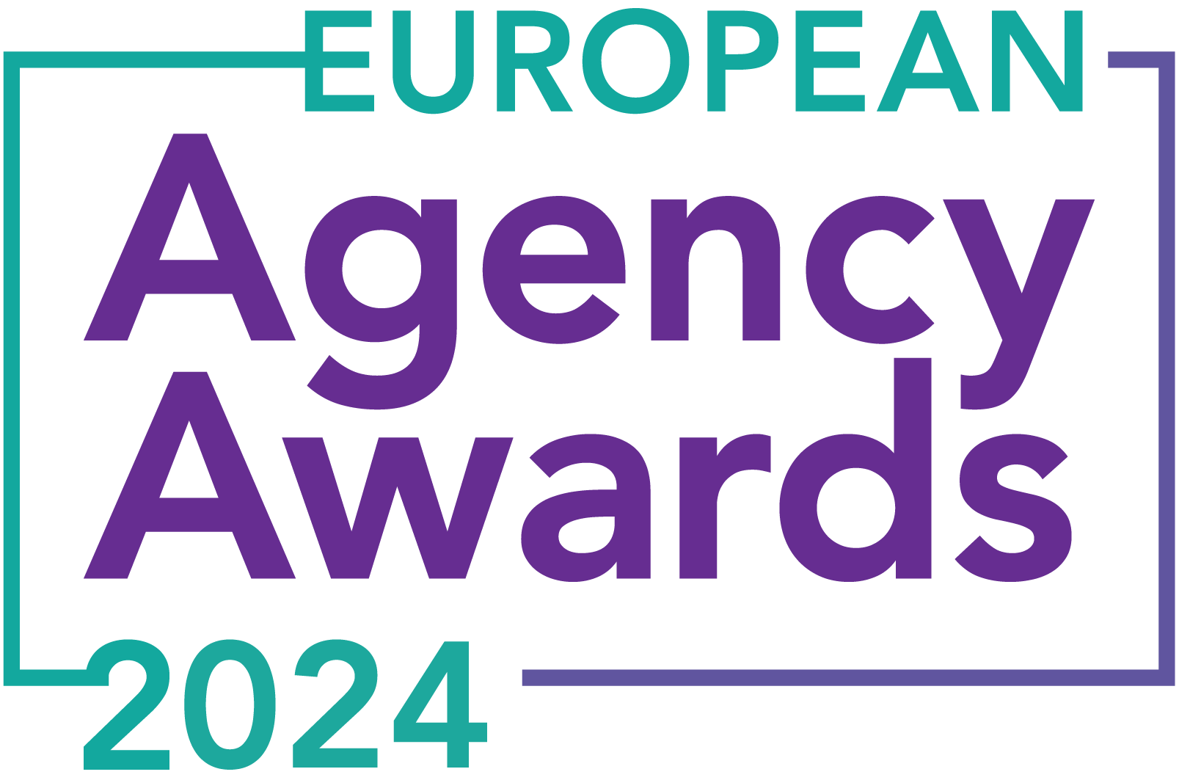

**European Agency Awards 2024 Entry Form**

**Please complete this entry form and upload it via the online entry portal** [**here**](https://europeanagencyawards.com/entry-form) **along with any supporting files.**

**Please note all documents must be under 2MB.**

* You can upload multiple entries via the online entry portal. You will need to fill out a separate entry form for each entry e.g., five entries = five individual entry forms
* If you are uploading the same entry into another category, you will need to edit your entry form appropriately to match the category criteria.
* Please make sure the correct category is checked in section B. If the correct category is not checked, your entry may be classed as void and therefore not judged.
* Entry questions are dependent on your chosen category, so please take care when filling out each entry. Please delete any sections of the entry form not required for your category.
* If your entry form does not match your online submission and category selection, your entry may be classed as a duplication error and may not be judged.
* **All entries must not exceed 1000 words.** The word count does not include the company information/summary in section A or the questions already within the form.
* All entries should relate to work carried out between **March 2023 - July 2024**
* Please follow the format and order of the criteria within this form. If you do not use the entry form below or miss information from your submission you may be penalized by the judges.
* All judges are bound by our terms and conditions and are required to acknowledge these prior to logging into their judging portals. Our judging T&C’s can be found here: <https://europeanagencyawards.com/terms>
* For more information on how to enter, entry fees and the deadline date, visit <https://europeanagencyawards.com/how-to-enter>
* Payment for all entries must be made at the time of submission.
* Please read the [Terms & Conditions](https://europeanagencyawards.com/terms)before submitting your entry.

|  |  |
| --- | --- |
| **SECTION A – YOUR DETAILS** | |
| **Organisation Name** | MONSOON Agency |
| **Contact Name** | Monika Siwek |

By submitting this form, you agree to the terms and conditions and declare that all facts and figures contained within are accurate and true, and that permission to enter has been given by all involved parties.

|  |
| --- |
| **SECTION B – SELECT YOUR CATEGORY**  Please select your category carefully and insert an X in the second column. Entry questions are dependent on chosen category – please complete section C, D, E or F as indicated. |

|  |  |  |
| --- | --- | --- |
| **1. Best Social Media Campaign** |  | Please complete section C |
| **2. Best SEO Campaign** |  | Please complete section C |
| **3. Best PPC Campaign** |  | Please complete section C |
| **4. Best PR Campaign** |  | Please complete section C |
| **5. Best Not-for-Profit Campaign** |  | Please complete section C |
| **6. Best Marketing Campaign** |  | Please complete section C |
| **7. Best Integrated Campaign** |  | Please complete section C |
| **8. Best Event** |  | Please complete section C |
| **9. Best New Business Campaign** |  | Please complete section C |
| **10. Best Crisis Communications or Response Campaign** |  | Please complete section C |
| **11. Campaign Effectiveness Award** |  | Please complete section C |
| **12. Best Pan European Campaign** |  | Please complete section C |
| **13. Best Use of AI in Client Campaign** |  | Please complete section C |
| **14. Best AI Agency Software Solution** |  | Please complete section C |
| **15. Best Agency Culture** |  | Please complete section D |
| **16. Best Charitable/Corporate Social Response Initiative** |  | Please complete section D |
| **17. Best Culture Transformation Initiative** | **X** | Please complete section D |
| **18. Best Flexible Working Policy** |  | Please complete section D |
| **19. Best Inclusion and Diversity Initiative** |  | Please complete section D |
| **20. Rising Agency Star Award** |  | Please complete section E |
| **21. Best New Agency** |  | Please complete section E |
| **22. Digital Agency of the Year** |  | Please complete section E |
| **23. Media Buying Agency of the Year** |  | Please complete section E |
| **24. B2B Agency of the Year** |  | Please complete section E |
| **25. B2C Agency of the Year** |  | Please complete section E |
| **26. eCommerce Agency of the Year** |  | Please complete section E |
| **27. SEO Agency of the Year** |  | Please complete section E |
| **28. PPC Agency of the Year** |  | Please complete section E |
| **29. Integrated Search Agency of the Year** |  | Please complete section E |
| **30. Social Media Agency of the Year** |  | Please complete section E |
| **31. Marketing Agency of the Year** |  | Please complete section E |
| **32. Creative/Design Agency of the Year** |  | Please complete section E |
| **33. Advertising Agency of the Year** |  | Please complete section E |
| **34. CRO Agency of the Year** |  | Please complete section E |
| **35. UX Agency of the Year** |  | Please complete section E |
| **36. Independent Agency of the Year** |  | Please complete section E |
| **37. PR Agency of the Year** |  | Please complete section E |
| **38. Innovative Agency of the Year** |  | Please complete section E |
| **39. Integrated Agency of the Year** |  | Please complete section E |
| **40. Best Small Agency of the Year** |  | Please complete section E |
| **41. Best Large Agency of the Year** |  | Please complete section E |

|  |
| --- |
| **SECTION D – CULTURE & CONTINUITY AWARDS**  Please complete the following sections providing details of the culture of the agency. Detail investment in training, support, and development of the agency’s team and how this has helped to win new business and grow existing accounts. Please note entries must not exceed a total word count of 1000 words in this section.  All information provided will remain confidential to the judges before and after the event and will not be shared with anyone outside of the judging panel allocated to review your entry. |
| **Name of Team / Agency**  Please keep this concise as it will appear on the website if you are shortlisted. |
| MONSOON Agency |
| **Team / Agency Overview**  Give details of number of employees, structure etc. Judges will be looking for clarity and context to help understand more about your agency or team. |
| MONSOON is a team of 19 marketing experts with extensive experience working with both local and international brands, from large corporations to small businesses. We provide a wide array of digital marketing services across platforms like Google, YouTube, Meta, TikTok, LinkedIn, Pinterest, Quora, Reddit, and App Advertising. Additionally, we offer content creation services, including text, visuals, and landing page creation, making us a holistic agency capable of executing any digital campaign from start to finish.  Our leadership team includes founders Maciej, Monika, and Lasse, as well as COO Michał, who drives sales, business development, and organizational culture.  A group of people in a row  Description automatically generated  The operational team is organized with designated leaders for customer success, paid search, paid social, and content creation. In the past year, we have added four leaders to our organization and doubled our team size, creating a supportive environment that encourages both vertical and horizontal growth. The scaling and recruitment of the team were managed by these leaders. |
| **Details of company culture initiatives & budget allocated (1-10 points)**  e.g., flexible working, holiday schemes, training and development, incentive schemes, rewards packages, CSR and volunteering initiatives |
| **Fully remote, yet highly efficient and consistently connected**  Within last year we made a decision to build 100% remote organization and now we effiiciently operate full-time remotely, employing people from Poland, Germany, and Italy. Team members are welcome to work from anywhere in the world, with no fixed hours. Most start between 8 and 10 AM and finish between 4 and 6 PM Berlin’s time.  To maintain connection while working fully remote, we foster team cohesion through several initiatives:   * Quarterly in-person meetings, often combined with conferences or team events. * Summer and Christmas parties. * Daily informal morning coffee meetings at 9:30 on Meet for casual chats. * Weekly “Edu Friday” sessions, featuring internal training and external speakers every second week. * Monthly virtual all-hands meetings for organizational updates from the C-level team. * Regular project-dedicated meetings, client meetings, and numerous one-on-ones. * Communication via Slack and Google Meet.   This approach keeps us efficient and well-connected. Team members have expressed that, despite the distance, they feel integrated into the organization and do not experience a lack of connection or communication with their peers.  **MONSOON’s Team Events:**    **Edu Friday:**    **Guaranteed incentives for growing together with the organization:**  Another objective for the organization within last 12 months focused on growth without overburdening our team. We aimed to scale number of clients, boost monthly revenue, automate 20% of our processes, streamline onboarding for new team members, and lessen the operational workload for the co-founders.  This was crucial from the founders’ perspective. We wanted MONSOON to operate seamlessly even if the founders step away temporarily, ensuring everyone knows their responsibilities, manages projects smoothly, feels connected to the organization, and enjoys their work.  Therefore we decided to incentivize people for taking responsibility and driving initaitves:   * Our financial bonuses (on top of regular salaries) are based on OKRs, where each team member is invited to lead an initiative aimed at improving our workspace. These initiatives and the involvement of team members are incentivized by their team leader. The initiative needs to relate to any aspect of our organization, aiming to improve any process, collaboration, or aspect of daily work. * We offer training initiatives, which include a six-month mentorship and leadership program conducted by external agencies, as well as financial support for language courses. * We also provide a €1500 training budget per employee per year. * Additionally, we offer sales-based bonuses, including a referral program with a 10% lifetime commission for bringing new clients to the organization and a 5% commission for participating in the sales process. |
| **Evidence positive impact / results of any initiatives (1-10 points)**  e.g., increased productivity, staff retention, staff promotion and development |
| Team-wise, we are proud to have developed four team leaders from within our own structure over the last year, offering our team members excellent opportunities to advance their careers. We prioritize internal development and growth, rather than external hiring. Last year, we also hired a COO who has helped us build a strong organization.    In 12 months, we transformed our organization from a company where 60% of operational work was handled by two co-founders, Maciej and Monika, to one that operates independently from the founders. Our team now handles all important aspects, such as sales, project onboarding, recruiting, running campaigns, scaling and nurturing client partnerships, developing their own teams, training new joiners, and creating new processes. All these elements are now managed by the team with little to no involvement from the founders, making the organization self-reliant and independent.    We democratized the sales process at MONSOON. Previously, sales were handled solely by Maciej and Lasse, which made it difficult to scale and quite overwhelming for two people.  Now, all Team Leaders and the COO are involved in sales calls with prospects, offering consulting services in four different languages: German, Spanish, Italian, and French, and are incentivized for successful wins.    We have developed a team of great experts who enjoy working together, supporting each other, and functioning like a big family. Our cohesive and supportive team culture is reflected in our positive [GoWork reviews](https://www.gowork.pl/opinie_czytaj,24003578). |
| **Why you think you should win (1-10 points)**  What do you think sets your culture apart from other agencies/teams being judges? Judges will be looking for the thing that makes your culture different to the others, what is unique? |
| The transformation we underwent in the last 12 months has been significant and very uplifting for us!  Our exceptional team of experts has driven significant growth, with many members evolving from channel experts to team leaders. Our operations now span 20 countries across five continents, managing monthly budgets from €5,000 to €300,000. We’ve significantly boosted client revenues, often leading them to expand their collaboration with us.  This year alone, we upsold 15 additional services, adding €25,000 to our monthly payroll. Despite a challenging start to 2024 in terms of revenue, where we fell short of our financial targets, we maintained solid financial growth to continue developing and sustaining the organization. Monsoon is entirely self-funded and has never relied on external investment.    Most importantly, over the past 12 months, we’ve focused on growing and maturing our organization, enhancing team skills, and creating a robust structure for continuous growth. Our unique culture, strategic focus, and dedication to client success make us stand out. |
| **URLs** |
| [**https://monsoon.agency/**](https://monsoon.agency/)  [**https://www.linkedin.com/company/20329407/**](https://www.linkedin.com/company/20329407/) |
| **Please detail any supporting documents you are including as part of your submission**  Optional – please upload to online entry portal when submitting this entry form |
|  |