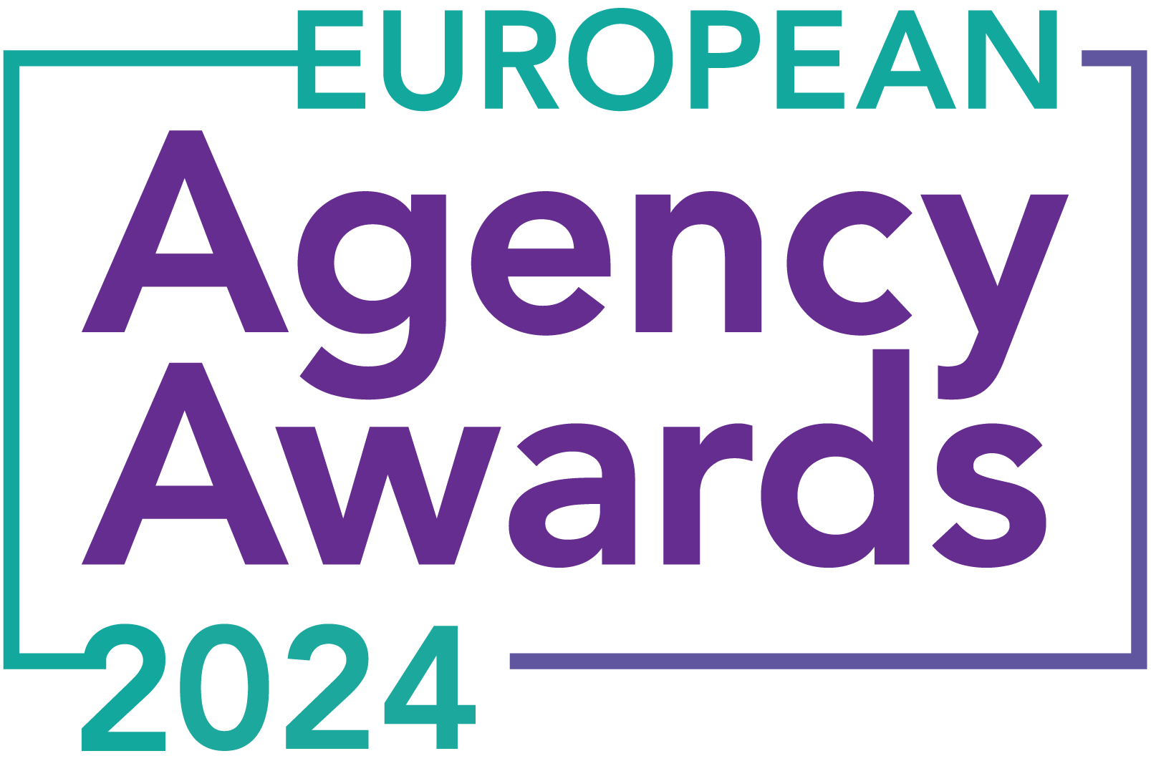

**European Agency Awards 2024 Entry Form**

**Please complete this entry form and upload it via the online entry portal** [**here**](https://europeanagencyawards.com/entry-form) **along with any supporting files.**

**Please note all documents must be under 2MB.**

* You can upload multiple entries via the online entry portal. You will need to fill out a separate entry form for each entry e.g., five entries = five individual entry forms
* If you are uploading the same entry into another category, you will need to edit your entry form appropriately to match the category criteria.
* Please make sure the correct category is checked in section B. If the correct category is not checked, your entry may be classed as void and therefore not judged.
* Entry questions are dependent on your chosen category, so please take care when filling out each entry. Please delete any sections of the entry form not required for your category.
* If your entry form does not match your online submission and category selection, your entry may be classed as a duplication error and may not be judged.
* **All entries must not exceed 1000 words.** The word count does not include the company information/summary in section A or the questions already within the form.
* All entries should relate to work carried out between **March 2023 - July 2024**
* Please follow the format and order of the criteria within this form. If you do not use the entry form below or miss information from your submission you may be penalized by the judges.
* All judges are bound by our terms and conditions and are required to acknowledge these prior to logging into their judging portals. Our judging T&C’s can be found here: <https://europeanagencyawards.com/terms>
* For more information on how to enter, entry fees and the deadline date, visit <https://europeanagencyawards.com/how-to-enter>
* Payment for all entries must be made at the time of submission.
* Please read the [Terms & Conditions](https://europeanagencyawards.com/terms)before submitting your entry.

| **SECTION A – YOUR DETAILS** | |
| --- | --- |
| **Organisation Name** | KANT DIGITAL ApS |
| **Contact Name** | Christian Fedderholdt |

By submitting this form, you agree to the terms and conditions and declare that all facts and figures contained within are accurate and true, and that permission to enter has been given by all involved parties.

| **SECTION B – SELECT YOUR CATEGORY**  Please select your category carefully and insert an X in the second column. Entry questions are dependent on chosen category – please complete section C, D, E or F as indicated. |
| --- |

| **1. Best Social Media Campaign** |  | Please complete section C |
| --- | --- | --- |
| **2. Best SEO Campaign** |  | Please complete section C |
| **3. Best PPC Campaign** |  | Please complete section C |
| **4. Best PR Campaign** |  | Please complete section C |
| **5. Best Not-for-Profit Campaign** |  | Please complete section C |
| **6. Best Marketing Campaign** |  | Please complete section C |
| **7. Best Integrated Campaign** |  | Please complete section C |
| **8. Best Event** |  | Please complete section C |
| **9. Best New Business Campaign** |  | Please complete section C |
| **10. Best Crisis Communications or Response Campaign** |  | Please complete section C |
| **11. Campaign Effectiveness Award** |  | Please complete section C |
| **12. Best Pan European Campaign** |  | Please complete section C |
| **13. Best Use of AI in Client Campaign** |  | Please complete section C |
| **14. Best AI Agency Software Solution** |  | Please complete section C |
| **15. Best Agency Culture** |  | Please complete section D |
| **16. Best Charitable/Corporate Social Response Initiative** |  | Please complete section D |
| **17. Best Culture Transformation Initiative** |  | Please complete section D |
| **18. Best Flexible Working Policy** |  | Please complete section D |
| **19. Best Inclusion and Diversity Initiative** |  | Please complete section D |
| **20. Rising Agency Star Award** |  | Please complete section E |
| **21. Best New Agency** | X | Please complete section E |
| **22. Digital Agency of the Year** |  | Please complete section E |
| **23. Media Buying Agency of the Year** |  | Please complete section E |
| **24. B2B Agency of the Year** |  | Please complete section E |
| **25. B2C Agency of the Year** |  | Please complete section E |
| **26. eCommerce Agency of the Year** |  | Please complete section E |
| **27. SEO Agency of the Year** |  | Please complete section E |
| **28. PPC Agency of the Year** |  | Please complete section E |
| **29. Integrated Search Agency of the Year** |  | Please complete section E |
| **30. Social Media Agency of the Year** |  | Please complete section E |
| **31. Marketing Agency of the Year** |  | Please complete section E |
| **32. Creative/Design Agency of the Year** |  | Please complete section E |
| **33. Advertising Agency of the Year** |  | Please complete section E |
| **34. CRO Agency of the Year** |  | Please complete section E |
| **35. UX Agency of the Year** |  | Please complete section E |
| **36. Independent Agency of the Year** |  | Please complete section E |
| **37. PR Agency of the Year** |  | Please complete section E |
| **38. Innovative Agency of the Year** |  | Please complete section E |
| **39. Integrated Agency of the Year** |  | Please complete section E |
| **40. Best Small Agency of the Year** |  | Please complete section E |
| **41. Best Large Agency of the Year** |  | Please complete section E |

| **SECTION E – AGENCY / TEAM / RISING AGENCY STAR AWARDS**  Please complete the following sections providing details of the agency / team / individual that you are entering. Please note entries can be self-nominated or nominated by a third party and must not exceed a total word count of 1000 words.  All information provided will remain confidential to the judges before and after the event and will not be shared with anyone outside of the judging panel allocated to review your entry. |
| --- |
| **Name of Nominee - Agency / Team / Rising Agency Star**  Please keep this concise as it will appear on the website if you are shortlisted. |
| KANT |
| **Date of Birth** (Rising Agency Star nominees only)  ***Please note that nominee must be under 30 on October 19, 2023*** |
|  |
| **Contact email address of nominee** (Rising Agency Star nominees only) |
|  |
| **Contact phone number of nominee** (Rising Agency Star nominees only) |
|  |
| **Overview of the Agency / Team / Rising Agency Star nominee**  Please include numbers, staff turnover, roles etc for agency and team nominations or current and previous job roles etc for Rising Star nominations |
| Employee details:  ● SEO: 1  ● Content: 2  ● Paid search: 3  ● Paid Social: 1  ● Sales: 1  Since the inception, one former employee has been terminated due to inappropriate behavior with clients and difficulties with cooperation. |
| **Agency / Team / Rising Agency Star objectives (1-10 points)**  Tell us what you were looking to achieve and any targets that have been set within the agency or team to help achieve your goals. We recommend showing targets as quantifiable metrics e.g., ‘Increase conversions from 150 to 300 a month’ rather than ‘Increase conversions by 10%’. |
| As we approached 2024, we at KANT prepared our new operating budget by categorizing clients into ICP A and ICP B based on existing data. Our track record shows we excel at scaling and increasing MRR with these clients.  Client A has an average MRR of €2,338, while Client B averages €1,895. Details about these categories will be provided in the section "Details of any challenges faced and how these were overcome."  Using 2023 data, we forecasted securing 32 new clients in 2024 (2.67 per month) with an initial MRR of €1,072, expecting this to increase through upselling. In the first half 2024, we acquired 19 new clients with an average MRR of €1,380. Our goal for 2024 is to maintain 2.67 new clients per month, totaling 34 for the year, leading to an MRR of over €78,000 by December 2024. |
| **Recent work example(s**) **(1-10 points)**  Please include details of recent client or campaign work. How does your recent work display creativity and make your team or agency stand out amongst others? |
| **SEO collaboration with DEKRA Denmark:**  Our goal was to enhance DEKRA's organic search rankings for their car inspection halls across Denmark and drive more traffic to their unique landing pages. We focused on improving local  keywords to rank in the top 3 on Google SERPs, targeting all car owners nationwide. Our  strategy included thorough keyword research, incorporating car inspection data and creating a  content map, with a specific focus on optimizing for different regions of Denmark.    The diagram below displays keywords distributed across Danish regions, categorized by local search intent.  Chart  Additionally, we compared current estimated traffic across regions to potential traffic, based on a hypothetical position 1 ranking for keywords, factoring in search volumes and CTR.  Chart  In every region, a variety of cities collectively shape the overall search behavior patterns characteristic of that specific area.    Based on the research found and the budget allocated for the project, the following SEO roadmap was planned:    The plan is very content-heavy, with SEO-related tasks divided into the following  categories:   * Content * Tech * UX * Authority * Management   Chart  For a complete perspective on the overall spending within the same time frame across all categories, we crafted the following circular diagram.  Chart  We collaborated with the DEKRA team to establish rhetorical guidelines through a tone of voice workshop, ensuring our content aligns stylistically with the DEKRA brand while prioritizing user engagement.    **Results:**  We monitored 283 client-relevant keywords, initially averagely ranking at 8.47. Today's data indicates an improved average position of 5.36.  We've achieved an average reduction of -3.11 in the overall organic rank, equating to a favorable decrease of -36.77%.  Chart  Having assessed the ranking improvement, we've re-calculated estimated visits and traffic potential. Here are the results.    Looking at the actual numbers from Google Search Console, filtering queries related to car inspections traffic with locations:    Chart  Chart  Seasonal search patterns are complex due to government regulations governing car inspection timelines. Inspections are mandatory every four years after a new car's registration, becoming biennial until the car is eight years old, then annual. Determining seasonality is challenging as it hinges on when owners purchase their vehicles.    **Actual numbers for inspection hall conversions from DEKRA:** |
| **Details of any recent achievements (1-10 points)**  What makes your team or agency stand out? Please include details of any achievements you feel make your agency, team or rising star award worthy. What are you proud of? |
| We successfully concluded our very first financial year (Aug 1, 2022 - Dec 31, 2023) with EUR 661,398 in total revenue and a EUR 63,590 profit. While profitability is crucial, our focus remains on fostering mutual profitability and customer value.  Our approach, free of binding contracts, ensures meaningful collaboration and customer satisfaction. Notably, our efforts resulted in a company aligned with positive values, benefiting both customers and our business.  We have grown our MRR by 90%. This is an increase in MRR from €34,513 in March 2023 to €65,557 in July 2024.  Data for March 2023–July 2024:  Chart  Average Gross Revenue Churn Rate: -3,94%  Average Expansion Rate: 5,62%  Average Growth Rate: 7,84%  Despite a modest gross revenue churn rate of -3,94% we experienced an impressive 5,62% expansion in our customer base. Additionally, our substantial growth in new customers contributes to an average monthly growth rate of 7,84% in total. |
| **Details of any challenges faced and how these were overcome (1-10 points)**  What challenges were unique to you and how have you overcome them. What was the end result of overcoming these challenges? |
| As a new marketing agency, we questioned the need to enter an already crowded market. This led us to define our Ideal Customer Profiles (ICPs) through thorough analysis of our existing clientele, considering factors like segmentation, churn rate, and revenue retention. After almost two years in business, we've categorized our clients into A and B groups:  **Primary: (A)**  Small and medium-sized Danish service and production companies that sell their products or services in their own name to D2C (Direct to consumer) or via distributors/partners.  **Secondary: (B)**  Small and medium-sized Danish e-commerce businesses that sell a diverse product mix with a large assortment.  This division aligns with our focus on mutual profitability and growth. Our primary customers boast the highest retention rate and revenue value per customer, and we collaborate with them across various marketing disciplines. This targeted approach informs our Go-to-Market strategy, facilitating effective segmentation and communication with our ICP.  **Recruitment:**  To address recruitment challenges, we're offering ownership stakes to future employees, encouraging long-term commitment and a sense of belonging. As KANT expands, having a dedicated team is crucial. Our unique approach to employee retention and ownership aims to attract top talent, differentiating us from competitors and establishing KANT as a premier employer in the industry. |
| **Why should your Agency / Team / Rising Agency Star win? (1-10 points)**  Please detail what you feel makes you stand out amongst others and why you feel your entry is award winning. What makes you unique? What gives you the competitive edge? |
| KANT excels at strategic client segmentation, resulting in impressive growth. For 2024, we forecasted securing 34 new clients, aiming for an MRR of over €78,000 by year-end. Our SEO work with DEKRA Denmark improved their average ranking from 8.47 to 5.36, driving significant traffic.  In our first financial year, we achieved €661,398 in revenue and €63,590 profit. Since March 2023 - July 2024 we have grown our MRR by 90% from €34,513 to €65,557. We maintain a low churn rate (-3.94%) and high expansion rate (5.62%).  Our approach, free of binding contracts, ensures meaningful collaboration and customer satisfaction. Offering ownership stakes to employees fosters long-term commitment and attracts top talent. KANT’s strategic planning, consistent success, financial strength, and innovative employee retention make us a standout agency deserving of this award. |
| **URLs** |
| <https://www.dekra.dk/bilsyn> |
| **Please detail any supporting documents you are including as part of your submission**  Optional – please upload to online entry portal when submitting this entry form |
|  |