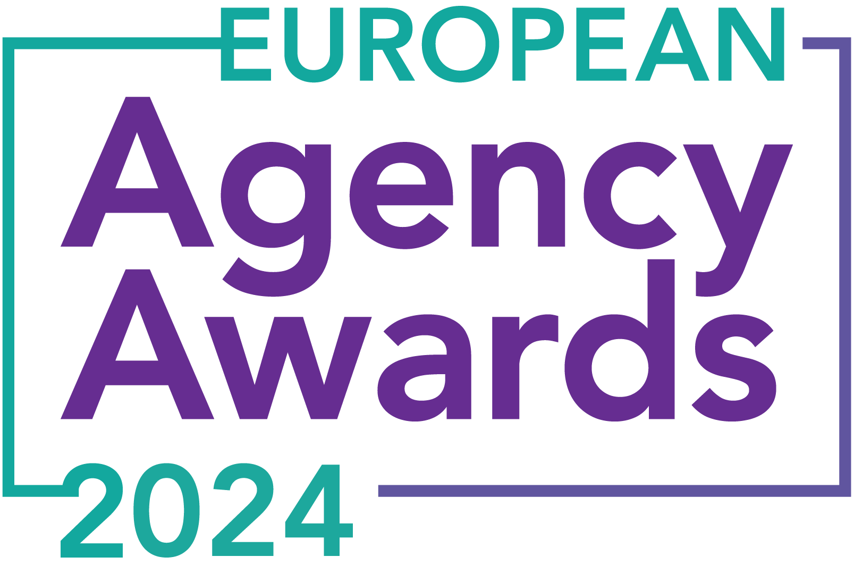

**European Agency Awards 2024 Entry Form**

**Please complete this entry form and upload it via the online entry portal** [**here**](https://europeanagencyawards.com/entry-form) **along with any supporting files.**

**Please note all documents must be under 2MB.**

* You can upload multiple entries via the online entry portal. You will need to fill out a separate entry form for each entry e.g., five entries = five individual entry forms
* If you are uploading the same entry into another category, you will need to edit your entry form appropriately to match the category criteria.
* Please make sure the correct category is checked in section B. If the correct category is not checked, your entry may be classed as void and therefore not judged.
* Entry questions are dependent on your chosen category, so please take care when filling out each entry. Please delete any sections of the entry form not required for your category.
* If your entry form does not match your online submission and category selection, your entry may be classed as a duplication error and may not be judged.
* **All entries must not exceed 1000 words.** The word count does not include the company information/summary in section A or the questions already within the form.
* All entries should relate to work carried out between **March 2023 - July 2024**
* Please follow the format and order of the criteria within this form. If you do not use the entry form below or miss information from your submission you may be penalized by the judges.
* All judges are bound by our terms and conditions and are required to acknowledge these prior to logging into their judging portals. Our judging T&C’s can be found here: <https://europeanagencyawards.com/terms>
* For more information on how to enter, entry fees and the deadline date, visit <https://europeanagencyawards.com/how-to-enter>
* Payment for all entries must be made at the time of submission.
* Please read the [Terms & Conditions](https://europeanagencyawards.com/terms)before submitting your entry.

|  |  |
| --- | --- |
| **SECTION A – YOUR DETAILS** | |
| **Organisation Name** | MONSOON Agency |
| **Contact Name** | Monika Siwek |

By submitting this form, you agree to the terms and conditions and declare that all facts and figures contained within are accurate and true, and that permission to enter has been given by all involved parties.

|  |
| --- |
| **SECTION B – SELECT YOUR CATEGORY**  Please select your category carefully and insert an X in the second column. Entry questions are dependent on chosen category – please complete section C, D, E or F as indicated. |

|  |  |  |
| --- | --- | --- |
| **1. Best Social Media Campaign** |  | Please complete section C |
| **2. Best SEO Campaign** |  | Please complete section C |
| **3. Best PPC Campaign** |  | Please complete section C |
| **4. Best PR Campaign** |  | Please complete section C |
| **5. Best Not-for-Profit Campaign** |  | Please complete section C |
| **6. Best Marketing Campaign** |  | Please complete section C |
| **7. Best Integrated Campaign** |  | Please complete section C |
| **8. Best Event** |  | Please complete section C |
| **9. Best New Business Campaign** |  | Please complete section C |
| **10. Best Crisis Communications or Response Campaign** |  | Please complete section C |
| **11. Campaign Effectiveness Award** |  | Please complete section C |
| **12. Best Pan European Campaign** | **X** | Please complete section C |
| **13. Best Use of AI in Client Campaign** |  | Please complete section C |
| **14. Best AI Agency Software Solution** |  | Please complete section C |
| **15. Best Agency Culture** |  | Please complete section D |
| **16. Best Charitable/Corporate Social Response Initiative** |  | Please complete section D |
| **17. Best Culture Transformation Initiative** |  | Please complete section D |
| **18. Best Flexible Working Policy** |  | Please complete section D |
| **19. Best Inclusion and Diversity Initiative** |  | Please complete section D |
| **20. Rising Agency Star Award** |  | Please complete section E |
| **21. Best New Agency** |  | Please complete section E |
| **22. Digital Agency of the Year** |  | Please complete section E |
| **23. Media Buying Agency of the Year** |  | Please complete section E |
| **24. B2B Agency of the Year** |  | Please complete section E |
| **25. B2C Agency of the Year** |  | Please complete section E |
| **26. eCommerce Agency of the Year** |  | Please complete section E |
| **27. SEO Agency of the Year** |  | Please complete section E |
| **28. PPC Agency of the Year** |  | Please complete section E |
| **29. Integrated Search Agency of the Year** |  | Please complete section E |
| **30. Social Media Agency of the Year** |  | Please complete section E |
| **31. Marketing Agency of the Year** |  | Please complete section E |
| **32. Creative/Design Agency of the Year** |  | Please complete section E |
| **33. Advertising Agency of the Year** |  | Please complete section E |
| **34. CRO Agency of the Year** |  | Please complete section E |
| **35. UX Agency of the Year** |  | Please complete section E |
| **36. Independent Agency of the Year** |  | Please complete section E |
| **37. PR Agency of the Year** |  | Please complete section E |
| **38. Innovative Agency of the Year** |  | Please complete section E |
| **39. Integrated Agency of the Year** |  | Please complete section E |
| **40. Best Small Agency of the Year** |  | Please complete section E |
| **41. Best Large Agency of the Year** |  | Please complete section E |

|  |
| --- |
| **SECTION C – CAMPAIGN AWARDS**  Please complete the following sections providing details of the campaign that you are entering. Please note entries must not exceed a total word count of 1000 words.  All information provided will remain confidential to the judges before and after the event and will not be shared with anyone outside of the judging panel allocated to review your entry. |
| **Entrant Name(s), Client Name & Campaign Title**  How you wish for the campaign to be credited including your organisation name, any partners / clients you want to credit & the title of your campaign.  Please structure your title in the following format:  ***"Entrant Name & Client Name - Campaign Name"***  Please keep this concise as it will appear on the website if you are shortlisted. |
| MONSOON Agency, SunRoof & New Era of Solar Roofs |
| **Objective(s) & budget (1-10 points)**  Tell us what you were looking to achieve from the campaign and any targets that were set. We recommend showing targets as quantifiable metrics e.g., ‘Increase conversions from 150 to 300 a month’ rather than ‘Increase conversions by 10%’.  Please include a breakdown of implementation costs, staffing costs, agency fees etc. All elements of the entry form are confidential, and judges will not share this information. If you are unable to provide a detailed budget breakdown, please include the financial band your budget is within along with the percentage budget allocated for staffing costs, agency fees and media spend etc. |
| [SunRoof](https://sunroof.se/), a Swedish solar roof producer, operates in Sweden, Germany, Poland. The brand is committed to accelerating the transition to sustainable energy with an emphasis on quality and design. As an agency, we have collaborated with SunRoof for many years, helping them become a market leader in their vertical on these markets.  This year, we faced a particularly tough challenge.    Our goal was to increase the number of incoming leads in Q2 of 2024 for Poland specifically, while maintaining the same media budget. We aimed to generate a minimum of 450 leads per month in April, May, and June, totaling 1350 leads for Q2, and achieve a CPL reduction to €30.  The challenge was multifaceted. Historically, the strongest quarters for this sector have been at the start of the year (Q1) and in Q3, due to the seasonality of the photovoltaic sector. Despite the presence of multiple smaller players in the market, two new major competitors, [SolRoof](https://solroof.eu/en/) and [MyRoof](https://en.myroof.pl/), entered the market, further crowding it.  Additionally, we faced a declining search demand, as confirmed by official documents from Google, indicating the market was shrinking further.    Poland held strategic importance for SunRoof due to an upcoming round of investor funding. However, similar to many EU economies, Poland is grappling with post-war market stagnation and inflation.    Additionally, the market in Poland presents unique challenges compared to more environmentally-oriented countries like Germany and Sweden. Polish consumers may not yet be as inclined to invest in advanced technological solutions from the sustainable sector.    Total media budget we had for the campaign was:   * Total media budget: €13,500 (excluding agency fees) * Split between Google Ads and Meta Ads (approximately 50/50) * Additional budget: €500 for graphics and landing page development |
| **Target audience & strategy (1-10 points)**  Please provide us with details around the audience you were targeting and your overall strategy to reach them as well as the strategy to meet the overall objectives. |
| Our target audience consisted of homeowners in Poland interested in green energy and becoming energy independent. These individuals are typically looking to invest in solar power for their homes, specifically by installing solar panels on their roofs.    Our strategy was shaped by the challenging market conditions. We aimed to address the pricing aspect and position SunRoof distinctively from its competitors. We sought to differentiate SunRoof’s solar roofs from other solar solutions in the market.  Simultaneously, we emphasized the affordability of solar roofs, communicating that they are now a more cost-effective option than traditional roofs with photovoltaic panels. We extensively highlighted the technology's benefits and its positive environmental impact, all while underscoring the affordable price.    To achieve it, we created a series of ads illustrating that solar roofs are not only an elegant and energy-efficient solution but also affordable for everyone. We integrated this narrative into all our campaign materials to ensure it resonated with our target audience. |
| **Implementation & creativity (1-10 points)**  Please give us a detailed explanation of your implementation for the campaign. Include screenshots to help us visualize campaigns. Provide information on the creativity of the campaign. |
| To locally adapt the campaign, we utilized the most popular social platforms and search engines in Poland. We concentrated on two primary digital channels: Google Ads and Meta Ads.  Across them, we employed various Google campaign types, including Search, Performance Max, Demand Gen, and YouTube campaigns. On Meta Ads, we developed a strategic funnel to target different stages of the customer journey, starting with top-of-funnel traffic campaigns to build awareness, followed by conversion-focused campaigns to generate leads. We also incorporated lead generation campaigns with instant forms.  We also designed a dedicated landing page to educate potential customers about SunRoof’s solar roofs: <https://offers.sunroof.se/pl-lp/nowy-dach-solarny/>    We also created comparison ads that clearly illustrated the advantages of solar roofs, making the choice obvious for the target audience – the ads highlight the benefits of solar roofs over traditional panels.      To further enhance their brand awareness, our client collaborated with renowned Polish TV personality and traveler Martyna Wojciechowska, who runs a foundation for single mothers called UNAWEZA. SunRoof sponsored the roof for one of the foundation's new buildings, a gesture that was very well received by the public. |
| **Details of any challenges faced and how these were overcome (1-10 points)**  What challenges were unique to you and how have you overcome them. What was the end result of overcoming these challenges? |
| The biggest challenge we faced was twofold:   * A declining search demand, which hindered our efforts to increase search volume; * Polish consumers' reservations about investing in premium products during a period of mild market recession;   To address both, we created a series of ads illustrating that solar roofs are not only an elegant and energy-efficient solution but also affordable for everyone. We integrated this narrative into all our campaign materials to ensure it resonated with our target audience.  Additionally, we designed a holistic marketing funnel to: A) reach as wide (yet relevant) an audience as possible, B) educate clients about the advantages of SunRoof and convert them into informed, ready-to-invest leads for the sales team, and C) maximize potential customer reach within our limited budget. We knew that effective visuals and storytelling could significantly enhance our campaigns' efficiency. |
| **Results & evaluation (1-10 points)**  Please relate these to the objectives and targets stated above. Provide actual numbers rather than percentages wherever possible. |
| * **Increased Lead Volume:** despite the challenges, we achieved our goal of generating generating 1707 leads in total and reducing the CPL to €24, surpassing our target.      * **Improved Lead Quality:** The quality of leads significantly improved, leading to higher conversion rates and increased sales. In Q2 we generated 27 sold roofs in total for Poland, setting the new record and going significanlty over the average we had of less than 15 roofs per quarters * **We manged** to imporve YoY results – in Q2 of 2023 we only generated 1099 leads, in Q2 of 2022 1362 leads. |
| **Why should your campaign win? (1-10 points)**  What do you think sets your campaign apart from the other campaigns being judged? Judges will in particular be looking for the thing that makes this campaign different to the others, what is unique? |
| We believe we should win, because not only did we meet our ambitious goal, but this achievement was made within a highly competitive and seasonally challenging market.  We also accomplished what many consider impossible in lead generation. We significantly increased the volume of leads while also enhancing their quality. This dual focus ensured that our client received not just more leads but better, conversion-ready prospects.  .  Our campaign directly led to record sales months for SunRoof. By enhancing lead quality, we significantly improved overall sales performance and positively impacted the client's revenue.  We achieved the primary business objective, proving that Poland can be a highly profitable market, making the business case very attractive for investors. |
| **URLs** |
| [**https://offers.sunroof.se/pl-lp/nowy-dach-solarny/**](https://offers.sunroof.se/pl-lp/nowy-dach-solarny/)  [**https://sunroof.se/**](https://sunroof.se/) |
| **Please detail any supporting documents you are including as part of your submission**  Optional – please upload to online entry portal when submitting this entry form |
|  |