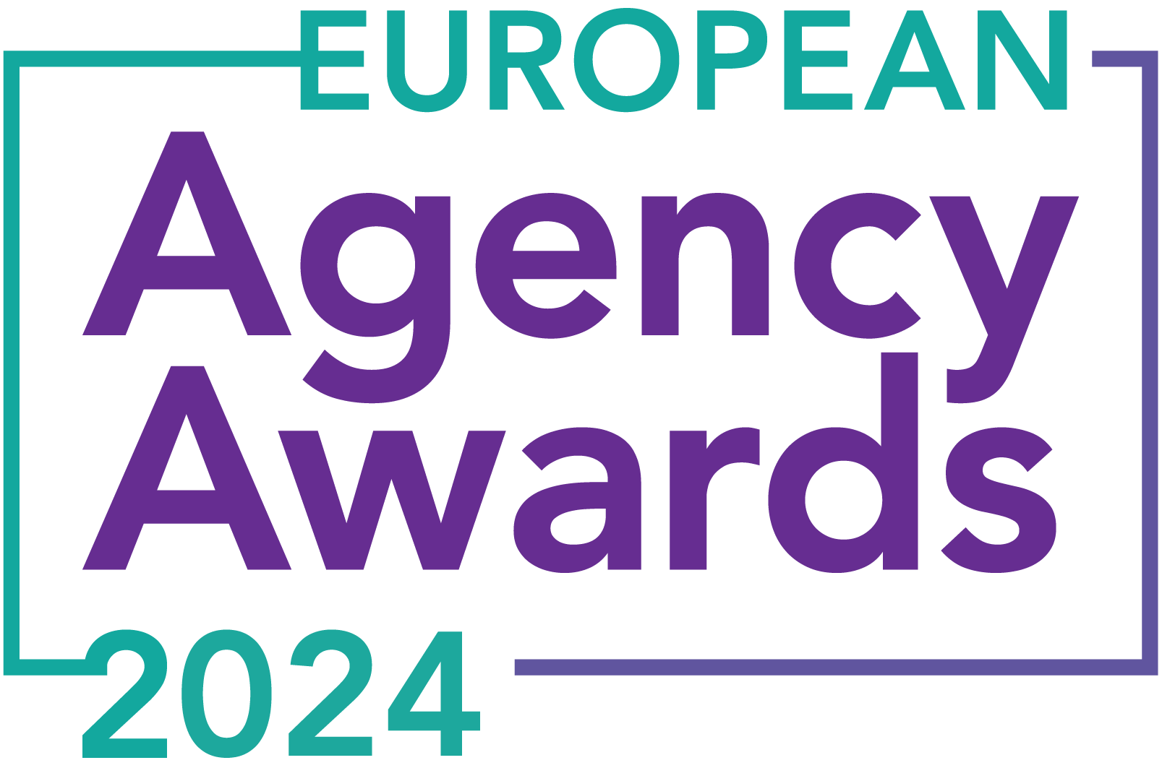

**European Agency Awards 2024 Entry Form**

**Please complete this entry form and upload it via the online entry portal** [**here**](https://europeanagencyawards.com/entry-form) **along with any supporting files.**

**Please note all documents must be under 2MB.**

* You can upload multiple entries via the online entry portal. You will need to fill out a separate entry form for each entry e.g., five entries = five individual entry forms
* If you are uploading the same entry into another category, you will need to edit your entry form appropriately to match the category criteria.
* Please make sure the correct category is checked in section B. If the correct category is not checked, your entry may be classed as void and therefore not judged.
* Entry questions are dependent on your chosen category, so please take care when filling out each entry. Please delete any sections of the entry form not required for your category.
* If your entry form does not match your online submission and category selection, your entry may be classed as a duplication error and may not be judged.
* **All entries must not exceed 1000 words.** The word count does not include the company information/summary in section A or the questions already within the form.
* All entries should relate to work carried out between **March 2023 - July 2024**
* Please follow the format and order of the criteria within this form. If you do not use the entry form below or miss information from your submission you may be penalized by the judges.
* All judges are bound by our terms and conditions and are required to acknowledge these prior to logging into their judging portals. Our judging T&C’s can be found here: <https://europeanagencyawards.com/terms>
* For more information on how to enter, entry fees and the deadline date, visit <https://europeanagencyawards.com/how-to-enter>
* Payment for all entries must be made at the time of submission.
* Please read the [Terms & Conditions](https://europeanagencyawards.com/terms)before submitting your entry.

|  |  |
| --- | --- |
| **SECTION A – YOUR DETAILS** | |
| **Organisation Name** | TrunkBBI |
| **Contact Name** | Adam Britton |

By submitting this form, you agree to the terms and conditions and declare that all facts and figures contained within are accurate and true, and that permission to enter has been given by all involved parties.

|  |
| --- |
| **SECTION B – SELECT YOUR CATEGORY**  Please select your category carefully and insert an X in the second column. Entry questions are dependent on chosen category – please complete section C, D, E or F as indicated. |

|  |  |  |
| --- | --- | --- |
| **1. Best Social Media Campaign** |  | Please complete section C |
| **2. Best SEO Campaign** | X | Please complete section C |
| **3. Best PPC Campaign** |  | Please complete section C |
| **4. Best PR Campaign** |  | Please complete section C |
| **5. Best Not-for-Profit Campaign** |  | Please complete section C |
| **6. Best Marketing Campaign** |  | Please complete section C |
| **7. Best Integrated Campaign** |  | Please complete section C |
| **8. Best Event** |  | Please complete section C |
| **9. Best New Business Campaign** |  | Please complete section C |
| **10. Best Crisis Communications or Response Campaign** |  | Please complete section C |
| **11. Campaign Effectiveness Award** |  | Please complete section C |
| **12. Best Pan European Campaign** |  | Please complete section C |
| **13. Best Use of AI in Client Campaign** |  | Please complete section C |
| **14. Best AI Agency Software Solution** |  | Please complete section C |
| **15. Best Agency Culture** |  | Please complete section D |
| **16. Best Charitable/Corporate Social Response Initiative** |  | Please complete section D |
| **17. Best Culture Transformation Initiative** |  | Please complete section D |
| **18. Best Flexible Working Policy** |  | Please complete section D |
| **19. Best Inclusion and Diversity Initiative** |  | Please complete section D |
| **20. Rising Agency Star Award** |  | Please complete section E |
| **21. Best New Agency** |  | Please complete section E |
| **22. Digital Agency of the Year** |  | Please complete section E |
| **23. Media Buying Agency of the Year** |  | Please complete section E |
| **24. B2B Agency of the Year** |  | Please complete section E |
| **25. B2C Agency of the Year** |  | Please complete section E |
| **26. eCommerce Agency of the Year** |  | Please complete section E |
| **27. SEO Agency of the Year** |  | Please complete section E |
| **28. PPC Agency of the Year** |  | Please complete section E |
| **29. Integrated Search Agency of the Year** |  | Please complete section E |
| **30. Social Media Agency of the Year** |  | Please complete section E |
| **31. Marketing Agency of the Year** |  | Please complete section E |
| **32. Creative/Design Agency of the Year** |  | Please complete section E |
| **33. Advertising Agency of the Year** |  | Please complete section E |
| **34. CRO Agency of the Year** |  | Please complete section E |
| **35. UX Agency of the Year** |  | Please complete section E |
| **36. Independent Agency of the Year** |  | Please complete section E |
| **37. PR Agency of the Year** |  | Please complete section E |
| **38. Innovative Agency of the Year** |  | Please complete section E |
| **39. Integrated Agency of the Year** |  | Please complete section E |
| **40. Best Small Agency of the Year** |  | Please complete section E |
| **41. Best Large Agency of the Year** |  | Please complete section E |

|  |
| --- |
| **SECTION C – CAMPAIGN AWARDS**  Please complete the following sections providing details of the campaign that you are entering. Please note entries must not exceed a total word count of 1000 words.  All information provided will remain confidential to the judges before and after the event and will not be shared with anyone outside of the judging panel allocated to review your entry. |
| **Entrant Name(s), Client Name & Campaign Title**  How you wish for the campaign to be credited including your organisation name, any partners / clients you want to credit & the title of your campaign.  Please structure your title in the following format:  ***"Entrant Name & Client Name - Campaign Name"***  Please keep this concise as it will appear on the website if you are shortlisted. |
| TrunkBBI & Halfords – Driving organic search performance for Tyres |
| **Objective(s) & budget (1-10 points)**  Tell us what you were looking to achieve from the campaign and any targets that were set. We recommend showing targets as quantifiable metrics e.g., ‘Increase conversions from 150 to 300 a month’ rather than ‘Increase conversions by 10%’.  Please include a breakdown of implementation costs, staffing costs, agency fees etc. All elements of the entry form are confidential, and judges will not share this information. If you are unable to provide a detailed budget breakdown, please include the financial band your budget is within along with the percentage budget allocated for staffing costs, agency fees and media spend etc. |
| Halfords aimed to grow their organic search performance and revenue driven from the vehicle tyres product category. TrunkBBI's mission was to outperform key competitors and achieve:   * A 15% increase in organic search sessions to tyre pages in 12 months (from 1.165m to 1.339m sessions). * A 15% uplift in revenue from tyre sales over the same period (from £5.68m to £6.53m). * Become the organic search market leader for tyres, surpassing Black Circles and Asda Tyres.   This was to be accomplished with a monthly client budget of £8,000, translating to 8-10 workdays per month, focusing on technical SEO, content, copywriting, and UX. |
| **Target audience & strategy (1-10 points)**  Please provide us with details around the audience you were targeting and your overall strategy to reach them as well as the strategy to meet the overall objectives. |
| Halfords wanted to target all UK motorists looking to purchase tyres, ranging from knowledgeable petrol-heads through to those with little motoring experience. With a huge audience to target, our organic strategy needed to be creative and flexible for a wide audience.  We developed on an organic strategy covering 4 key areas:   * Extensive keyword research – enabling us to understand what opportunity there is in the tyre market, competitor rankings, Halfords rankings and search intent. * Enhancing technical SEO – improving search engines’ crawl and index of the Halfords site to increase organic visibility. * Improving onsite content - creating a keyword driven content strategy to target relevant users at transactional and research stages of their journey. * UX and page design - optimising on-page UX and layout to encourage conversion and tyre purchases. |
| **Implementation & creativity (1-10 points)**  Please give us a detailed explanation of your implementation for the campaign. Include screenshots to help us visualize campaigns. Provide information on the creativity of the campaign. |
| 1. Extensive Keyword Research   We began with conducting extensive keyword research, reviewing tyre formats (winter, 4x4, summer etc), manufacturers (Bridgestone, Goodyear etc), tread patterns, quality (budget, premium etc), car make and model (BMW, Audi A3 etc) amongst other keyword categories. This enabled us to map Halfords existing ranking positions vs competitors and identify opportunities for ranking growth. We also aligned keywords to commercial intent to ensure we drove revenue improvements.   1. Enhancing Technical SEO   The implementation of our strategy began with a comprehensive technical SEO audit, identifying issues that would impact the Halfords website’s performance in search engines. Based on the objectives, this focused specifically on tyre-related pages and elements, including but not limited to:   * Site load time * Structured data * Meta titles and descriptions   2.1 Site Load Time  We performed site speed tests for key tyre pages, attributing "pass" "or "fail" to each Core Web Vital metric. Our SEO and development teams collaborated to identify recommendations that could be implemented by Halfords to reduce site load times and improvd search and conversion performance. Halfords originally had the poorest site load time scores:         * 1. Structured Data   Structured data improvements were implemented to enhance Halfords’ appearance in search engines, demonstrate trust signals and improve click-through rate. These included:   * Product * Review * Offer * Breadcrumb * FAQ   FAQ structured data example:  A screenshot of a computer  Description automatically generated  Breadcrumbs structured data example:  A tire on a white background  Description automatically generated   * 1. Meta Titles & Descriptions   Additionally, we refined meta descriptions for 82 tyre pages, making them more relevant and action oriented. Our comprehensive keyword research further informed our strategy, focusing on search intent and topic categories.     1. Improving onsite content   Alongside technical SEO, we scrutinized each keyword topic cluster to understand the search intent, E-E-A-T signals, and how competitors ranked. Our findings revealed missed opportunities in price comparison and specific tyre types like winter tyres. This led to a targeted content strategy to enhance Halfords' keyword rankings and organic traffic.  We produced 220 content pieces, including product listings, detail pages, and educational guides. Each piece was backed by a comprehensive SEO brief detailing target keywords, user journey, search intent, structure, FAQs, internal links, competitor insights, and E-E-A-T factors.    A close-up of a questionnaire  Description automatically generatedA close-up of a document  Description automatically generatedA screenshot of a computer  Description automatically generated   1. UX and Page Design   To ensure our strategy not only attracted organic traffic but also converted effectively, we conducted a UX audit of the tyre category. This identified key enhancements to support SEO and user experience, such as:   * Better internal linking and anchor text. * Increased accessibility by removing text from images. * More explicit calls to action. * New content components for better performance. * Suitable templates for every user journey stage.   A screenshot of a website  Description automatically generated  Our UX team then created page and component wireframes focused on improving tyre page structure, layout and ease of use for customers. Example wireframes:      This was then developed and implemented by Halfords in-house development team. |
| **Details of any challenges faced and how these were overcome (1-10 points)**  What challenges were unique to you and how have you overcome them. What was the end result of overcoming these challenges? |
| Our unique challenges included navigating the complex Halfords CMS to implement UX and page structure enhancements. By creatively adapting our recommendations to align with existing site functionalities, the UX changes were successfully executed by Halfords.  Additionally, the volume of content produced by TrunkBBI outpaced Halfords' capacity to review and upload to the website. We addressed this by helping them hire and train an extra team member, streamlining the content handling process and alleviating the bottleneck. |
| **Results & evaluation (1-10 points)**  Please relate these to the objectives and targets stated above. Provide actual numbers rather than percentages wherever possible. |
| * 25.8% YoY increase in organic sessions to the tyres section of the Halfords website 2022 vs 2023 (from 1.165m to 1.465m) – Target was a 15% increase. * 35.2% YoY increase in organic transactions 2022 vs 2023 (from 32.3k to 43.8k) * 44% YoY increase in annual revenue from organic search 2022 vs 2023 (£5.68M to £8.23M) – Target was a 15% increase. * Tyre sales from organic traffic has generated an additional £2.55 million in revenue during 2023 vs 2022 for Halfords, which is an **ROI of 2556%** (annual agency spend of £96,000) * Based on our tyre keyword set, at the end of 2022 Halfords were 3rd in the tyre organic search market. Based on keyword ranking improvements driven by TrunkBBI, Halfords now hold position 1 in the organic search market share analysis, over taking Black Circles and Asda Tyres. This is also confirmed by Sistrix organic search visibility scores:   A graph showing a graph of a stock market  Description automatically generated with medium confidence   * Halfords tyre pages are also seeing rich results within the SERPs, thanks to additional content and FAQ structured data. Questions and answers from the Halfords page now appear directly in search results. Users can see relevant answers and other helpful information, before clicking through to the site:        * The content produced by TrunkBBI on-site has increased organic rankings, which is driving a huge improvement in organic clicks, sessions, transactions, and revenue. Keyword categories have increased average rank by 15 positions, as well completely new rankings:      * As a result of TrunkBBI’s SEO activity delivering a large increase in tyre sales and revenue, the Tyre product category has become the largest revenue driving product category in Halfords business, increasing from 28% of total sales in 2018 to 47% in 2023. Alongside this, the client has informed us they have been able to increase margins by up to 8% on tyres from key manufacturers by decreasing the wholesale cost of the products due to additional volume purchasing. |
| **Why should your campaign win? (1-10 points)**  What do you think sets your campaign apart from the other campaigns being judged? Judges will in particular be looking for the thing that makes this campaign different to the others, what is unique? |
| Our comprehensive SEO approach included technical SEO, content strategy, copy production and UX improvements, enabling us to deliver business changing results for our clients. Halfords tyre category has increased from the 3rd largest revenue driving product area to the largest revenue product area for Halfords. We’ve exceeded initial targets of 20% growth (44% revenue growth in 2023) and we’ve demonstrated a huge 2556% ROI to the client.  Rich Foulkes, Halfords Group SEO Manager:    Thanks to our success, we’re now working on multiple other Halfords product categories, including Car Parts, with the target of achieving similar success. |
| **URLs** |
| <https://www.halfords.com/tyres/>  <https://www.halfords.com/tyres/winter-tyres/>  <https://www.halfords.com/tyres/bridgestone/>  <https://www.halfords.com/tyres/4x4-tyres/>  <https://www.halfords.com/tyres/premium-tyres/>  <https://www.halfords.com/tyres/mobile-tyre-fitting/>  <https://www.halfords.com/tyre-safety.html>  <https://www.halfords.com/tyres/advice/all-season-or-winter-tyres.html>  <https://www.halfords.com/tyres/advice/tread-depth-and-safety.html>  <https://www.halfords.com/tyres/advice/tips-to-make-your-tyres-last-longer.html> |
| **Please detail any supporting documents you are including as part of your submission**  Optional – please upload to online entry portal when submitting this entry form |
|  |

|  |
| --- |
| **SECTION D – CULTURE & CONTINUITY AWARDS**  Please complete the following sections providing details of the culture of the agency. Detail investment in training, support, and development of the agency’s team and how this has helped to win new business and grow existing accounts. Please note entries must not exceed a total word count of 1000 words in this section.  All information provided will remain confidential to the judges before and after the event and will not be shared with anyone outside of the judging panel allocated to review your entry. |
| **Name of Team / Agency**  Please keep this concise as it will appear on the website if you are shortlisted. |
|  |
| **Team / Agency Overview**  Give details of number of employees, structure etc. Judges will be looking for clarity and context to help understand more about your agency or team. |
|  |
| **Details of company culture initiatives & budget allocated (1-10 points)**  e.g., flexible working, holiday schemes, training and development, incentive schemes, rewards packages, CSR and volunteering initiatives |
|  |
| **Evidence positive impact / results of any initiatives (1-10 points)**  e.g., increased productivity, staff retention, staff promotion and development |
|  |
| **Why you think you should win (1-10 points)**  What do you think sets your culture apart from other agencies/teams being judges? Judges will be looking for the thing that makes your culture different to the others, what is unique? |
|  |
| **URLs** |
|  |
| **Please detail any supporting documents you are including as part of your submission**  Optional – please upload to online entry portal when submitting this entry form |
|  |

|  |
| --- |
| **SECTION E – AGENCY / TEAM / RISING AGENCY STAR AWARDS**  Please complete the following sections providing details of the agency / team / individual that you are entering. Please note entries can be self-nominated or nominated by a third party and must not exceed a total word count of 1000 words.  All information provided will remain confidential to the judges before and after the event and will not be shared with anyone outside of the judging panel allocated to review your entry. |
| **Name of Nominee - Agency / Team / Rising Agency Star**  Please keep this concise as it will appear on the website if you are shortlisted. |
|  |
| **Date of Birth** (Rising Agency Star nominees only)  ***Please note that nominee must be under 30 on October 19, 2023*** |
|  |
| **Contact email address of nominee** (Rising Agency Star nominees only) |
|  |
| **Contact phone number of nominee** (Rising Agency Star nominees only) |
|  |
| **Overview of the Agency / Team / Rising Agency Star nominee**  Please include numbers, staff turnover, roles etc for agency and team nominations or current and previous job roles etc for Rising Star nominations |
|  |
| **Agency / Team / Rising Agency Star objectives (1-10 points)**  Tell us what you were looking to achieve and any targets that have been set within the agency or team to help achieve your goals. We recommend showing targets as quantifiable metrics e.g., ‘Increase conversions from 150 to 300 a month’ rather than ‘Increase conversions by 10%’. |
|  |
| **Recent work example(s**) **(1-10 points)**  Please include details of recent client or campaign work. How does your recent work display creativity and make your team or agency stand out amongst others? |
|  |
| **Details of any recent achievements (1-10 points)**  What makes your team or agency stand out? Please include details of any achievements you feel make your agency, team or rising star award worthy. What are you proud of? |
|  |
| **Details of any challenges faced and how these were overcome (1-10 points)**  What challenges were unique to you and how have you overcome them. What was the end result of overcoming these challenges? |
|  |
| **Why should your Agency / Team / Rising Agency Star win? (1-10 points)**  Please detail what you feel makes you stand out amongst others and why you feel your entry is award winning. What makes you unique? What gives you the competitive edge? |
|  |
| **URLs** |
|  |
| **Please detail any supporting documents you are including as part of your submission**  Optional – please upload to online entry portal when submitting this entry form |
|  |