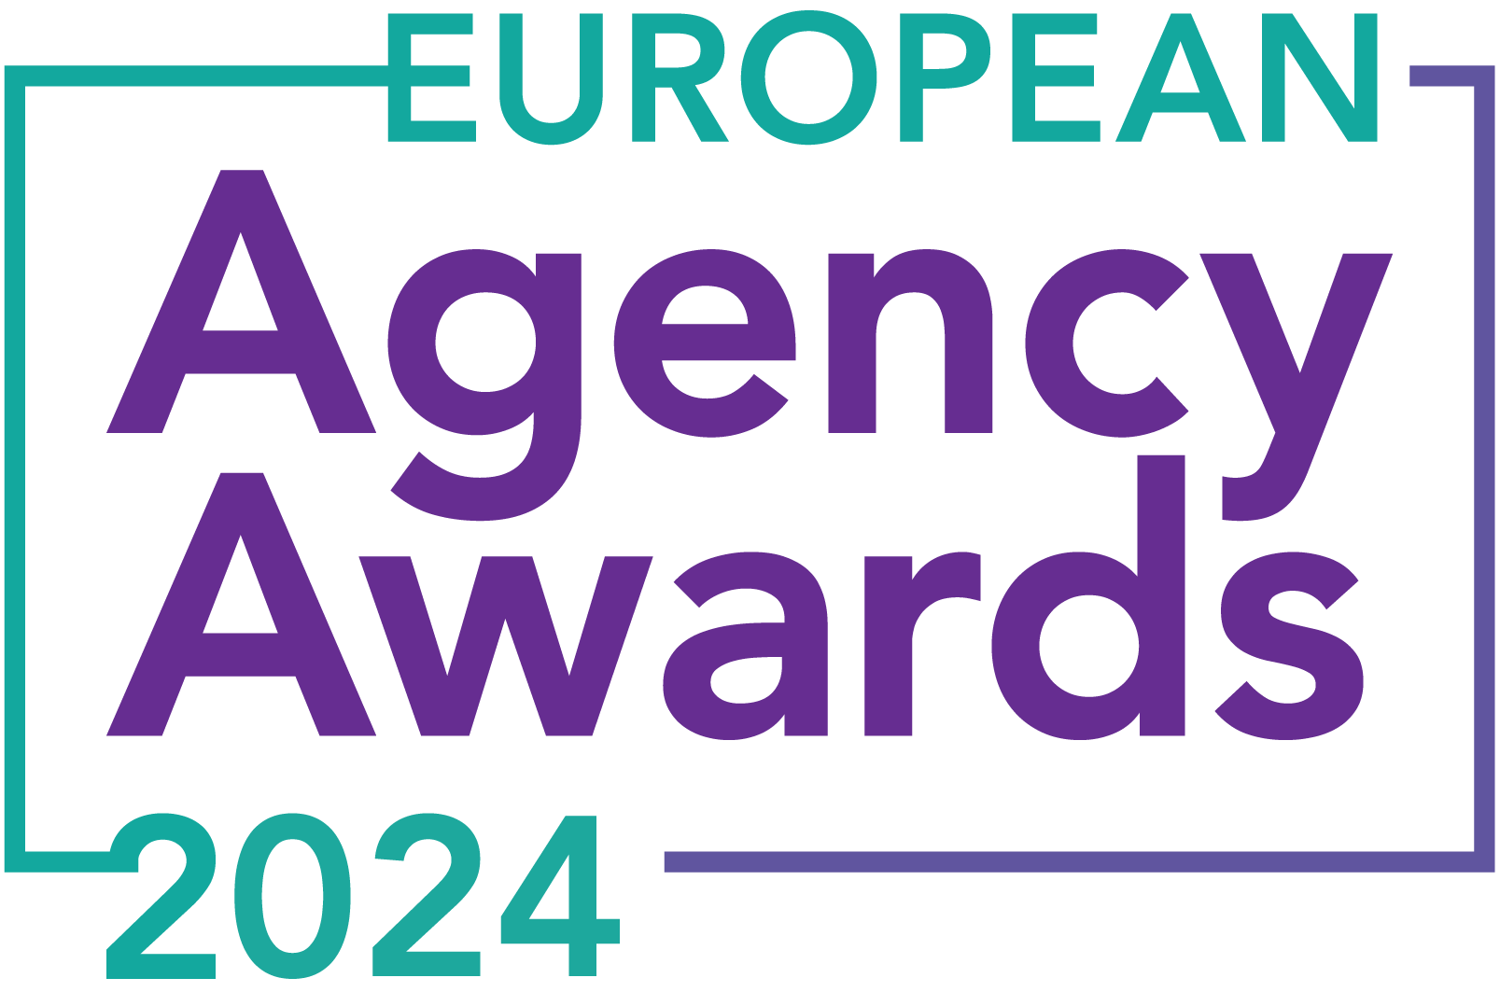

**European Agency Awards 2024 Entry Form**

**Please complete this entry form and upload it via the online entry portal** [**here**](https://europeanagencyawards.com/entry-form) **along with any supporting files.**

**Please note all documents must be under 2MB.**

* You can upload multiple entries via the online entry portal. You will need to fill out a separate entry form for each entry e.g., five entries = five individual entry forms
* If you are uploading the same entry into another category, you will need to edit your entry form appropriately to match the category criteria.
* Please make sure the correct category is checked in section B. If the correct category is not checked, your entry may be classed as void and therefore not judged.
* Entry questions are dependent on your chosen category, so please take care when filling out each entry. Please delete any sections of the entry form not required for your category.
* If your entry form does not match your online submission and category selection, your entry may be classed as a duplication error and may not be judged.
* **All entries must not exceed 1000 words.** The word count does not include the company information/summary in section A or the questions already within the form.
* All entries should relate to work carried out between **March 2023 - July 2024**
* Please follow the format and order of the criteria within this form. If you do not use the entry form below or miss information from your submission you may be penalized by the judges.
* All judges are bound by our terms and conditions and are required to acknowledge these prior to logging into their judging portals. Our judging T&C’s can be found here: <https://europeanagencyawards.com/terms>
* For more information on how to enter, entry fees and the deadline date, visit <https://europeanagencyawards.com/how-to-enter>
* Payment for all entries must be made at the time of submission.
* Please read the [Terms & Conditions](https://europeanagencyawards.com/terms)before submitting your entry.

|  |  |
| --- | --- |
| **SECTION A – YOUR DETAILS** | |
| **Organisation Name** | MONSOON Agency |
| **Contact Name** | Monika Siwek |

By submitting this form, you agree to the terms and conditions and declare that all facts and figures contained within are accurate and true, and that permission to enter has been given by all involved parties.

|  |
| --- |
| **SECTION B – SELECT YOUR CATEGORY**  Please select your category carefully and insert an X in the second column. Entry questions are dependent on chosen category – please complete section C, D, E or F as indicated. |

|  |  |  |
| --- | --- | --- |
| **1. Best Social Media Campaign** |  | Please complete section C |
| **2. Best SEO Campaign** |  | Please complete section C |
| **3. Best PPC Campaign** |  | Please complete section C |
| **4. Best PR Campaign** |  | Please complete section C |
| **5. Best Not-for-Profit Campaign** |  | Please complete section C |
| **6. Best Marketing Campaign** |  | Please complete section C |
| **7. Best Integrated Campaign** |  | Please complete section C |
| **8. Best Event** |  | Please complete section C |
| **9. Best New Business Campaign** |  | Please complete section C |
| **10. Best Crisis Communications or Response Campaign** |  | Please complete section C |
| **11. Campaign Effectiveness Award** |  | Please complete section C |
| **12. Best Pan European Campaign** |  | Please complete section C |
| **13. Best Use of AI in Client Campaign** |  | Please complete section C |
| **14. Best AI Agency Software Solution** |  | Please complete section C |
| **15. Best Agency Culture** |  | Please complete section D |
| **16. Best Charitable/Corporate Social Response Initiative** |  | Please complete section D |
| **17. Best Culture Transformation Initiative** |  | Please complete section D |
| **18. Best Flexible Working Policy** |  | Please complete section D |
| **19. Best Inclusion and Diversity Initiative** |  | Please complete section D |
| **20. Rising Agency Star Award** |  | Please complete section E |
| **21. Best New Agency** |  | Please complete section E |
| **22. Digital Agency of the Year** |  | Please complete section E |
| **23. Media Buying Agency of the Year** |  | Please complete section E |
| **24. B2B Agency of the Year** |  | Please complete section E |
| **25. B2C Agency of the Year** |  | Please complete section E |
| **26. eCommerce Agency of the Year** |  | Please complete section E |
| **27. SEO Agency of the Year** |  | Please complete section E |
| **28. PPC Agency of the Year** |  | Please complete section E |
| **29. Integrated Search Agency of the Year** |  | Please complete section E |
| **30. Social Media Agency of the Year** |  | Please complete section E |
| **31. Marketing Agency of the Year** |  | Please complete section E |
| **32. Creative/Design Agency of the Year** |  | Please complete section E |
| **33. Advertising Agency of the Year** |  | Please complete section E |
| **34. CRO Agency of the Year** |  | Please complete section E |
| **35. UX Agency of the Year** |  | Please complete section E |
| **36. Independent Agency of the Year** |  | Please complete section E |
| **37. PR Agency of the Year** |  | Please complete section E |
| **38. Innovative Agency of the Year** |  | Please complete section E |
| **39. Integrated Agency of the Year** |  | Please complete section E |
| **40. Best Small Agency of the Year** | X | Please complete section E |
| **41. Best Large Agency of the Year** |  | Please complete section E |

|  |
| --- |
| **SECTION E – AGENCY / TEAM / RISING AGENCY STAR AWARDS**  Please complete the following sections providing details of the agency / team / individual that you are entering. Please note entries can be self-nominated or nominated by a third party and must not exceed a total word count of 1000 words.  All information provided will remain confidential to the judges before and after the event and will not be shared with anyone outside of the judging panel allocated to review your entry. |
| **Name of Nominee - Agency / Team / Rising Agency Star**  Please keep this concise as it will appear on the website if you are shortlisted. |
| **MONSOON Agency** |
| **Date of Birth** (Rising Agency Star nominees only)  ***Please note that nominee must be under 30 on October 19, 2023*** |
|  |
| **Contact email address of nominee** (Rising Agency Star nominees only) |
|  |
| **Contact phone number of nominee** (Rising Agency Star nominees only) |
|  |
| **Overview of the Agency / Team / Rising Agency Star nominee**  Please include numbers, staff turnover, roles etc for agency and team nominations or current and previous job roles etc for Rising Star nominations |
| MONSOON is a dedicated group of 19 marketing professionals with extensive experience in working with both local and international brands, ranging from large corporations to small businesses. We offer a comprehensive suite of services for digital and performance marketing, including platforms like Google, YouTube, Meta, TikTok, LinkedIn, Pinterest, Quora, Reddit, App Advertising, and more.  Though we may appear small, we’ve seen significant growth, doubling our size over the past year from 9 to 19 team members. We have cultivated an organizational structure and culture that promotes skill development and career growth. Our team operates 100% remotely, with members based in Poland, Germany, and Italy.  A group of people in a row  Description automatically generated  In the past year, our client base has grown substantially. We’ve expanded from managing 18 projects to handling 32. While our reach is international, our primary focus is on the European market, particularly the DACH region. We collaborate with brands across various industries, emphasizing partnerships with companies that make a positive impact. Our portfolio includes medtech companies, sustainability projects, and eco-friendly solutions. |
| **Agency / Team / Rising Agency Star objectives (1-10 points)**  Tell us what you were looking to achieve and any targets that have been set within the agency or team to help achieve your goals. We recommend showing targets as quantifiable metrics e.g., ‘Increase conversions from 150 to 300 a month’ rather than ‘Increase conversions by 10%’. |
| Our primary goal last year was growth, with a focus on maintaining a balanced and supportive work environment for our team. We set ambitious targets in several areas:   * **Revenue Growth:** Increase monthly revenue from ~€40,000 in January 2023 to €75,000 by June 2024, aiming for nearly 100% growth. * **Process Automation:** Implement automation to handle 20% of our processes, saving approximately 300 hours per month. * **Time to Independence:** Reduce the time it takes for new team members to reach full capacity from around 2 months to a maximum of 1 month. * **Team Independence:** Reduce the operational workload of the two co-founders from approximately 300 hours per month to a maximum of 50 hours.   Ensuring the agency can function smoothly without the founders’ constant involvement was particularly important. This meant empowering everyone to understand their roles, manage projects effectively, feel connected to the organization, and enjoy their work. |
| **Recent work example(s**) **(1-10 points)**  Please include details of recent client or campaign work. How does your recent work display creativity and make your team or agency stand out amongst others? |
| **Three biggest success cases we are the most proud of:**   * [FPRO](https://de.fpro.com/)**:** We successfully launched FPRO on the German market by the end of 2023. FPRO is a football mat and app training program for young athletes to improve their dribbling skills. The company operates in 8 different markets, US & UK and some European ones. Taking over operational work in October 2023, we grew the client's revenue from €98,000 in Q3 to to €714,000 Q4, making Germany main revenue driver for the entire holding.      * We helped [**Clearlight Saunas**](https://www.clearlightinfrarotkabinen.de/campaigns/infrarotsauna) grow significantly within first 5 months of the collaboration by reducing the average CPL and exceeding the goal of 120 leads per week. The client was so pleased with the results that they expanded their campaigns with us to six markets: UK, Germany, Austria, Switzerland, Australia, and New Zealand. Our work on this project earned us a nomination for the European Search Awards.        * [SunRoof](https://sunroof.se/de/)**:** We achieved our ambitious lead and sales goals for SunRoof in a highly competitive and seasonally challenging market. We not only increased the volume of leads but also significantly enhanced their quality. The campaign led to record sales months for SunRoof, proving project to be highly profitable and making the business case very attractive for investors. |
| **Details of any recent achievements (1-10 points)**  What makes your team or agency stand out? Please include details of any achievements you feel make your agency, team or rising star award worthy. What are you proud of? |
| Our client-centric approach sets us apart—we align our strategies with their business goals and act as a close-knit extension of their teams. Our clients often refer to us as their "external marketing team." This year, we have successfully upsold 15 additional services to our clients, adding an extra €25,000 to our monthly payroll.  We are also proud of our internal development. We have promoted four team leaders from within, providing our team with excellent career progression opportunities and fostering a supportive environment.    Team-wise, we are proud of developing four team leaders from within our own structure, offering our team members excellent opportunities to advance their careers. We prioritize internal development and growth, fostering a supportive environment that encourages career progression. |
| **Details of any challenges faced and how these were overcome (1-10 points)**  What challenges were unique to you and how have you overcome them. What was the end result of overcoming these challenges? |
| Managing a rapidly growing team with first-time managers was a key challenge. We implemented a program to mentor these new leaders in soft skills, team development, and provided regular supervision. This program included:   * **Kate:** Transitioned from Google Ads Expert to Head of Customer Success. * **Aga:** Promoted from Senior Google Ads Specialist to Google Team Leader. * **Marco:** Moved from Project Manager and Senior Meta Expert to Social Media Team Leader. * **Jakob:** Advanced from Senior Marketing Manager to Content Creation Team Leader.   The transparent communication model we adopted built mutual trust and confidence, leading to improved leadership, enhanced organizational culture, and relieved the founders from daily operational tasks, allowing them to focus on strategic growth.    To build confidence in the leaders and foster trust from the owners, we adopted a highly transparent communication model. This included feedforward-based communication in both directions - from the owners to the team and from the team to the owners.  **End Result:**   * **Improved Leadership:** The first-time manager program equipped our new leaders with the necessary skills and support, resulting in a more effective and cohesive management team. * **Enhanced Trust:** The transparent communication model helped build mutual trust and confidence between the owners and the new leaders, creating a stronger organizational culture. * **Organizational Growth:** These efforts allowed us to maintain high performance and morale within the organization, even as we navigated rapid growth and changes * **Founders:** lastly, the founders are now relieved from operational tasks and are able to fully focus on further business growth. |
| **Why should your Agency / Team / Rising Agency Star win? (1-10 points)**  Please detail what you feel makes you stand out amongst others and why you feel your entry is award winning. What makes you unique? What gives you the competitive edge? |
| We have built a team of exceptional experts committed to MONSOON’s growth. Many of our team members have been with us from the beginning, evolving from channel specialists to team leaders. Over the past year, we have concentrated on growing and maturing our organization, enhancing our team’s skills, and creating a robust structure that supports continuous development. This transition has made us more specialized and efficient, enabling us to deliver outstanding results for our clients.  In conclusion, MONSOON is a small yet highly capable agency, much like a nimble boat, skillfully navigating our clients to their goals with precision and expertise. |
| **URLs** |
| [**https://monsoon.agency/**](https://monsoon.agency/)  [**https://www.linkedin.com/company/20329407/**](https://www.linkedin.com/company/20329407/) |
| **Please detail any supporting documents you are including as part of your submission**  Optional – please upload to online entry portal when submitting this entry form |
|  |