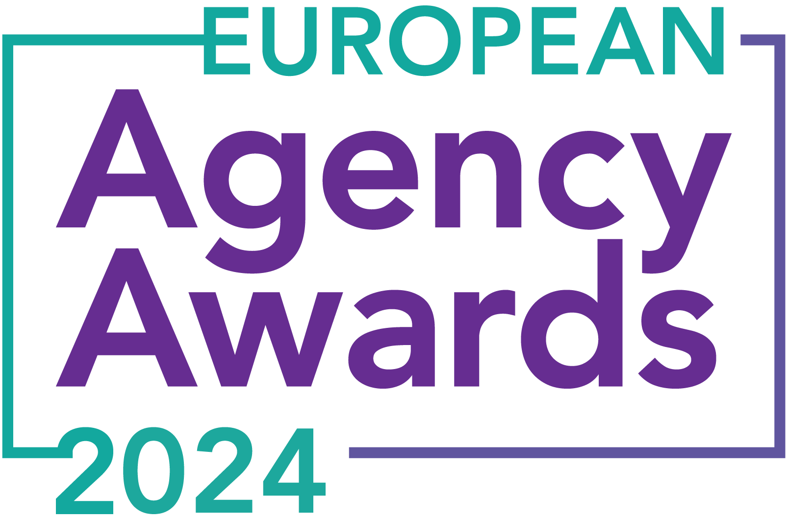

**European Agency Awards 2024 Entry Form**

**Please complete this entry form and upload it via the online entry portal** [**here**](https://europeanagencyawards.com/entry-form) **along with any supporting files.**

**Please note all documents must be under 2MB.**

* You can upload multiple entries via the online entry portal. You will need to fill out a separate entry form for each entry e.g., five entries = five individual entry forms
* If you are uploading the same entry into another category, you will need to edit your entry form appropriately to match the category criteria.
* Please make sure the correct category is checked in section B. If the correct category is not checked, your entry may be classed as void and therefore not judged.
* Entry questions are dependent on your chosen category, so please take care when filling out each entry. Please delete any sections of the entry form not required for your category.
* If your entry form does not match your online submission and category selection, your entry may be classed as a duplication error and may not be judged.
* **All entries must not exceed 1000 words.** The word count does not include the company information/summary in section A or the questions already within the form.
* All entries should relate to work carried out between **March 2023 - July 2024**
* Please follow the format and order of the criteria within this form. If you do not use the entry form below or miss information from your submission you may be penalized by the judges.
* All judges are bound by our terms and conditions and are required to acknowledge these prior to logging into their judging portals. Our judging T&C’s can be found here: <https://europeanagencyawards.com/terms>
* For more information on how to enter, entry fees and the deadline date, visit <https://europeanagencyawards.com/how-to-enter>
* Payment for all entries must be made at the time of submission.
* Please read the [Terms & Conditions](https://europeanagencyawards.com/terms)before submitting your entry.

|  |  |
| --- | --- |
| **SECTION A – YOUR DETAILS** | |
| **Organisation Name** | TrunkBBI |
| **Contact Name** | Adam Britton |

By submitting this form, you agree to the terms and conditions and declare that all facts and figures contained within are accurate and true, and that permission to enter has been given by all involved parties.

|  |
| --- |
| **SECTION B – SELECT YOUR CATEGORY**  Please select your category carefully and insert an X in the second column. Entry questions are dependent on chosen category – please complete section C, D, E or F as indicated. |

|  |  |  |
| --- | --- | --- |
| **1. Best Social Media Campaign** |  | Please complete section C |
| **2. Best SEO Campaign** |  | Please complete section C |
| **3. Best PPC Campaign** |  | Please complete section C |
| **4. Best PR Campaign** |  | Please complete section C |
| **5. Best Not-for-Profit Campaign** |  | Please complete section C |
| **6. Best Marketing Campaign** |  | Please complete section C |
| **7. Best Integrated Campaign** |  | Please complete section C |
| **8. Best Event** |  | Please complete section C |
| **9. Best New Business Campaign** |  | Please complete section C |
| **10. Best Crisis Communications or Response Campaign** |  | Please complete section C |
| **11. Campaign Effectiveness Award** |  | Please complete section C |
| **12. Best Pan European Campaign** |  | Please complete section C |
| **13. Best Use of AI in Client Campaign** |  | Please complete section C |
| **14. Best AI Agency Software Solution** |  | Please complete section C |
| **15. Best Agency Culture** |  | Please complete section D |
| **16. Best Charitable/Corporate Social Response Initiative** |  | Please complete section D |
| **17. Best Culture Transformation Initiative** |  | Please complete section D |
| **18. Best Flexible Working Policy** |  | Please complete section D |
| **19. Best Inclusion and Diversity Initiative** |  | Please complete section D |
| **20. Rising Agency Star Award** |  | Please complete section E |
| **21. Best New Agency** |  | Please complete section E |
| **22. Digital Agency of the Year** |  | Please complete section E |
| **23. Media Buying Agency of the Year** |  | Please complete section E |
| **24. B2B Agency of the Year** |  | Please complete section E |
| **25. B2C Agency of the Year** |  | Please complete section E |
| **26. eCommerce Agency of the Year** |  | Please complete section E |
| **27. SEO Agency of the Year** |  | Please complete section E |
| **28. PPC Agency of the Year** |  | Please complete section E |
| **29. Integrated Search Agency of the Year** |  | Please complete section E |
| **30. Social Media Agency of the Year** |  | Please complete section E |
| **31. Marketing Agency of the Year** |  | Please complete section E |
| **32. Creative/Design Agency of the Year** |  | Please complete section E |
| **33. Advertising Agency of the Year** |  | Please complete section E |
| **34. CRO Agency of the Year** |  | Please complete section E |
| **35. UX Agency of the Year** |  | Please complete section E |
| **36. Independent Agency of the Year** | x | Please complete section E |
| **37. PR Agency of the Year** |  | Please complete section E |
| **38. Innovative Agency of the Year** |  | Please complete section E |
| **39. Integrated Agency of the Year** |  | Please complete section E |
| **40. Best Small Agency of the Year** |  | Please complete section E |
| **41. Best Large Agency of the Year** |  | Please complete section E |

|  |
| --- |
| **SECTION C – CAMPAIGN AWARDS**  Please complete the following sections providing details of the campaign that you are entering. Please note entries must not exceed a total word count of 1000 words.  All information provided will remain confidential to the judges before and after the event and will not be shared with anyone outside of the judging panel allocated to review your entry. |
| **Entrant Name(s), Client Name & Campaign Title**  How you wish for the campaign to be credited including your organisation name, any partners / clients you want to credit & the title of your campaign.  Please structure your title in the following format:  ***"Entrant Name & Client Name - Campaign Name"***  Please keep this concise as it will appear on the website if you are shortlisted. |
|  |
| **Objective(s) & budget (1-10 points)**  Tell us what you were looking to achieve from the campaign and any targets that were set. We recommend showing targets as quantifiable metrics e.g., ‘Increase conversions from 150 to 300 a month’ rather than ‘Increase conversions by 10%’.  Please include a breakdown of implementation costs, staffing costs, agency fees etc. All elements of the entry form are confidential, and judges will not share this information. If you are unable to provide a detailed budget breakdown, please include the financial band your budget is within along with the percentage budget allocated for staffing costs, agency fees and media spend etc. |
|  |
| **Target audience & strategy (1-10 points)**  Please provide us with details around the audience you were targeting and your overall strategy to reach them as well as the strategy to meet the overall objectives. |
|  |
| **Implementation & creativity (1-10 points)**  Please give us a detailed explanation of your implementation for the campaign. Include screenshots to help us visualize campaigns. Provide information on the creativity of the campaign. |
|  |
| **Details of any challenges faced and how these were overcome (1-10 points)**  What challenges were unique to you and how have you overcome them. What was the end result of overcoming these challenges? |
|  |
| **Results & evaluation (1-10 points)**  Please relate these to the objectives and targets stated above. Provide actual numbers rather than percentages wherever possible. |
|  |
| **Why should your campaign win? (1-10 points)**  What do you think sets your campaign apart from the other campaigns being judged? Judges will in particular be looking for the thing that makes this campaign different to the others, what is unique? |
|  |
| **URLs** |
|  |
| **Please detail any supporting documents you are including as part of your submission**  Optional – please upload to online entry portal when submitting this entry form |
|  |

|  |
| --- |
| **SECTION D – CULTURE & CONTINUITY AWARDS**  Please complete the following sections providing details of the culture of the agency. Detail investment in training, support, and development of the agency’s team and how this has helped to win new business and grow existing accounts. Please note entries must not exceed a total word count of 1000 words in this section.  All information provided will remain confidential to the judges before and after the event and will not be shared with anyone outside of the judging panel allocated to review your entry. |
| **Name of Team / Agency**  Please keep this concise as it will appear on the website if you are shortlisted. |
|  |
| **Team / Agency Overview**  Give details of number of employees, structure etc. Judges will be looking for clarity and context to help understand more about your agency or team. |
|  |
| **Details of company culture initiatives & budget allocated (1-10 points)**  e.g., flexible working, holiday schemes, training and development, incentive schemes, rewards packages, CSR and volunteering initiatives |
|  |
| **Evidence positive impact / results of any initiatives (1-10 points)**  e.g., increased productivity, staff retention, staff promotion and development |
|  |
| **Why you think you should win (1-10 points)**  What do you think sets your culture apart from other agencies/teams being judges? Judges will be looking for the thing that makes your culture different to the others, what is unique? |
|  |
| **URLs** |
|  |
| **Please detail any supporting documents you are including as part of your submission**  Optional – please upload to online entry portal when submitting this entry form |
|  |

|  |
| --- |
| **SECTION E – AGENCY / TEAM / RISING AGENCY STAR AWARDS**  Please complete the following sections providing details of the agency / team / individual that you are entering. Please note entries can be self-nominated or nominated by a third party and must not exceed a total word count of 1000 words.  All information provided will remain confidential to the judges before and after the event and will not be shared with anyone outside of the judging panel allocated to review your entry. |
| **Name of Nominee - Agency / Team / Rising Agency Star**  Please keep this concise as it will appear on the website if you are shortlisted. |
| TrunkBBI |
| **Date of Birth** (Rising Agency Star nominees only)  ***Please note that nominee must be under 30 on October 19, 2023*** |
|  |
| **Contact email address of nominee** (Rising Agency Star nominees only) |
|  |
| **Contact phone number of nominee** (Rising Agency Star nominees only) |
|  |
| **Overview of the Agency / Team / Rising Agency Star nominee**  Please include numbers, staff turnover, roles etc for agency and team nominations or current and previous job roles etc for Rising Star nominations |
| TrunkBBI is a fully integrated creative and performance agency based in Manchester and Leeds, home to over 70 experts in creative, performance, and strategy.  We deliver everything in-house, from digital PR and technical SEO to UX, gamification, film, and animation. We currently serve 30+ clients across multiple sectors, including Auto Trader, Greene King, GE Healthcare, Gallagher Insurance, Moonpig, and Jack Daniel’s.  Our current voluntary staff turnover is 8%.  Still independently owned, our leadership team includes four key figures:  Jon (CEO) founded the agency in 2011 and is actively involved in daily operations. Tim (Operations Director) was Jon’s first hire and now leads operations. Adam (Chief Creative Officer) has been with the business for over 10 years, progressing from Creative Director to MD before moving into the CCO role. Hannah (Managing Director) is the former Client Services Director, now approaching her fifth year. |
| **Agency / Team / Rising Agency Star objectives (1-10 points)**  Tell us what you were looking to achieve and any targets that have been set within the agency or team to help achieve your goals. We recommend showing targets as quantifiable metrics e.g., ‘Increase conversions from 150 to 300 a month’ rather than ‘Increase conversions by 10%’. |
| In July 2023, we presented our 3-year and 1-year business plans to the whole agency to ensure accountability and team alignment with our vision and mission.  This FY, we focused on stability and refining our ways of working. While past years have seen ambitious revenue targets, this year was about quality and stability for our team and clients.  Our agency north star is: To be globally recognised and respected for our work and culture.  To achieve this, our 23/24 manifesto includes:  **Culture & People**   * Achieve ‘great place to work’ accolade * Retain IPA Gold accreditation * Land B-corp certification * Increase employee engagement score from 70% * Launch a ‘Leadership Programme’ * Ensure company values are lived by all staff * Maintain <10% voluntary staff turnover   **Commercial & Operational**   * Drive Operational Excellence initiatives to increase margin to 19% * Double retained revenue from £125k to £250k per month * Land >3 integrated clients using strategy, creative, and performance services * Departments to implement business plans with commercial goals * Increase average blended rate to £115 per hour * Achieve staff engagement NPS score >80% * Maintain <15% hard client churn |
| **Recent work example(s**) **(1-10 points)**  Please include details of recent client or campaign work. How does your recent work display creativity and make your team or agency stand out amongst others? |
| At TrunkBBI, we've consistently delivered award-winning campaigns that showcase our creativity and strategic excellence. Here are some standout examples that triumphed at the European Content Awards.  Our video campaign for Stockport County FC celebrated their rich history and future aspirations, achieving a 10500% ROI and selling out the kit in 20 minutes. Our gamification campaign for Jack Daniel's and McLaren created an engaging game that tested players’ reaction times against an animated F1 driver, captivating audiences and strengthening brand partnerships.  In partnership with StayWise, we revolutionised fire safety education for children by developing interactive digital resources, blending creativity with technology. Our internal content campaign for Places for People highlighted our expertise in fostering meaningful communication within organisations, significantly improving engagement and community bonds.  Lastly, our campaign for Greene King IPA captured the excitement of rugby supporters and emphasised the refreshing experience of enjoying a pint, resonating deeply with both rugby fans and casual drinkers.  These examples demonstrate our dedication to creating impactful, award-winning campaigns that sets us apart in the industry, showcasing our flexibility across various campaign types from internal comms to game & interactive, film, integrated, and brand partnership campaigns. |
| **Details of any recent achievements (1-10 points)**  What makes your team or agency stand out? Please include details of any achievements you feel make your agency, team or rising star award worthy. What are you proud of? |
| Our recent accomplishments showcase our commitment to excellence in culture, people, and operations. Here’s what makes us stand out:  **Culture & People**   * Ranked 20th on Campaign’s Best Places to Work list in our first year. * Retained IPA Gold accreditation. * Achieved BCORP certification with a score of 82 points. * Increased employee engagement score from 70% to 76%. * Launched a ‘Leadership Programme’ with 85% enrolment among line managers. * Company values are embraced by all staff. * Maintained a low voluntary staff turnover rate of 8%. * Promoted 30% of our staff in the last 12 months. * Celebrated multiple wins at the European Content Awards.   **Commercial & Operational**   * Increased margin to 19% through Operational Excellence initiatives. * Boosted retained revenue by 112%, from £125k to £265k per month. * Acquired seven new integrated clients utilizing our strategy, creative, and performance services. * Raised the average blended rate to £125 per hour, £10 above target. * Achieved a staff engagement NPS score of 88%. * Maintained a client churn rate of 14%.   These achievements highlight our dedication to creating a positive work environment, fostering professional growth, and delivering exceptional results for our clients. |
| **Details of any challenges faced and how these were overcome (1-10 points)**  What challenges were unique to you and how have you overcome them. What was the end result of overcoming these challenges? |
| As an independent agency, maintaining workforce stability during recent economic challenges was tough. With client budgets cut and a cost-of-living crisis affecting our staff, we needed to act without compromising our culture or reputation.  Embracing our value of “the truth kindly told,” we had open discussions with our staff about the situation.  We reduced £45k from our P&L overheads without cutting staff costs. A switch to salary-sacrifice pension arrangements boosted take-home pay, and a financial wellbeing platform offered support on debt management, mortgages, savings, and pensions.  Since January 2024, we’ve been able to provide overdue and backdated pay rises, reaffirming our commitment to our team. Despite the challenges, we navigated this period successfully, retaining all of our talented people and staying true to our core values that we are a people before profit business. |
| **Why should your Agency / Team / Rising Agency Star win? (1-10 points)**  Please detail what you feel makes you stand out amongst others and why you feel your entry is award winning. What makes you unique? What gives you the competitive edge? |
| TrunkBBI is an independent agency that consistently punches above its weight, going head-to-head with the biggest network agencies and emerging victorious in pitches and awards. Our recent triumphs at the European Content Awards, as well as pitch wins for seven-figure clients like Auto Trader and Gallagher Insurance against top network agencies, are a testament to our hard work.  Our independence allows us to remain agile and innovative, fostering a culture that prioritises creativity and excellence. Despite economic challenges, we maintained workforce stability, enhanced employee engagement, and continued to deliver top-tier work for our clients. Our inclusion in Campaign’s Best Places to Work list, IPA Gold and our BCORP certification reflect our commitment to our people and ethical business practices.  We have driven significant growth through operational excellence initiatives, boosting revenue and client retention. Our unique blend of creative strategy, technological innovation, and a people-first approach gives us a competitive edge. We consistently exceed client expectations, crafting impactful campaigns that resonate and deliver measurable results.  Being independently owned allows us to stay true to our core values, maintaining a strong, cohesive team that thrives on collaboration and ingenuity. |
| **URLs** |
| [**www.trunkbbi.com**](http://www.trunkbbi.com) |
| **Please detail any supporting documents you are including as part of your submission**  Optional – please upload to online entry portal when submitting this entry form |
|  |