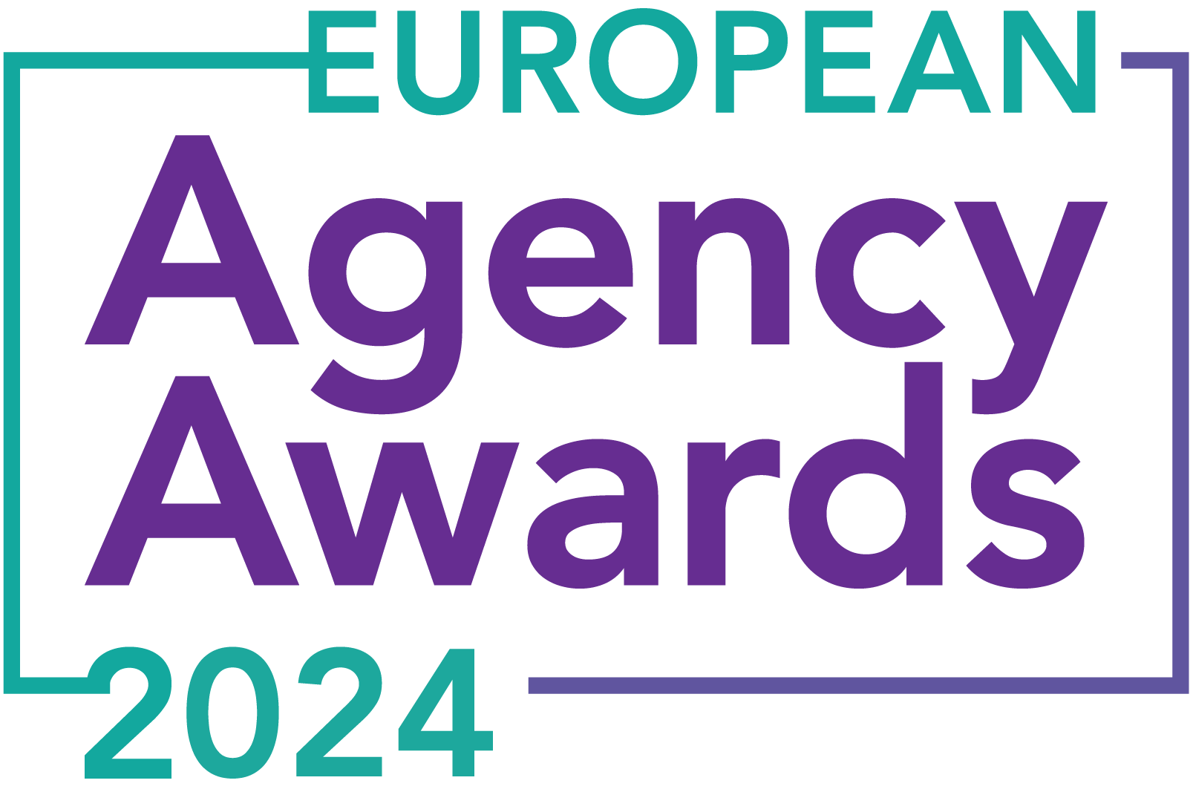

**European Agency Awards 2024 Entry Form**

**Please complete this entry form and upload it via the online entry portal** [**here**](https://europeanagencyawards.com/entry-form) **along with any supporting files.**

**Please note all documents must be under 2MB.**

* You can upload multiple entries via the online entry portal. You will need to fill out a separate entry form for each entry e.g., five entries = five individual entry forms
* If you are uploading the same entry into another category, you will need to edit your entry form appropriately to match the category criteria.
* Please make sure the correct category is checked in section B. If the correct category is not checked, your entry may be classed as void and therefore not judged.
* Entry questions are dependent on your chosen category, so please take care when filling out each entry. Please delete any sections of the entry form not required for your category.
* If your entry form does not match your online submission and category selection, your entry may be classed as a duplication error and may not be judged.
* **All entries must not exceed 1000 words.** The word count does not include the company information/summary in section A or the questions already within the form.
* All entries should relate to work carried out between **March 2023 - July 2024**
* Please follow the format and order of the criteria within this form. If you do not use the entry form below or miss information from your submission you may be penalized by the judges.
* All judges are bound by our terms and conditions and are required to acknowledge these prior to logging into their judging portals. Our judging T&C’s can be found here: <https://europeanagencyawards.com/terms>
* For more information on how to enter, entry fees and the deadline date, visit <https://europeanagencyawards.com/how-to-enter>
* Payment for all entries must be made at the time of submission.
* Please read the [Terms & Conditions](https://europeanagencyawards.com/terms)before submitting your entry.

|  |  |
| --- | --- |
| **SECTION A – YOUR DETAILS** | |
| **Organisation Name** | TrunkBBI |
| **Contact Name** | Adam Britton |

By submitting this form, you agree to the terms and conditions and declare that all facts and figures contained within are accurate and true, and that permission to enter has been given by all involved parties.

|  |
| --- |
| **SECTION B – SELECT YOUR CATEGORY**  Please select your category carefully and insert an X in the second column. Entry questions are dependent on chosen category – please complete section C, D, E or F as indicated. |

|  |  |  |
| --- | --- | --- |
| **1. Best Social Media Campaign** |  | Please complete section C |
| **2. Best SEO Campaign** |  | Please complete section C |
| **3. Best PPC Campaign** |  | Please complete section C |
| **4. Best PR Campaign** |  | Please complete section C |
| **5. Best Not-for-Profit Campaign** |  | Please complete section C |
| **6. Best Marketing Campaign** |  | Please complete section C |
| **7. Best Integrated Campaign** |  | Please complete section C |
| **8. Best Event** |  | Please complete section C |
| **9. Best New Business Campaign** |  | Please complete section C |
| **10. Best Crisis Communications or Response Campaign** |  | Please complete section C |
| **11. Campaign Effectiveness Award** |  | Please complete section C |
| **12. Best Pan European Campaign** |  | Please complete section C |
| **13. Best Use of AI in Client Campaign** |  | Please complete section C |
| **14. Best AI Agency Software Solution** |  | Please complete section C |
| **15. Best Agency Culture** |  | Please complete section D |
| **16. Best Charitable/Corporate Social Response Initiative** |  | Please complete section D |
| **17. Best Culture Transformation Initiative** |  | Please complete section D |
| **18. Best Flexible Working Policy** |  | Please complete section D |
| **19. Best Inclusion and Diversity Initiative** |  | Please complete section D |
| **20. Rising Agency Star Award** |  | Please complete section E |
| **21. Best New Agency** |  | Please complete section E |
| **22. Digital Agency of the Year** |  | Please complete section E |
| **23. Media Buying Agency of the Year** |  | Please complete section E |
| **24. B2B Agency of the Year** |  | Please complete section E |
| **25. B2C Agency of the Year** |  | Please complete section E |
| **26. eCommerce Agency of the Year** |  | Please complete section E |
| **27. SEO Agency of the Year** |  | Please complete section E |
| **28. PPC Agency of the Year** |  | Please complete section E |
| **29. Integrated Search Agency of the Year** |  | Please complete section E |
| **30. Social Media Agency of the Year** |  | Please complete section E |
| **31. Marketing Agency of the Year** |  | Please complete section E |
| **32. Creative/Design Agency of the Year** |  | Please complete section E |
| **33. Advertising Agency of the Year** |  | Please complete section E |
| **34. CRO Agency of the Year** |  | Please complete section E |
| **35. UX Agency of the Year** |  | Please complete section E |
| **36. Independent Agency of the Year** |  | Please complete section E |
| **37. PR Agency of the Year** |  | Please complete section E |
| **38. Innovative Agency of the Year** |  | Please complete section E |
| **39. Integrated Agency of the Year** | x | Please complete section E |
| **40. Best Small Agency of the Year** |  | Please complete section E |
| **41. Best Large Agency of the Year** |  | Please complete section E |

|  |
| --- |
| **SECTION C – CAMPAIGN AWARDS**  Please complete the following sections providing details of the campaign that you are entering. Please note entries must not exceed a total word count of 1000 words.  All information provided will remain confidential to the judges before and after the event and will not be shared with anyone outside of the judging panel allocated to review your entry. |
| **Entrant Name(s), Client Name & Campaign Title**  How you wish for the campaign to be credited including your organisation name, any partners / clients you want to credit & the title of your campaign.  Please structure your title in the following format:  ***"Entrant Name & Client Name - Campaign Name"***  Please keep this concise as it will appear on the website if you are shortlisted. |
|  |
| **Objective(s) & budget (1-10 points)**  Tell us what you were looking to achieve from the campaign and any targets that were set. We recommend showing targets as quantifiable metrics e.g., ‘Increase conversions from 150 to 300 a month’ rather than ‘Increase conversions by 10%’.  Please include a breakdown of implementation costs, staffing costs, agency fees etc. All elements of the entry form are confidential, and judges will not share this information. If you are unable to provide a detailed budget breakdown, please include the financial band your budget is within along with the percentage budget allocated for staffing costs, agency fees and media spend etc. |
|  |
| **Target audience & strategy (1-10 points)**  Please provide us with details around the audience you were targeting and your overall strategy to reach them as well as the strategy to meet the overall objectives. |
|  |
| **Implementation & creativity (1-10 points)**  Please give us a detailed explanation of your implementation for the campaign. Include screenshots to help us visualize campaigns. Provide information on the creativity of the campaign. |
|  |
| **Details of any challenges faced and how these were overcome (1-10 points)**  What challenges were unique to you and how have you overcome them. What was the end result of overcoming these challenges? |
|  |
| **Results & evaluation (1-10 points)**  Please relate these to the objectives and targets stated above. Provide actual numbers rather than percentages wherever possible. |
|  |
| **Why should your campaign win? (1-10 points)**  What do you think sets your campaign apart from the other campaigns being judged? Judges will in particular be looking for the thing that makes this campaign different to the others, what is unique? |
|  |
| **URLs** |
|  |
| **Please detail any supporting documents you are including as part of your submission**  Optional – please upload to online entry portal when submitting this entry form |
|  |

|  |
| --- |
| **SECTION D – CULTURE & CONTINUITY AWARDS**  Please complete the following sections providing details of the culture of the agency. Detail investment in training, support, and development of the agency’s team and how this has helped to win new business and grow existing accounts. Please note entries must not exceed a total word count of 1000 words in this section.  All information provided will remain confidential to the judges before and after the event and will not be shared with anyone outside of the judging panel allocated to review your entry. |
| **Name of Team / Agency**  Please keep this concise as it will appear on the website if you are shortlisted. |
|  |
| **Team / Agency Overview**  Give details of number of employees, structure etc. Judges will be looking for clarity and context to help understand more about your agency or team. |
|  |
| **Details of company culture initiatives & budget allocated (1-10 points)**  e.g., flexible working, holiday schemes, training and development, incentive schemes, rewards packages, CSR and volunteering initiatives |
|  |
| **Evidence positive impact / results of any initiatives (1-10 points)**  e.g., increased productivity, staff retention, staff promotion and development |
|  |
| **Why you think you should win (1-10 points)**  What do you think sets your culture apart from other agencies/teams being judges? Judges will be looking for the thing that makes your culture different to the others, what is unique? |
|  |
| **URLs** |
|  |
| **Please detail any supporting documents you are including as part of your submission**  Optional – please upload to online entry portal when submitting this entry form |
|  |

|  |
| --- |
| **SECTION E – AGENCY / TEAM / RISING AGENCY STAR AWARDS**  Please complete the following sections providing details of the agency / team / individual that you are entering. Please note entries can be self-nominated or nominated by a third party and must not exceed a total word count of 1000 words.  All information provided will remain confidential to the judges before and after the event and will not be shared with anyone outside of the judging panel allocated to review your entry. |
| **Name of Nominee - Agency / Team / Rising Agency Star**  Please keep this concise as it will appear on the website if you are shortlisted. |
| TrunkBBI |
| **Date of Birth** (Rising Agency Star nominees only)  ***Please note that nominee must be under 30 on October 19, 2023*** |
|  |
| **Contact email address of nominee** (Rising Agency Star nominees only) |
|  |
| **Contact phone number of nominee** (Rising Agency Star nominees only) |
|  |
| **Overview of the Agency / Team / Rising Agency Star nominee**  Please include numbers, staff turnover, roles etc for agency and team nominations or current and previous job roles etc for Rising Star nominations |
| TrunkBBI is *the* creative and performance agency; A fully integrated marketing agency based in Manchester and Leeds, housing over 70 creative, performance, and strategy experts.  We deliver everything in-house under one roof, from digital PR and technical SEO to UX, gamification, film and animation. Our current voluntary staff turnover is 8%. |
| **Agency / Team / Rising Agency Star objectives (1-10 points)**  Tell us what you were looking to achieve and any targets that have been set within the agency or team to help achieve your goals. We recommend showing targets as quantifiable metrics e.g., ‘Increase conversions from 150 to 300 a month’ rather than ‘Increase conversions by 10%’. |
| In July 2023, we presented our 3-year and 1-year business plans to the whole agency to ensure accountability and team alignment with our vision and mission.  This FY, we focused on stability and refining our ways of working. While past years have seen ambitious revenue targets, this year was about quality and stability for our team and clients.  Our agency north star is: To be globally recognised and respected for our work and culture.  To achieve this, our 23/24 manifesto includes:  **Culture & People**   * Achieve ‘great place to work’ accolade * Retain IPA Gold accreditation * Land B-corp certification * Increase employee engagement score from 70% * Launch a ‘Leadership Programme’ * Ensure company values are lived by all staff * Maintain <10% voluntary staff turnover   **Commercial & Operational**   * Drive Operational Excellence initiatives to increase margin to 19% * Double retained revenue from £125k to £250k per month * Land >3 integrated clients using strategy, creative, and performance services * Departments to implement business plans with commercial goals * Increase average blended rate to £115 per hour * Achieve staff engagement NPS score >80% * Maintain <15% hard client churn |
| **Recent work example(s**) **(1-10 points)**  Please include details of recent client or campaign work. How does your recent work display creativity and make your team or agency stand out amongst others? |
| At TrunkBBI, our award-winning campaigns showcase the seamless integration of all nine of our delivery teams. Here are some standout examples that triumphed at the European Content Awards.  Our Stockport County FC campaign achieved a 10500% ROI and sold out the kit in 20 minutes. This success was driven by our creative team’s compelling video content, our strategy team’s targeted plan, and our performance team’s digital marketing efforts.  The Jack Daniel's and McLaren gamification campaign tested players’ reaction times against an animated F1 driver. Our creative team designed the game, tech team coded it, the strategy team identified key engagement tactics, and the performance team optimised digital channels to captivate audiences.  For StayWise, we developed interactive fire safety education resources for children. Our creative team crafted engaging content, again working with our tech team to code it, the strategy team ensured educational effectiveness, and the performance team maximised accessibility and impact.  Our internal campaign for Places for People improved employee engagement. The creative team produced dynamic content, the strategy team planned engagement tactics, and the performance team implemented these strategies to foster community bonds.  The Greene King IPA campaign captured the excitement of rugby supporters. Our creative team crafted visuals, the strategy team tailored messaging, and the performance team executed targeted social media strategies to resonate with fans.  These examples demonstrate our ability to create impactful campaigns through the integrated efforts of our creative, strategy, and performance teams. Our seamless blending of these elements sets us apart in the industry. |
| **Details of any recent achievements (1-10 points)**  What makes your team or agency stand out? Please include details of any achievements you feel make your agency, team or rising star award worthy. What are you proud of? |
| Our recent accomplishments showcase our commitment to excellence in culture, people, and operations. Here’s what makes us stand out:  **Culture & People**   * Ranked 20th on Campaign’s Best Places to Work list in our first year. * Retained IPA Gold accreditation. * Achieved BCORP certification with a score of 82 points. * Increased employee engagement score from 70% to 76%. * Launched a ‘Leadership Programme’ with 85% enrolment among line managers. * Company values are embraced by all staff. * Maintained a low voluntary staff turnover rate of 8%. * Promoted 30% of our staff in the last 12 months. * Celebrated multiple wins at the European Content Awards.   **Commercial & Operational**   * Increased margin to 19% through Operational Excellence initiatives. * Boosted retained revenue by 112%, from £125k to £265k per month. * Acquired seven new integrated clients utilizing our strategy, creative, and performance services. * Raised the average blended rate to £125 per hour, £10 above target. * Achieved a staff engagement NPS score of 88%. * Maintained a client churn rate of 14%.   These achievements highlight our dedication to creating a positive work environment, fostering professional growth, and delivering exceptional results for our clients. |
| **Details of any challenges faced and how these were overcome (1-10 points)**  What challenges were unique to you and how have you overcome them. What was the end result of overcoming these challenges? |
| As an independent agency, maintaining workforce stability during recent economic challenges was tough. With client budgets cut and a cost-of-living crisis affecting our staff, we needed to act without compromising our culture or reputation.  Creating an integrated environment for our 72 staff across 9 departments in two offices hasn’t been easy. We’ve fostered collaboration through several initiatives.  Our Board+ team, composed of eight senior leaders, reports directly to the board. They meet every Monday for 30 minutes to discuss updates and challenges. Additionally, the team holds quarterly off-site sessions to present and discuss department business plans and progress, focusing on sharing challenges and collaborating across departments and channels.  Weekly round-ups also play a key role in our integration efforts, with the Board+ team sharing great work, client feedback, team promotions, and other good news, keeping everyone connected.  Embracing our value of “the truth kindly told,” we had open discussions with our staff about the economic situation. We reduced £45k from our P&L overheads without cutting staff costs. A switch to salary-sacrifice pension arrangements boosted take-home pay, and a financial wellbeing platform offered support on debt management, mortgages, savings, and pensions.  Since January 2024, we’ve been able to provide overdue and backdated pay rises, reaffirming our commitment to our team. Despite the challenges, we navigated this period successfully, retaining all our talented people and staying true to our core values of being a people-before-profit business. |
| **Why should your Agency / Team / Rising Agency Star win? (1-10 points)**  Please detail what you feel makes you stand out amongst others and why you feel your entry is award winning. What makes you unique? What gives you the competitive edge? |
| We relentlessly strive to improve, creating a better environment for our people, clients, and the planet.  The past couple of years have been tough for agencies, but we've not only weathered the storm but also charged straight into it with a loyal and committed team. This speaks volumes about our business and work environment.  We've committed to developing our people, a fact we highlight in client pitches. We re-positioned the agency last year, updating our values to reflect this.  “Constantly curious” is now one of our six core values, embodying who we are and our dedication to ongoing learning.  Ambition drives us forward. Never satisfied with ready-made solutions, we explore new opportunities and embrace fresh technologies. Our best idea is our next idea. This isn't just how we work; it's who we are.  We’re not comfortable standing still. Our team tends to stay with us for a long time because of our dynamic environment.  Our belief in nurturing growth and fostering an inclusive, innovative, socially conscious environment where everyone feels empowered truly makes us stand out. This is why we believe we make a compelling case to win this award. |
| **URLs** |
| **www.trunkbbi.com** |
| **Please detail any supporting documents you are including as part of your submission**  Optional – please upload to online entry portal when submitting this entry form |
|  |