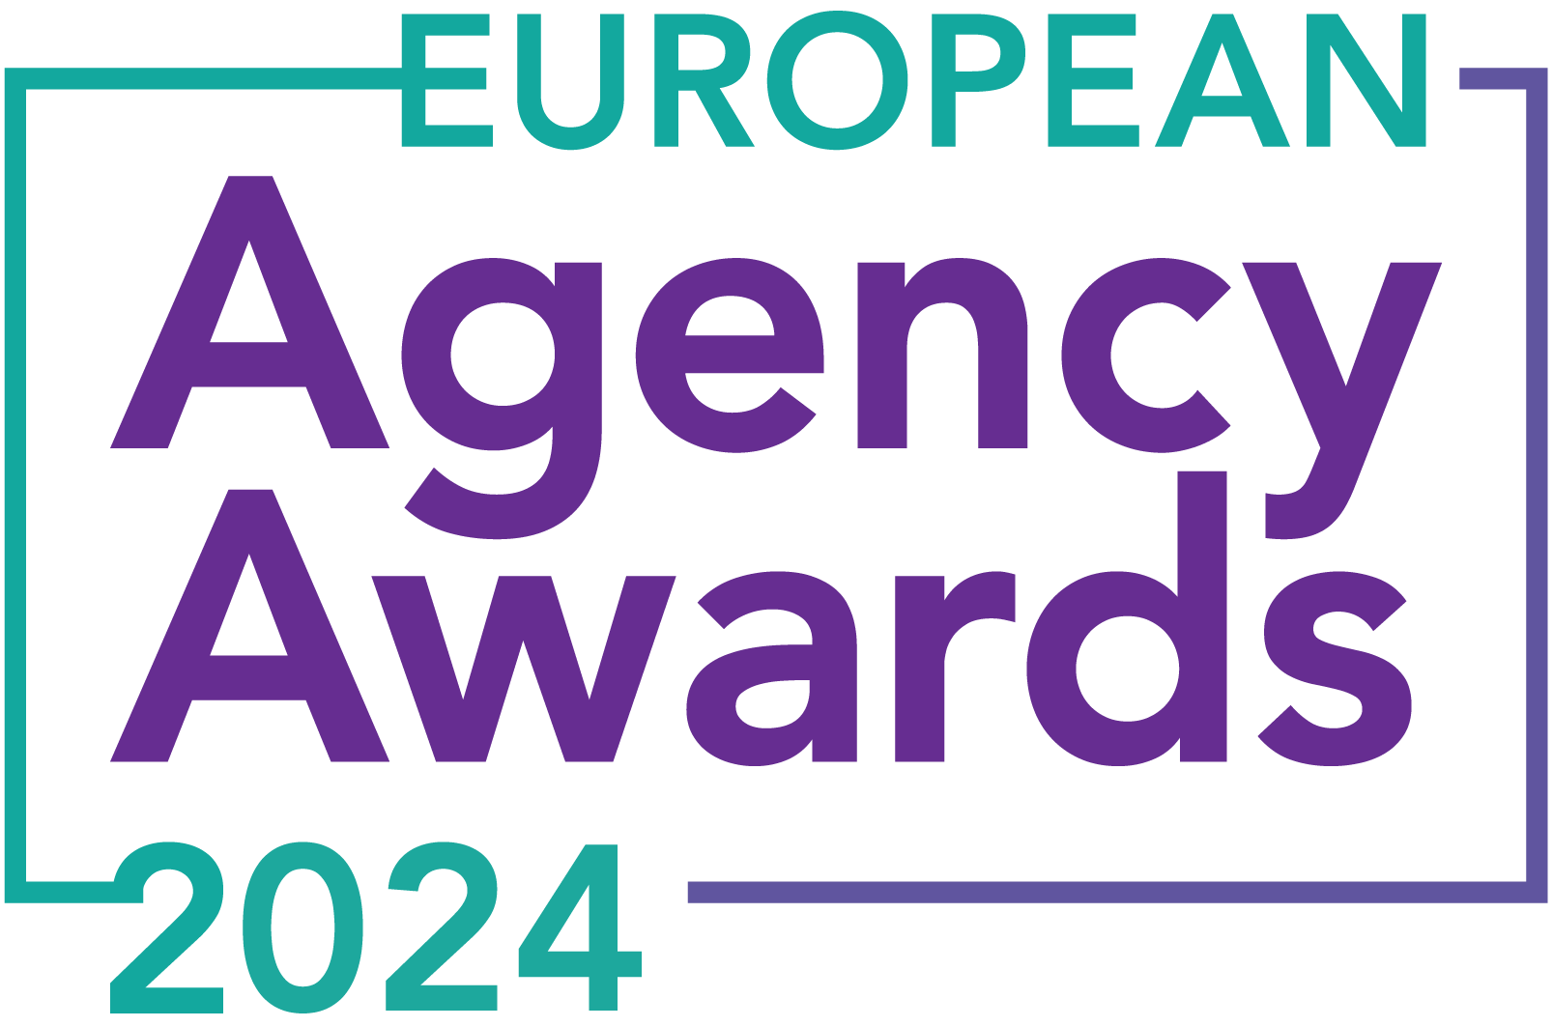

**European Agency Awards 2024 Entry Form**

**Please complete this entry form and upload it via the online entry portal** [**here**](https://europeanagencyawards.com/entry-form) **along with any supporting files.**

**Please note all documents must be under 2MB.**

* You can upload multiple entries via the online entry portal. You will need to fill out a separate entry form for each entry e.g., five entries = five individual entry forms
* If you are uploading the same entry into another category, you will need to edit your entry form appropriately to match the category criteria.
* Please make sure the correct category is checked in section B. If the correct category is not checked, your entry may be classed as void and therefore not judged.
* Entry questions are dependent on your chosen category, so please take care when filling out each entry. Please delete any sections of the entry form not required for your category.
* If your entry form does not match your online submission and category selection, your entry may be classed as a duplication error and may not be judged.
* **All entries must not exceed 1000 words.** The word count does not include the company information/summary in section A or the questions already within the form.
* All entries should relate to work carried out between **March 2023 - July 2024**
* Please follow the format and order of the criteria within this form. If you do not use the entry form below or miss information from your submission you may be penalized by the judges.
* All judges are bound by our terms and conditions and are required to acknowledge these prior to logging into their judging portals. Our judging T&C’s can be found here: <https://europeanagencyawards.com/terms>
* For more information on how to enter, entry fees and the deadline date, visit <https://europeanagencyawards.com/how-to-enter>
* Payment for all entries must be made at the time of submission.
* Please read the [Terms & Conditions](https://europeanagencyawards.com/terms)before submitting your entry.

|  |  |
| --- | --- |
| **SECTION A – YOUR DETAILS** | |
| **Organisation Name** | TrunkBBI |
| **Contact Name** | Adam Britton |

By submitting this form, you agree to the terms and conditions and declare that all facts and figures contained within are accurate and true, and that permission to enter has been given by all involved parties.

|  |
| --- |
| **SECTION B – SELECT YOUR CATEGORY**  Please select your category carefully and insert an X in the second column. Entry questions are dependent on chosen category – please complete section C, D, E or F as indicated. |

|  |  |  |
| --- | --- | --- |
| **1. Best Social Media Campaign** |  | Please complete section C |
| **2. Best SEO Campaign** |  | Please complete section C |
| **3. Best PPC Campaign** |  | Please complete section C |
| **4. Best PR Campaign** |  | Please complete section C |
| **5. Best Not-for-Profit Campaign** |  | Please complete section C |
| **6. Best Marketing Campaign** | x | Please complete section C |
| **7. Best Integrated Campaign** |  | Please complete section C |
| **8. Best Event** |  | Please complete section C |
| **9. Best New Business Campaign** |  | Please complete section C |
| **10. Best Crisis Communications or Response Campaign** |  | Please complete section C |
| **11. Campaign Effectiveness Award** |  | Please complete section C |
| **12. Best Pan European Campaign** |  | Please complete section C |
| **13. Best Use of AI in Client Campaign** |  | Please complete section C |
| **14. Best AI Agency Software Solution** |  | Please complete section C |
| **15. Best Agency Culture** |  | Please complete section D |
| **16. Best Charitable/Corporate Social Response Initiative** |  | Please complete section D |
| **17. Best Culture Transformation Initiative** |  | Please complete section D |
| **18. Best Flexible Working Policy** |  | Please complete section D |
| **19. Best Inclusion and Diversity Initiative** |  | Please complete section D |
| **20. Rising Agency Star Award** |  | Please complete section E |
| **21. Best New Agency** |  | Please complete section E |
| **22. Digital Agency of the Year** |  | Please complete section E |
| **23. Media Buying Agency of the Year** |  | Please complete section E |
| **24. B2B Agency of the Year** |  | Please complete section E |
| **25. B2C Agency of the Year** |  | Please complete section E |
| **26. eCommerce Agency of the Year** |  | Please complete section E |
| **27. SEO Agency of the Year** |  | Please complete section E |
| **28. PPC Agency of the Year** |  | Please complete section E |
| **29. Integrated Search Agency of the Year** |  | Please complete section E |
| **30. Social Media Agency of the Year** |  | Please complete section E |
| **31. Marketing Agency of the Year** |  | Please complete section E |
| **32. Creative/Design Agency of the Year** |  | Please complete section E |
| **33. Advertising Agency of the Year** |  | Please complete section E |
| **34. CRO Agency of the Year** |  | Please complete section E |
| **35. UX Agency of the Year** |  | Please complete section E |
| **36. Independent Agency of the Year** |  | Please complete section E |
| **37. PR Agency of the Year** |  | Please complete section E |
| **38. Innovative Agency of the Year** |  | Please complete section E |
| **39. Integrated Agency of the Year** |  | Please complete section E |
| **40. Best Small Agency of the Year** |  | Please complete section E |
| **41. Best Large Agency of the Year** |  | Please complete section E |

|  |
| --- |
| **SECTION C – CAMPAIGN AWARDS**  Please complete the following sections providing details of the campaign that you are entering. Please note entries must not exceed a total word count of 1000 words.  All information provided will remain confidential to the judges before and after the event and will not be shared with anyone outside of the judging panel allocated to review your entry. |
| **Entrant Name(s), Client Name & Campaign Title**  How you wish for the campaign to be credited including your organisation name, any partners / clients you want to credit & the title of your campaign.  Please structure your title in the following format:  ***"Entrant Name & Client Name - Campaign Name"***  Please keep this concise as it will appear on the website if you are shortlisted. |
| TrunkBBI & Greene King IPA – That’s Refreshing |
| **Objective(s) & budget (1-10 points)**  Tell us what you were looking to achieve from the campaign and any targets that were set. We recommend showing targets as quantifiable metrics e.g., ‘Increase conversions from 150 to 300 a month’ rather than ‘Increase conversions by 10%’.  Please include a breakdown of implementation costs, staffing costs, agency fees etc. All elements of the entry form are confidential, and judges will not share this information. If you are unable to provide a detailed budget breakdown, please include the financial band your budget is within along with the percentage budget allocated for staffing costs, agency fees and media spend etc. |
| Greene King IPA, a heritage brand with strong Rugby Union associations, approached us with a clear challenge: boost off-trade sales during the 7-week Rugby World Cup 2023 period. Historically, their average sales in a typical 7-week duration stood at £1.34 million, but during the Rugby World Cup 2019, there was no uplift due to the lack of a dedicated campaign. For the Rugby World Cup 2023, our goal was to elevate off-trade sales to £1.75 million while deeply connecting the brand with grassroots sports through the "Proud To Pitch In" initiative.  The "Proud To Pitch In" initiative is integral to Greene King IPA's commitment to supporting grassroots sports. For every 4-pack sold, the brand donates 50p to grassroots sports, aiding community-level sports development.  **Budget Breakdown:**   * Agency Fees (Ideation & Production): £40,000 * Third-Party Costs (Talent, Location, Costume, etc.): £10,000   Media costs not included in above, only production & execution of campaign.  Our mission was to craft an integrated campaign that not only linked Greene King IPA with the Rugby World Cup, despite not having official sponsorship rights, but also drove significant growth in off-trade sales while promoting grassroots sports through the "Proud To Pitch In" initiative. |
| **Target audience & strategy (1-10 points)**  Please provide us with details around the audience you were targeting and your overall strategy to reach them as well as the strategy to meet the overall objectives. |
| **Target Audience & Strategy**  Our campaign engaged two distinct yet interconnected audiences: ale drinkers who are grassroots rugby enthusiasts and/or international rugby followers.  **The Study:** Our research and study of these audiences showed that their grassroots game on a weekend is their world cup final. It’s something they take huge pride in and it’s sometimes something a whole year has built up to. But they also don’t mind taking the mick out of themselves and having a laugh at how seriously they do sometimes take it. We really wanted to play on both things.  **Resonating Across Audiences:** Our approach bridged the gap between grassroots passion and international professionalism, celebrating dedication while inviting appreciation for grassroots spirit. This innovative and emotionally resonant approach connected both audiences deeply. |
| **Implementation & creativity (1-10 points)**  Please give us a detailed explanation of your implementation for the campaign. Include screenshots to help us visualize campaigns. Provide information on the creativity of the campaign. |
| We rolled out a comprehensive integrated campaign, encompassing out-of-home (OOH) advertising, digital display, film & animation (across SkyAdmart, VOD, social & YoutTube), and grassroots engagement.  **Creative Approach:** We created three distinct scenarios, each blending grassroots rugby with elite professionalism. These scenarios started with high production value, mimicking elite rugby preparations, only to reveal their true grassroots nature halfway through – a creative twist that resonated strongly with our audience.   * **Scenario One:** A manager meticulously crafting tactics. * **Scenario Two:** A rousing team talk reminiscent of Martin Johnson. * **Scenario Three:** A fly-half taking conversions as seriously as Owen Farrell.   Our OOH campaign featured billboards and posters strategically placed around key purchase locations that were supporting the PTPI initiative, ensuring maximum visibility.  We targeted consumers online through Sky AdSmart, YouTube pre-rolls and social with film content that had huge engagement, taking insight from a study our strategy team had delivered that rugby fans are likely to dual screen during ad breaks we wanted to hit them on both their TV as well as the device in their hand. So it was important that the creative felt part of the same story but felt at home on each platform. Additionally, we partnered with thousands of grassroots clubs, encouraging them to champion Greene King IPA during the Rugby World Cup, thus embedding the brand within the heart of the rugby community.  This meant our audience was seeing the campaign outside their favourite supermarkets, between their favourite TV shows, before their favourite online content and on their sport news websites through display. |
| **Details of any challenges faced and how these were overcome (1-10 points)**  What challenges were unique to you and how have you overcome them. What was the end result of overcoming these challenges? |
| Our main challenge was to align Greene King IPA with the Rugby World Cup without official sponsorship rights. We overcame this by creating a campaign that initially presented itself as part of the World Cup, only to reveal its grassroots focus midway through. This "rug-pull" moment not only circumvented the sponsorship limitations but also became a powerful storytelling element, engaging both elite and grassroots rugby audiences deeply.  This meant we were able to turn a challenge into a solution, a solution that had huge impacts on the overall success of the campaign. |
| **Results & evaluation (1-10 points)**  Please relate these to the objectives and targets stated above. Provide actual numbers rather than percentages wherever possible. |
| Greene King IPA declared this campaign as their best-performing integrated marketing campaign to date. Beyond the exceptional sales figures, which exceeded the initial target and surpassed £2 million over the 7-week Rugby World Cup period, the campaign also achieved remarkable engagement metrics. Watch times and post engagement far exceeded previous campaigns, indicating the audience's strong connection with the content.  Furthermore, the campaign's success extended beyond the brand's bottom line. The "Proud to Pitch In" initiative, where 50p of each 4-pack sold was donated to grassroots sports, raised approximately £200,000 to support local sporting communities. This not only resonated with the target audience but also showcased Greene King IPA's commitment to fostering grassroots sports.  In essence, the campaign's outstanding results, both in terms of sales and community impact, underscore its effectiveness and ability to connect with consumers at various levels, solidifying its position as a standout marketing success story. The results were so strong on the campaign, Greene King have now moved 2 new beer lines into TrunkBBI’s hands to activate throughout 2024. |
| **Why should your campaign win? (1-10 points)**  What do you think sets your campaign apart from the other campaigns being judged? Judges will in particular be looking for the thing that makes this campaign different to the others, what is unique? |
| Our campaign’s brilliance lay in its creative "rug-pull" twist, blending elite rugby professionalism with grassroots authenticity through high-quality film and animation content on Sky AdSmart, YouTube, VOD, and social media.  We ensured maximum visibility with out-of-home advertising at key purchase locations and cohesive digital display ads across platforms. Partnering with grassroots clubs further embedded Greene King IPA within the rugby community, amplifying the campaign’s reach.  The campaign’s success is evident: significant sales growth, exceptional engagement metrics, and a substantial contribution to grassroots sports through the "Proud to Pitch In" initiative. By combining creative storytelling, strategic media placement, and community engagement, we delivered a cohesive, impactful campaign that exceeded objectives.  This holistic approach, executed entirely in-house, showcases our expertise and dedication, making us a deserving candidate for the Best Marketing Campaign of the Year (large) award. |
| **URLs** |
| **Video URLs PTPI Tactician-** [**https://vimeo.com/884800586/dfdd2a1d3f?share=copy**](https://vimeo.com/884800586/dfdd2a1d3f?share=copy)  **PTPI - Team** [**https://vimeo.com/884800710/c6f68b578d?share=copy**](https://vimeo.com/884800710/c6f68b578d?share=copy)  **PTPI - Fly Half** [**https://vimeo.com/884800456/3fc7840a1a?share=copy**](https://vimeo.com/884800456/3fc7840a1a?share=copy) |
| **Please detail any supporting documents you are including as part of your submission**  Optional – please upload to online entry portal when submitting this entry form |
| Screengrabs from the campaign |

|  |
| --- |
| **SECTION D – CULTURE & CONTINUITY AWARDS**  Please complete the following sections providing details of the culture of the agency. Detail investment in training, support, and development of the agency’s team and how this has helped to win new business and grow existing accounts. Please note entries must not exceed a total word count of 1000 words in this section.  All information provided will remain confidential to the judges before and after the event and will not be shared with anyone outside of the judging panel allocated to review your entry. |
| **Name of Team / Agency**  Please keep this concise as it will appear on the website if you are shortlisted. |
|  |
| **Team / Agency Overview**  Give details of number of employees, structure etc. Judges will be looking for clarity and context to help understand more about your agency or team. |
|  |
| **Details of company culture initiatives & budget allocated (1-10 points)**  e.g., flexible working, holiday schemes, training and development, incentive schemes, rewards packages, CSR and volunteering initiatives |
|  |
| **Evidence positive impact / results of any initiatives (1-10 points)**  e.g., increased productivity, staff retention, staff promotion and development |
|  |
| **Why you think you should win (1-10 points)**  What do you think sets your culture apart from other agencies/teams being judges? Judges will be looking for the thing that makes your culture different to the others, what is unique? |
|  |
| **URLs** |
|  |
| **Please detail any supporting documents you are including as part of your submission**  Optional – please upload to online entry portal when submitting this entry form |
|  |

|  |
| --- |
| **SECTION E – AGENCY / TEAM / RISING AGENCY STAR AWARDS**  Please complete the following sections providing details of the agency / team / individual that you are entering. Please note entries can be self-nominated or nominated by a third party and must not exceed a total word count of 1000 words.  All information provided will remain confidential to the judges before and after the event and will not be shared with anyone outside of the judging panel allocated to review your entry. |
| **Name of Nominee - Agency / Team / Rising Agency Star**  Please keep this concise as it will appear on the website if you are shortlisted. |
|  |
| **Date of Birth** (Rising Agency Star nominees only)  ***Please note that nominee must be under 30 on October 19, 2023*** |
|  |
| **Contact email address of nominee** (Rising Agency Star nominees only) |
|  |
| **Contact phone number of nominee** (Rising Agency Star nominees only) |
|  |
| **Overview of the Agency / Team / Rising Agency Star nominee**  Please include numbers, staff turnover, roles etc for agency and team nominations or current and previous job roles etc for Rising Star nominations |
|  |
| **Agency / Team / Rising Agency Star objectives (1-10 points)**  Tell us what you were looking to achieve and any targets that have been set within the agency or team to help achieve your goals. We recommend showing targets as quantifiable metrics e.g., ‘Increase conversions from 150 to 300 a month’ rather than ‘Increase conversions by 10%’. |
|  |
| **Recent work example(s**) **(1-10 points)**  Please include details of recent client or campaign work. How does your recent work display creativity and make your team or agency stand out amongst others? |
|  |
| **Details of any recent achievements (1-10 points)**  What makes your team or agency stand out? Please include details of any achievements you feel make your agency, team or rising star award worthy. What are you proud of? |
|  |
| **Details of any challenges faced and how these were overcome (1-10 points)**  What challenges were unique to you and how have you overcome them. What was the end result of overcoming these challenges? |
|  |
| **Why should your Agency / Team / Rising Agency Star win? (1-10 points)**  Please detail what you feel makes you stand out amongst others and why you feel your entry is award winning. What makes you unique? What gives you the competitive edge? |
|  |
| **URLs** |
|  |
| **Please detail any supporting documents you are including as part of your submission**  Optional – please upload to online entry portal when submitting this entry form |
|  |