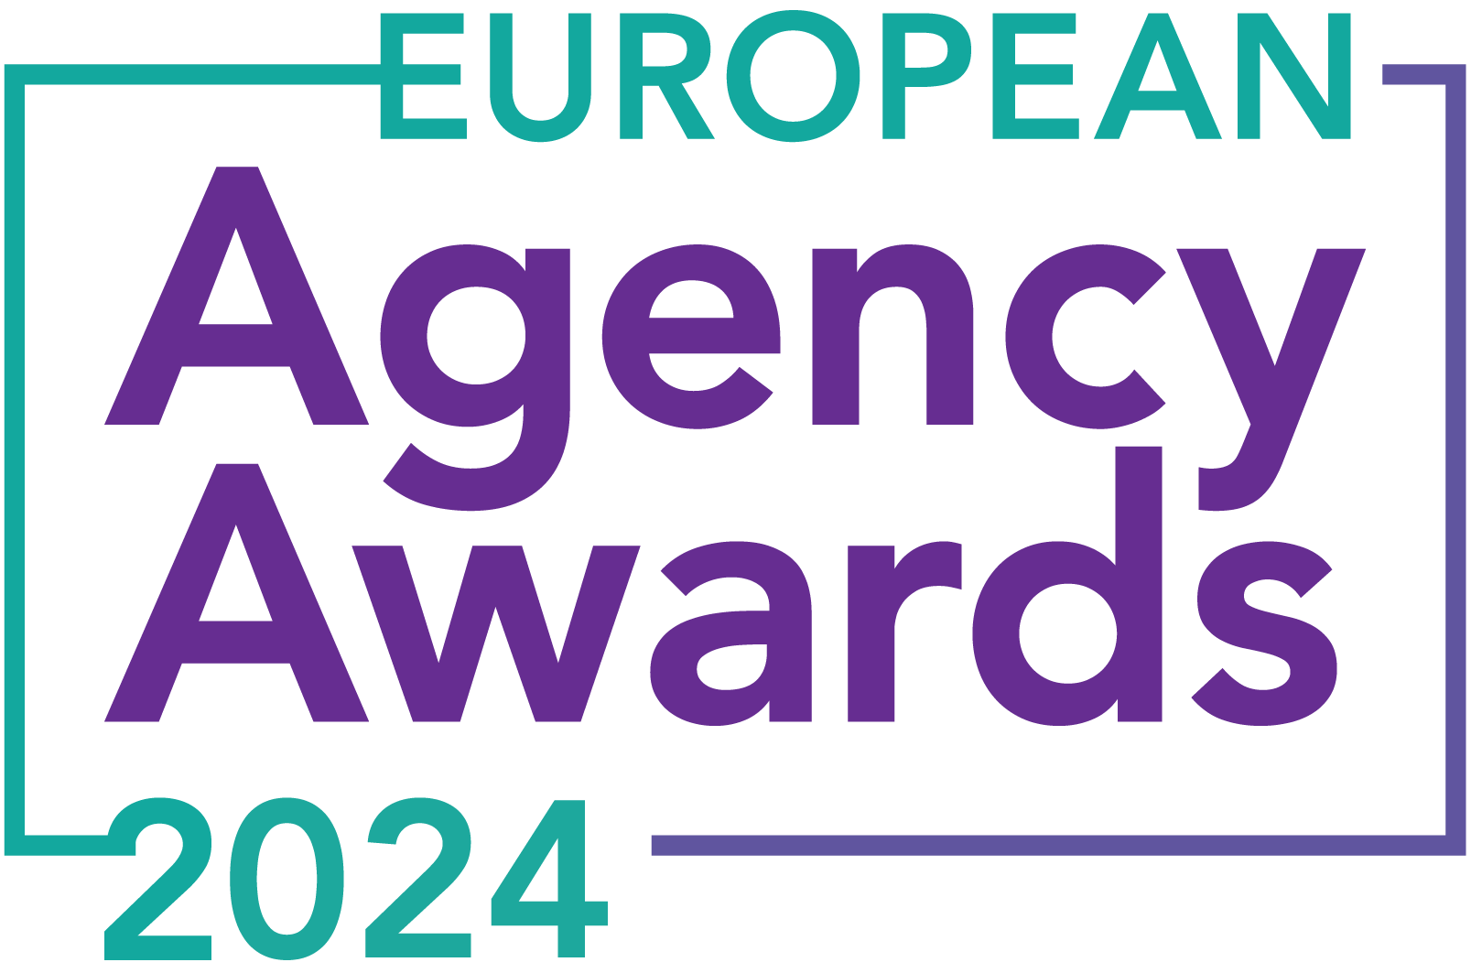

**European Agency Awards 2024 Entry Form**

**Please complete this entry form and upload it via the online entry portal** [**here**](https://europeanagencyawards.com/entry-form) **along with any supporting files.**

**Please note all documents must be under 2MB.**

* You can upload multiple entries via the online entry portal. You will need to fill out a separate entry form for each entry e.g., five entries = five individual entry forms
* If you are uploading the same entry into another category, you will need to edit your entry form appropriately to match the category criteria.
* Please make sure the correct category is checked in section B. If the correct category is not checked, your entry may be classed as void and therefore not judged.
* Entry questions are dependent on your chosen category, so please take care when filling out each entry. Please delete any sections of the entry form not required for your category.
* If your entry form does not match your online submission and category selection, your entry may be classed as a duplication error and may not be judged.
* **All entries must not exceed 1000 words.** The word count does not include the company information/summary in section A or the questions already within the form.
* All entries should relate to work carried out between **March 2023 - July 2024**
* Please follow the format and order of the criteria within this form. If you do not use the entry form below or miss information from your submission you may be penalized by the judges.
* All judges are bound by our terms and conditions and are required to acknowledge these prior to logging into their judging portals. Our judging T&C’s can be found here: <https://europeanagencyawards.com/terms>
* For more information on how to enter, entry fees and the deadline date, visit <https://europeanagencyawards.com/how-to-enter>
* Payment for all entries must be made at the time of submission.
* Please read the [Terms & Conditions](https://europeanagencyawards.com/terms)before submitting your entry.

|  |  |
| --- | --- |
| **SECTION A – YOUR DETAILS** | |
| **Organisation Name** | Rainy City Agency |
| **Contact Name** | Alex Waterworth |

By submitting this form, you agree to the terms and conditions and declare that all facts and figures contained within are accurate and true, and that permission to enter has been given by all involved parties.

|  |
| --- |
| **SECTION B – SELECT YOUR CATEGORY**  Please select your category carefully and insert an X in the second column. Entry questions are dependent on chosen category – please complete section C, D, E or F as indicated. |

|  |  |  |
| --- | --- | --- |
| **1. Best Social Media Campaign** |  | Please complete section C |
| **2. Best SEO Campaign** |  | Please complete section C |
| **3. Best PPC Campaign** |  | Please complete section C |
| **4. Best PR Campaign** |  | Please complete section C |
| **5. Best Not-for-Profit Campaign** |  | Please complete section C |
| **6. Best Marketing Campaign** |  | Please complete section C |
| **7. Best Integrated Campaign** |  | Please complete section C |
| **8. Best Event** |  | Please complete section C |
| **9. Best New Business Campaign** |  | Please complete section C |
| **10. Best Crisis Communications or Response Campaign** |  | Please complete section C |
| **11. Campaign Effectiveness Award** |  | Please complete section C |
| **12. Best Pan European Campaign** |  | Please complete section C |
| **13. Best Use of AI in Client Campaign** |  | Please complete section C |
| **14. Best AI Agency Software Solution** |  | Please complete section C |
| **15. Best Agency Culture** |  | Please complete section D |
| **16. Best Charitable/Corporate Social Response Initiative** |  | Please complete section D |
| **17. Best Culture Transformation Initiative** |  | Please complete section D |
| **18. Best Flexible Working Policy** |  | Please complete section D |
| **19. Best Inclusion and Diversity Initiative** |  | Please complete section D |
| **20. Rising Agency Star Award** |  | Please complete section E |
| **21. Best New Agency** |  | Please complete section E |
| **22. Digital Agency of the Year** |  | Please complete section E |
| **23. Media Buying Agency of the Year** |  | Please complete section E |
| **24. B2B Agency of the Year** |  | Please complete section E |
| **25. B2C Agency of the Year** |  | Please complete section E |
| **26. eCommerce Agency of the Year** |  | Please complete section E |
| **27. SEO Agency of the Year** |  | Please complete section E |
| **28. PPC Agency of the Year** |  | Please complete section E |
| **29. Integrated Search Agency of the Year** |  | Please complete section E |
| **30. Social Media Agency of the Year** |  | Please complete section E |
| **31. Marketing Agency of the Year** |  | Please complete section E |
| **32. Creative/Design Agency of the Year** |  | Please complete section E |
| **33. Advertising Agency of the Year** |  | Please complete section E |
| **34. CRO Agency of the Year** |  | Please complete section E |
| **35. UX Agency of the Year** | X | Please complete section E |
| **36. Independent Agency of the Year** |  | Please complete section E |
| **37. PR Agency of the Year** |  | Please complete section E |
| **38. Innovative Agency of the Year** |  | Please complete section E |
| **39. Integrated Agency of the Year** |  | Please complete section E |
| **40. Best Small Agency of the Year** |  | Please complete section E |
| **41. Best Large Agency of the Year** |  | Please complete section E |

|  |
| --- |
| **SECTION C – CAMPAIGN AWARDS**  Please complete the following sections providing details of the campaign that you are entering. Please note entries must not exceed a total word count of 1000 words.  All information provided will remain confidential to the judges before and after the event and will not be shared with anyone outside of the judging panel allocated to review your entry. |
| **Entrant Name(s), Client Name & Campaign Title**  How you wish for the campaign to be credited including your organisation name, any partners / clients you want to credit & the title of your campaign.  Please structure your title in the following format:  ***"Entrant Name & Client Name - Campaign Name"***  Please keep this concise as it will appear on the website if you are shortlisted. |
|  |
| **Objective(s) & budget (1-10 points)**  Tell us what you were looking to achieve from the campaign and any targets that were set. We recommend showing targets as quantifiable metrics e.g., ‘Increase conversions from 150 to 300 a month’ rather than ‘Increase conversions by 10%’.  Please include a breakdown of implementation costs, staffing costs, agency fees etc. All elements of the entry form are confidential, and judges will not share this information. If you are unable to provide a detailed budget breakdown, please include the financial band your budget is within along with the percentage budget allocated for staffing costs, agency fees and media spend etc. |
|  |
| **Target audience & strategy (1-10 points)**  Please provide us with details around the audience you were targeting and your overall strategy to reach them as well as the strategy to meet the overall objectives. |
|  |
| **Implementation & creativity (1-10 points)**  Please give us a detailed explanation of your implementation for the campaign. Include screenshots to help us visualize campaigns. Provide information on the creativity of the campaign. |
|  |
| **Details of any challenges faced and how these were overcome (1-10 points)**  What challenges were unique to you and how have you overcome them. What was the end result of overcoming these challenges? |
|  |
| **Results & evaluation (1-10 points)**  Please relate these to the objectives and targets stated above. Provide actual numbers rather than percentages wherever possible. |
|  |
| **Why should your campaign win? (1-10 points)**  What do you think sets your campaign apart from the other campaigns being judged? Judges will in particular be looking for the thing that makes this campaign different to the others, what is unique? |
|  |
| **URLs** |
|  |
| **Please detail any supporting documents you are including as part of your submission**  Optional – please upload to online entry portal when submitting this entry form |
|  |

|  |
| --- |
| **SECTION D – CULTURE & CONTINUITY AWARDS**  Please complete the following sections providing details of the culture of the agency. Detail investment in training, support, and development of the agency’s team and how this has helped to win new business and grow existing accounts. Please note entries must not exceed a total word count of 1000 words in this section.  All information provided will remain confidential to the judges before and after the event and will not be shared with anyone outside of the judging panel allocated to review your entry. |
| **Name of Team / Agency**  Please keep this concise as it will appear on the website if you are shortlisted. |
|  |
| **Team / Agency Overview**  Give details of number of employees, structure etc. Judges will be looking for clarity and context to help understand more about your agency or team. |
|  |
| **Details of company culture initiatives & budget allocated (1-10 points)**  e.g., flexible working, holiday schemes, training and development, incentive schemes, rewards packages, CSR and volunteering initiatives |
|  |
| **Evidence positive impact / results of any initiatives (1-10 points)**  e.g., increased productivity, staff retention, staff promotion and development |
|  |
| **Why you think you should win (1-10 points)**  What do you think sets your culture apart from other agencies/teams being judges? Judges will be looking for the thing that makes your culture different to the others, what is unique? |
|  |
| **URLs** |
|  |
| **Please detail any supporting documents you are including as part of your submission**  Optional – please upload to online entry portal when submitting this entry form |
|  |

|  |
| --- |
| **SECTION E – AGENCY / TEAM / RISING AGENCY STAR AWARDS**  Please complete the following sections providing details of the agency / team / individual that you are entering. Please note entries can be self-nominated or nominated by a third party and must not exceed a total word count of 1000 words.  All information provided will remain confidential to the judges before and after the event and will not be shared with anyone outside of the judging panel allocated to review your entry. |
| **Name of Nominee - Agency / Team / Rising Agency Star**  Please keep this concise as it will appear on the website if you are shortlisted. |
| Rainy City Agency |
| **Date of Birth** (Rising Agency Star nominees only)  ***Please note that nominee must be under 30 on October 19, 2023*** |
| N/A |
| **Contact email address of nominee** (Rising Agency Star nominees only) |
| N/A |
| **Contact phone number of nominee** (Rising Agency Star nominees only) |
| N/A |
| **Overview of the Agency / Team / Rising Agency Star nominee**  Please include numbers, staff turnover, roles etc for agency and team nominations or current and previous job roles etc for Rising Star nominations |
| Rainy City Agency, founded in 2017 by CEO Rebecca Worsley, is a leading e-commerce specialist, challenging industry norms and redefining digital success. Our Manchester-based team of 26 includes certified Shopify experts and UX specialists who consistently push the boundaries of e-commerce innovation.  In the past year alone, we've achieved a remarkable £1M turnover milestone, largely driven by our expanding US client base. This growth reflects our global impact, having served over 500 brands across the UK and internationally, generating revenues exceeding $10M for our clients. Our client partnerships, averaging over three years, further underscores the trust and value we consistently deliver.  Innovation is also at the heart of our approach. We've developed proprietary AI-driven tools, such as the Shopify Content Scheduling Module, which significantly enhances our clients' operational efficiency. This commitment to cutting-edge solutions sets us apart in a competitive landscape.  Looking ahead, we're not just adapting to the future of e-commerce – we're actively trying to reshape it. Our mission goes beyond profit margins, we're dedicated to empowering brands to thrive in the digital marketplace. By creating seamless, high-converting online experiences, we drive meaningful results and foster sustainable growth for our clients. |
| **Agency / Team / Rising Agency Star objectives (1-10 points)**  Tell us what you were looking to achieve and any targets that have been set within the agency or team to help achieve your goals. We recommend showing targets as quantifiable metrics e.g., ‘Increase conversions from 150 to 300 a month’ rather than ‘Increase conversions by 10%’. |
| **Our SMART objectives include:**   1. Market Expansion and Client Acquisition:  * Increase our outreach to US brands from 120 to 150 qualified leads per day, aiming for a 20% close rate by January 2025. * Expand our US presence by hiring 5 additional US-based sales representatives and establishing a physical office by Q4 2025.  1. Financial Growth:  * Double our revenue from £1.2 million to £2.4 million in the upcoming year through innovative eCommerce strategies and expanded service offerings.  1. Operational Excellence:  * Achieve a 95% client retention rate by enhancing our customer success program and delivering measurable results.  1. Team Development and Culture:  * Extend our high-performance culture to our US operations by 2025, ensuring 100% alignment with our core values. * Increase representation of women in senior roles.  1. Industry Leadership and Social Responsibility:  * Increase CEO involvement with Manchester's Digital Her programme and host quarterly women in tech events to promote diversity in the industry. * Encourage our team to attend career fairs and volunteer at educational institutions to inspire the next generation of e-commerce professionals. |
| **Recent work example(s**) **(1-10 points)**  Please include details of recent client or campaign work. How does your recent work display creativity and make your team or agency stand out amongst others? |
| Our recent work with MKI, Kendamil, and Sparkle in Pink exemplifies our creative approach and sets us apart in the UX landscape.  For [MKI](https://www.mkistore.co.uk/), we elevated their brand image through sleek design and user-friendly interfaces. We created a desktop burger-style mega menu with integrated search, showcasing our ability to blend aesthetics with functionality. Our ['Shop the Look' catalogue page](https://www.mkistore.co.uk/pages/looks) invites exploration, while our [bespoke content page](https://www.mkistore.co.uk/pages/about) solution with tabbed content streamlines user journeys, demonstrating our commitment to engaging, efficient UX.  With Kendamil, we fostered a sense of community through family-centric design. We developed an interactive homepage and a [product quiz](https://kendamil.com/pages/quiz?view=quiz-intro) that personalises the shopping experience. We also developed a [dedicated page for product bundles](https://kendamil.com/tools/bundle-subscriptions/bundle/8070934757595?product=my-formulas&selling_plan=3985080539&utm_term=BaB), encouraging value-driven purchases. Our [bespoke blog design](https://kendamil.com/blogs/blog) aimed to create a supportive community, illustrating our understanding that great UX goes beyond transactions to build brand loyalty.  Our work with [Sparkle in Pink](https://sparkleinpink.com/) highlights our ability to transform e-commerce businesses through strategic design and development. We tackled their slow Shopify store head-on, improving site speed scores from 7 to an average of 65. Recognising the shift towards mobile shopping, we developed a [React Native app](https://apps.apple.com/jm/app/sparkle-in-pink/id1353117981) that not only enhanced the user experience but also boosted their bottom line.  We implemented advanced features like AI-driven personalised recommendations, voice and image search options, and seamless social sharing capabilities. The results speak for themselves: a 15% increase in conversion rate, 19% increase in total orders, and a 16% rise in average order value. Most impressively, the mobile app now generates an additional $100,000 in monthly sales, with projections to reach half a million. |
| **Details of any recent achievements (1-10 points)**  What makes your team or agency stand out? Please include details of any achievements you feel make your agency, team or rising star award worthy. What are you proud of? |
| As we vie for the 'eCommerce Agency of the Year' award, our achievements speak volumes about our expertise, innovation, and commitment to excellence:   * We've surpassed £1 million in turnover, a testament to our clients' trust and the tangible results we deliver. * We celebrated the five-year milestone of our first employee, underscoring our commitment to nurturing talent. * We've maintained an impressive 70% operational efficiency rate, ensuring timely project delivery without compromising quality. * Our CEO, Rebecca Worsley, maintains her unique position as Europe's only female-led Shopify Plus partner. This distinction has enabled us to bring diverse perspectives to e-commerce solutions. * We've been featured in industry publications like Videowise's 'The $100M Store' and invited to speak at major e-commerce conferences like DTC Live and the IRX Agency Summit, establishing ourselves as thought leaders in the space. |
| **Details of any challenges faced and how these were overcome (1-10 points)**  What challenges were unique to you and how have you overcome them. What was the end result of overcoming these challenges? |
| As an e-commerce agency, Rainy City has faced unique challenges in a rapidly evolving digital landscape. One of our primary hurdles has been adapting to the constant shifts in consumer behaviour and technology. To overcome this, we've implemented a data-driven approach using advanced analytics tools like HotJar, Google Analytics, Airtable, ABtasty, and VWO. This enables us to anticipate market trends and tailor strategies for our clients, focusing on customer retention over acquisition.  Another significant challenge has been maintaining personalised service while scaling our operations. We've addressed this by adhering to our core values of communication, trust, and reliability.  Additionally, we've tackled the industry-wide issue of talent retention by creating a culture of continuous learning and innovation. We encourage our team to experiment with new technologies, participate in Lunch & Learns, and attend industry events. This approach has not only helped us attract and retain top talent but has also resulted in a diverse and balanced team. We’re proud to maintain a 50/50 ratio of women to men, reflecting our commitment to equality. |
| **Why should your Agency / Team / Rising Agency Star win? (1-10 points)**  Please detail what you feel makes you stand out amongst others and why you feel your entry is award winning. What makes you unique? What gives you the competitive edge? |
| Our unwavering commitment to excellence distinguishes us in a competitive landscape. We pride ourselves on a client-centric approach that goes beyond mere service provision, we immerse ourselves in understanding each client's unique challenges and aspirations, crafting bespoke solutions that drive tangible results. Our journey is marked by impressive financial milestones, streamlined operational efficiency, and remarkable resilience in the face of industry challenges—all of which underscore our agency's robust growth and market strength.  Securing the 'eCommerce Agency of the Year Award' would not only serve as a testament to our past achievements but also fuel our passion for innovation. This recognition would empower us to continue pushing the boundaries of what's possible in e-commerce, setting new benchmarks for excellence, and inspiring our team to reach even greater heights. It would ultimately reinforce our position as industry leaders. |
| **URLs** |
| Website:  <https://www.rainycityagency.com/>  LinkedIn:  <https://www.linkedin.com/company/rainy-city-agency/>  Instagram: <https://www.instagram.com/rainycityagency/>  Facebook:  <https://www.facebook.com/rainycityagency/> |
| **Please detail any supporting documents you are including as part of your submission**  Optional – please upload to online entry portal when submitting this entry form |
|  |