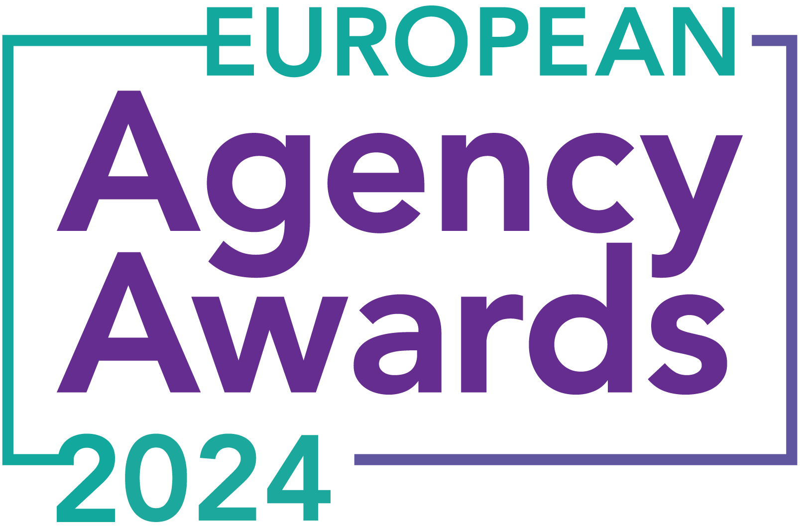

**European Agency Awards 2024 Entry Form**

**Please complete this entry form and upload it via the online entry portal** [**here**](https://europeanagencyawards.com/entry-form) **along with any supporting files.**

**Please note all documents must be under 2MB.**

* You can upload multiple entries via the online entry portal. You will need to fill out a separate entry form for each entry e.g., five entries = five individual entry forms
* If you are uploading the same entry into another category, you will need to edit your entry form appropriately to match the category criteria.
* Please make sure the correct category is checked in section B. If the correct category is not checked, your entry may be classed as void and therefore not judged.
* Entry questions are dependent on your chosen category, so please take care when filling out each entry. Please delete any sections of the entry form not required for your category.
* If your entry form does not match your online submission and category selection, your entry may be classed as a duplication error and may not be judged.
* **All entries must not exceed 1000 words.** The word count does not include the company information/summary in section A or the questions already within the form.
* All entries should relate to work carried out between **March 2023 - July 2024**
* Please follow the format and order of the criteria within this form. If you do not use the entry form below or miss information from your submission you may be penalized by the judges.
* All judges are bound by our terms and conditions and are required to acknowledge these prior to logging into their judging portals. Our judging T&C’s can be found here: <https://europeanagencyawards.com/terms>
* For more information on how to enter, entry fees and the deadline date, visit <https://europeanagencyawards.com/how-to-enter>
* Payment for all entries must be made at the time of submission.
* Please read the [Terms & Conditions](https://europeanagencyawards.com/terms)before submitting your entry.

| **SECTION A – YOUR DETAILS** | |
| --- | --- |
| **Organisation Name** | Wilderness Agency |
| **Contact Name** | George David |

By submitting this form, you agree to the terms and conditions and declare that all facts and figures contained within are accurate and true, and that permission to enter has been given by all involved parties.

| **SECTION B – SELECT YOUR CATEGORY**  Please select your category carefully and insert an X in the second column. Entry questions are dependent on chosen category – please complete section C, D, E or F as indicated. |
| --- |

| **1. Best Social Media Campaign** |  | Please complete section C |
| --- | --- | --- |
| **2. Best SEO Campaign** |  | Please complete section C |
| **3. Best PPC Campaign** |  | Please complete section C |
| **4. Best PR Campaign** |  | Please complete section C |
| **5. Best Not-for-Profit Campaign** |  | Please complete section C |
| **6. Best Marketing Campaign** |  | Please complete section C |
| **7. Best Integrated Campaign** |  | Please complete section C |
| **8. Best Event** |  | Please complete section C |
| **9. Best New Business Campaign** |  | Please complete section C |
| **10. Best Crisis Communications or Response Campaign** |  | Please complete section C |
| **11. Campaign Effectiveness Award** |  | Please complete section C |
| **12. Best Pan European Campaign** |  | Please complete section C |
| **13. Best Use of AI in Client Campaign** |  | Please complete section C |
| **14. Best AI Agency Software Solution** |  | Please complete section C |
| **15. Best Agency Culture** |  | Please complete section D |
| **16. Best Charitable/Corporate Social Response Initiative** |  | Please complete section D |
| **17. Best Culture Transformation Initiative** |  | Please complete section D |
| **18. Best Flexible Working Policy** |  | Please complete section D |
| **19. Best Inclusion and Diversity Initiative** |  | Please complete section D |
| **20. Rising Agency Star Award** |  | Please complete section E |
| **21. Best New Agency** |  | Please complete section E |
| **22. Digital Agency of the Year** |  | Please complete section E |
| **23. Media Buying Agency of the Year** |  | Please complete section E |
| **24. B2B Agency of the Year** |  | Please complete section E |
| **25. B2C Agency of the Year** |  | Please complete section E |
| **26. eCommerce Agency of the Year** |  | Please complete section E |
| **27. SEO Agency of the Year** |  | Please complete section E |
| **28. PPC Agency of the Year** |  | Please complete section E |
| **29. Integrated Search Agency of the Year** |  | Please complete section E |
| **30. Social Media Agency of the Year** | x | Please complete section E |
| **31. Marketing Agency of the Year** |  | Please complete section E |
| **32. Creative/Design Agency of the Year** |  | Please complete section E |
| **33. Advertising Agency of the Year** |  | Please complete section E |
| **34. CRO Agency of the Year** |  | Please complete section E |
| **35. UX Agency of the Year** |  | Please complete section E |
| **36. Independent Agency of the Year** |  | Please complete section E |
| **37. PR Agency of the Year** |  | Please complete section E |
| **38. Innovative Agency of the Year** |  | Please complete section E |
| **39. Integrated Agency of the Year** |  | Please complete section E |
| **40. Best Small Agency of the Year** |  | Please complete section E |
| **41. Best Large Agency of the Year** |  | Please complete section E |

| **SECTION C – CAMPAIGN AWARDS**  Please complete the following sections providing details of the campaign that you are entering. Please note entries must not exceed a total word count of 1000 words.  All information provided will remain confidential to the judges before and after the event and will not be shared with anyone outside of the judging panel allocated to review your entry. |
| --- |
| **Entrant Name(s), Client Name & Campaign Title**  How you wish for the campaign to be credited including your organisation name, any partners / clients you want to credit & the title of your campaign.  Please structure your title in the following format:  ***"Entrant Name & Client Name - Campaign Name"***  Please keep this concise as it will appear on the website if you are shortlisted. |
|  |
| **Objective(s) & budget (1-10 points)**  Tell us what you were looking to achieve from the campaign and any targets that were set. We recommend showing targets as quantifiable metrics e.g., ‘Increase conversions from 150 to 300 a month’ rather than ‘Increase conversions by 10%’.  Please include a breakdown of implementation costs, staffing costs, agency fees etc. All elements of the entry form are confidential, and judges will not share this information. If you are unable to provide a detailed budget breakdown, please include the financial band your budget is within along with the percentage budget allocated for staffing costs, agency fees and media spend etc. |
|  |
| **Target audience & strategy (1-10 points)**  Please provide us with details around the audience you were targeting and your overall strategy to reach them as well as the strategy to meet the overall objectives. |
|  |
| **Implementation & creativity (1-10 points)**  Please give us a detailed explanation of your implementation for the campaign. Include screenshots to help us visualize campaigns. Provide information on the creativity of the campaign. |
|  |
| **Details of any challenges faced and how these were overcome (1-10 points)**  What challenges were unique to you and how have you overcome them. What was the end result of overcoming these challenges? |
|  |
| **Results & evaluation (1-10 points)**  Please relate these to the objectives and targets stated above. Provide actual numbers rather than percentages wherever possible. |
|  |
| **Why should your campaign win? (1-10 points)**  What do you think sets your campaign apart from the other campaigns being judged? Judges will in particular be looking for the thing that makes this campaign different to the others, what is unique? |
|  |
| **URLs** |
|  |
| **Please detail any supporting documents you are including as part of your submission**  Optional – please upload to online entry portal when submitting this entry form |
|  |

| **SECTION D – CULTURE & CONTINUITY AWARDS**  Please complete the following sections providing details of the culture of the agency. Detail investment in training, support, and development of the agency’s team and how this has helped to win new business and grow existing accounts. Please note entries must not exceed a total word count of 1000 words in this section.  All information provided will remain confidential to the judges before and after the event and will not be shared with anyone outside of the judging panel allocated to review your entry. |
| --- |
| **Name of Team / Agency**  Please keep this concise as it will appear on the website if you are shortlisted. |
|  |
| **Team / Agency Overview**  Give details of number of employees, structure etc. Judges will be looking for clarity and context to help understand more about your agency or team. |
|  |
| **Details of company culture initiatives & budget allocated (1-10 points)**  e.g., flexible working, holiday schemes, training and development, incentive schemes, rewards packages, CSR and volunteering initiatives |
|  |
| **Evidence positive impact / results of any initiatives (1-10 points)**  e.g., increased productivity, staff retention, staff promotion and development |
|  |
| **Why you think you should win (1-10 points)**  What do you think sets your culture apart from other agencies/teams being judges? Judges will be looking for the thing that makes your culture different to the others, what is unique? |
|  |
| **URLs** |
|  |
| **Please detail any supporting documents you are including as part of your submission**  Optional – please upload to online entry portal when submitting this entry form |
|  |

| **SECTION E – AGENCY / TEAM / RISING AGENCY STAR AWARDS**  Please complete the following sections providing details of the agency / team / individual that you are entering. Please note entries can be self-nominated or nominated by a third party and must not exceed a total word count of 1000 words.  All information provided will remain confidential to the judges before and after the event and will not be shared with anyone outside of the judging panel allocated to review your entry. |
| --- |
| **Name of Nominee - Agency / Team / Rising Agency Star**  Please keep this concise as it will appear on the website if you are shortlisted. |
| Wilderness Agency |
| **Date of Birth** (Rising Agency Star nominees only)  ***Please note that nominee must be under 30 on October 19, 2023*** |
|  |
| **Contact email address of nominee** (Rising Agency Star nominees only) |
|  |
| **Contact phone number of nominee** (Rising Agency Star nominees only) |
|  |
| **Overview of the Agency / Team / Rising Agency Star nominee**  Please include numbers, staff turnover, roles etc for agency and team nominations or current and previous job roles etc for Rising Star nominations |
| Wilderness is the first social media transformation agency working with some of the world’s most beloved brands to transform their strategy, management, content, and operations.  Working with the likes of Disney+, Premiership Rugby, Paramount (PlutoTV), SKY Mobile, JBL, BBC Studios, Panasonic, Dolby, Checkmyfile and many more.  In February 2024, after 9 years as an independent agency they were acquired by Havas Media Network becoming part of Havas Play.  Since the acquisition the agency has increased revenue by more than 25% YOY and increased headcount by over 30% following an incredibly successful H1 in terms of new business with a 71% win ratio in the first half of 2024.  The agency has managed all of this whilst retaining incredibly strong team engagement and client satisfaction - averaging 4/5 in the former and 3.8/5 in the latter across the first 6 months of 2024.  144 |
| **Agency / Team / Rising Agency Star objectives (1-10 points)**  Tell us what you were looking to achieve and any targets that have been set within the agency or team to help achieve your goals. We recommend showing targets as quantifiable metrics e.g., ‘Increase conversions from 150 to 300 a month’ rather than ‘Increase conversions by 10%’. |
| One main objective coming into the year was to finalise the acquisition by Havas and ensure a smooth transition. We completed the acquisition in Feb and have since seen continued growth to over £2.5M of recognised UK revenue.  We set an ambitious £750K new business target for H1 and have achieved this recognising £787,466 of new business value in H1 with a 71% win ratio for new business pitches and upsell and cross-sell business.  In the first 6 months of 2024 we have won retained work this year with the likes of Premiership Rugby, new finance brand Check My File as well growing our retained relationship with global entertainment brands Disney (across Disney+) and Paramount (across PlutoTV).  We have also delivered social campaign work for the likes of Panasonic, Universal Pictures, Dolby, JBL, Galderma and more besides across strategy, creative and production.  This growth has allowed us to develop both a consumer and entertainment brand team to ensure we continue to diversify our client portfolio in the coming months and years.  **173** |
| **Recent work example(s**) **(1-10 points)**  Please include details of recent client or campaign work. How does your recent work display creativity and make your team or agency stand out amongst others? |
| Our work shows the breadth of clients and industries that we work in. From creating memes for credit rating company, [**Checkmyfile**](https://drive.google.com/drive/folders/1gXxjBhNMijVPlLLZVqDU404UjkruZZLL?usp=sharing), through to large scale productions for [**Sky Mobile**](https://drive.google.com/drive/folders/1sXQiipFsKC9_8boeMPWzeYHDQSkceH36?usp=sharing)with Jamie Laing.  We have branched out this year to work in industries that we previously hadn’t, including technology with [**Panasonic**](https://drive.google.com/drive/folders/17tfEq1ce9E6QX0ah0XKWBmF5__wOzIyj?usp=sharing) (and Dolby, although this work is still ongoing) and we have just completed our first campaign for a sports entity, [**Premiership Rugby**](https://drive.google.com/drive/folders/1EZ48UWav3u2pMY1kzMxauui4wHDDMtw3?usp=sharing).  We continue to work with entertainment brands, being retained by [**Disney+**](https://drive.google.com/drive/folders/1Oit5GMyhkGVy5ZRsxiAVp_xEt0SBqWdj?usp=sharing)and [**Paramount (PlutoTV)**](https://drive.google.com/drive/folders/1IGW29llnTX06pquHNlsJATmNFWsS4QjA?usp=sharing), and we utilise our understanding of entertaining audiences on social media and transfer this knowledge into consumer brands. |
| **Details of any recent achievements (1-10 points)**  What makes your team or agency stand out? Please include details of any achievements you feel make your agency, team or rising star award worthy. What are you proud of? |
| A big part of our success this year is our incredibly talented team. We have award nominated team members across Strategy, People, Growth and more - with George David nominated for the both the Rising Star and Business Developer of the Year at the BD100 Awards, Liam Hynes nominated for HR Professional of the Year at UK Company Culture Awards and Mollie Lyons and Abby Reilly both nominated for the Mark Hanson (Rising Star) Award at the UK Social Media Awards.  We have also been recognised for our work with a nomination for Best Use of Social in Entertainment at the UK Social Media Awards.  Not only that but our company culture has also been recognised with a nomination for best Company Culture at ALF Insights Award 2024.  We are on track to achieve our target of £2.5M UK recognised revenue in 2024 and increased revenue by more than 25% YOY. This has allowed us to increase our headcount by over 30% following an incredibly successful H1 in terms of new business with a 71% win ratio in the first half of 2024.  We have won a number of major brand clients including Premiership Rugby, Universal Pictures, Dolby, JBL, Checkmyfile and Panasonic.  We now have a blended pipeline from both our own inbound and outreach activities and from across the Havas Media Network and Havas Village London. Our average monthly pipeline value has been £1.5M since the acquisition in February and we are anticipating improved revenue and profit results in H2 of 2024. |
| **Details of any challenges faced and how these were overcome (1-10 points)**  What challenges were unique to you and how have you overcome them. What was the end result of overcoming these challenges? |
| The acquisition by Havas and subsequent transition could have proved a huge challenge to any business. Joining one of the world’s biggest communications networks could have derailed the plans of our independent team.  But our team has embraced the change and our operational structure has allowed us to quickly establish ourselves as the UK centre of excellence for social with the Havas Media Network.  During this period of transition and change we retained 5 of our 6 long-standing retained client contracts and have since added 3 new retained clients as well as having won numerous upsell projects, creative production and social campaigns. |
| **Why should your Agency / Team / Rising Agency Star win? (1-10 points)**  Please detail what you feel makes you stand out amongst others and why you feel your entry is award winning. What makes you unique? What gives you the competitive edge? |
| We have continued our rapid growth at Wilderness as one of Europe’s fastest growing social agencies. We have now joined one of the world’s biggest communication networks as part of Havas Play to supercharge that growth even further.  We have done so by winning retained work with global entertainment and consumer brands whilst maintaining our strong culture and commitment to a healthy and flexible work environment for the team.  Despite a challenging integration and onboarding to one of the biggest comms networks in the world we have maintained our focus to deliver award-winning work for the likes of Paramount and other global brands.  We have also maintained a strong new business winning streak with a 71% win rate in 2024 and have an ever increasingly active pipeline of direct and network opportunities with more than £1.5M average monthly pipeline value since the acquisition.  We have maintained our independent spirit and culture whilst fully embracing the opportunities and growth possibilities as part of one of the world’s biggest communications networks. |
| **URLs** |
| Website - <https://www.wilderness.agency/>  LinkedIn - <https://www.linkedin.com/company/wildernessagency>  Wilderness Creds - <https://docs.google.com/presentation/d/1ywrVKdg7iKpcLJjawRol4Y31Mvycff50xx1-4IlD5nY/edit?usp=sharing> |
| **Please detail any supporting documents you are including as part of your submission**  Optional – please upload to online entry portal when submitting this entry form |
|  |