10. Best Crisis Communications or Response Campaign

**Royal College of Occupational Therapists (RCOT) OT Week 2023 supporting materials**

***Examples of OT Week 2023 assets***

Email banner (also available in Welsh and for non-members)

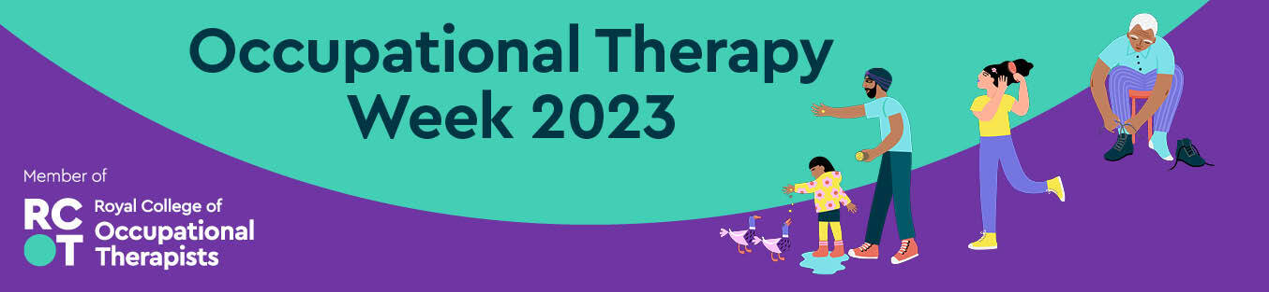

Examples of social media graphics (also available in Welsh and different ratios for stories)

|  |  |  |  |  |
| --- | --- | --- | --- | --- |
|  |  |  |  |  |