10. Best Crisis Communications or Response Campaign
Royal College of Occupational Therapists (RCOT) OT Week 2023 supporting materials
Survey results from 200 RCOT members who helped shape the campaign
Benchmark | Post campaign
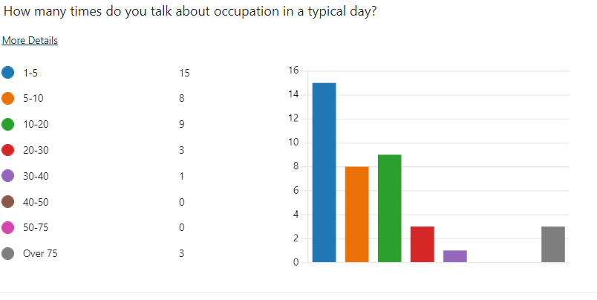 | 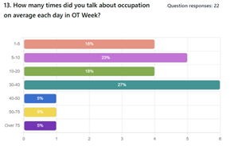
 | 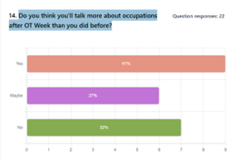
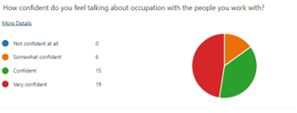 | 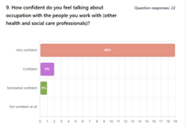
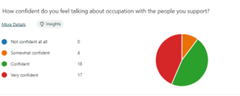 | 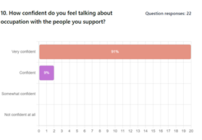
 | 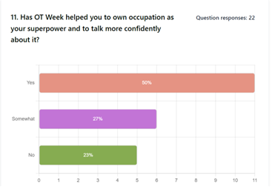
 | How did you get involved in OT Week?
 | Displayed a poster | 64%
 | Added a banner to my email signature | 55%
 | Shared a post on social media about occupation | 50%
 | Held and event/activity with health and social care colleagues | 45%
 | Read the Breaking barriers OTnews article | 36%
 | Watched the Breaking barriers event (live or on demand) | 36%
 | Followed some of the activities suggested in the calendar | 32%
 | Used the conversation prompts to discuss occupations | 27%
 | Other | 23%
 | Shared the animation on social media about occupation | 23%
 | Used the narrative in a newsletter | 18%
 | Used the 30 second script to introduce occupations | 14%
 | Used the narrative to update a website | 5%

