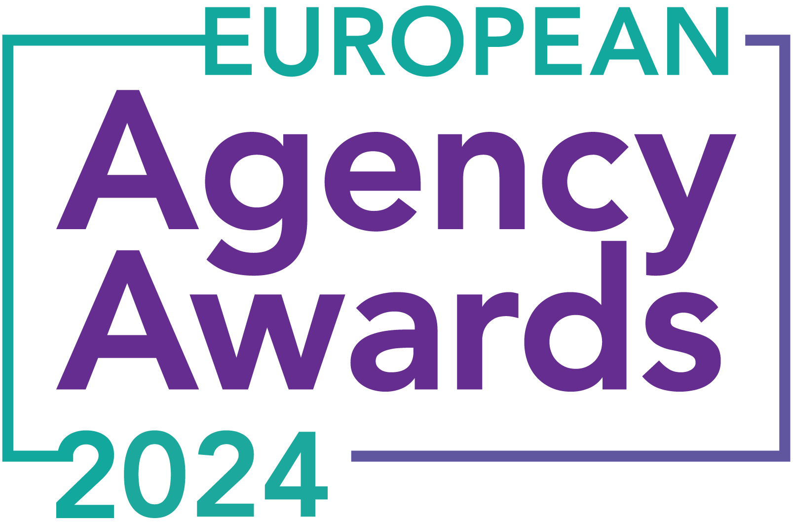

**European Agency Awards 2024 Entry Form**

**Please complete this entry form and upload it via the online entry portal** [**here**](https://europeanagencyawards.com/entry-form) **along with any supporting files.**

**Please note all documents must be under 2MB.**

* You can upload multiple entries via the online entry portal. You will need to fill out a separate entry form for each entry e.g., five entries = five individual entry forms
* If you are uploading the same entry into another category, you will need to edit your entry form appropriately to match the category criteria.
* Please make sure the correct category is checked in section B. If the correct category is not checked, your entry may be classed as void and therefore not judged.
* Entry questions are dependent on your chosen category, so please take care when filling out each entry. Please delete any sections of the entry form not required for your category.
* If your entry form does not match your online submission and category selection, your entry may be classed as a duplication error and may not be judged.
* **All entries must not exceed 1000 words.** The word count does not include the company information/summary in section A or the questions already within the form.
* All entries should relate to work carried out between **March 2023 - July 2024**
* Please follow the format and order of the criteria within this form. If you do not use the entry form below or miss information from your submission you may be penalized by the judges.
* All judges are bound by our terms and conditions and are required to acknowledge these prior to logging into their judging portals. Our judging T&C’s can be found here: <https://europeanagencyawards.com/terms>
* For more information on how to enter, entry fees and the deadline date, visit <https://europeanagencyawards.com/how-to-enter>
* Payment for all entries must be made at the time of submission.
* Please read the [Terms & Conditions](https://europeanagencyawards.com/terms)before submitting your entry.

| **SECTION A – YOUR DETAILS** | |
| --- | --- |
| **Organisation Name** | LAZZAWEB |
| **Contact Name** | Nikolaj Bæk |

By submitting this form, you agree to the terms and conditions and declare that all facts and figures contained within are accurate and true, and that permission to enter has been given by all involved parties.

| **SECTION B – SELECT YOUR CATEGORY**  Please select your category carefully and insert an X in the second column. Entry questions are dependent on chosen category – please complete section C, D, E or F as indicated. |
| --- |

| **1. Best Social Media Campaign** | **X** | Please complete section C |
| --- | --- | --- |
| **2. Best SEO Campaign** |  | Please complete section C |
| **3. Best PPC Campaign** |  | Please complete section C |
| **4. Best PR Campaign** |  | Please complete section C |
| **5. Best Not-for-Profit Campaign** |  | Please complete section C |
| **6. Best Marketing Campaign** |  | Please complete section C |
| **7. Best Integrated Campaign** |  | Please complete section C |
| **8. Best Event** |  | Please complete section C |
| **9. Best New Business Campaign** |  | Please complete section C |
| **10. Best Crisis Communications or Response Campaign** |  | Please complete section C |
| **11. Campaign Effectiveness Award** |  | Please complete section C |
| **12. Best Pan European Campaign** |  | Please complete section C |
| **13. Best Use of AI in Client Campaign** |  | Please complete section C |
| **14. Best AI Agency Software Solution** |  | Please complete section C |
| **15. Best Agency Culture** |  | Please complete section D |
| **16. Best Charitable/Corporate Social Response Initiative** |  | Please complete section D |
| **17. Best Culture Transformation Initiative** |  | Please complete section D |
| **18. Best Flexible Working Policy** |  | Please complete section D |
| **19. Best Inclusion and Diversity Initiative** |  | Please complete section D |
| **20. Rising Agency Star Award** |  | Please complete section E |
| **21. Best New Agency** |  | Please complete section E |
| **22. Digital Agency of the Year** |  | Please complete section E |
| **23. Media Buying Agency of the Year** |  | Please complete section E |
| **24. B2B Agency of the Year** |  | Please complete section E |
| **25. B2C Agency of the Year** |  | Please complete section E |
| **26. eCommerce Agency of the Year** |  | Please complete section E |
| **27. SEO Agency of the Year** |  | Please complete section E |
| **28. PPC Agency of the Year** |  | Please complete section E |
| **29. Integrated Search Agency of the Year** |  | Please complete section E |
| **30. Social Media Agency of the Year** |  | Please complete section E |
| **31. Marketing Agency of the Year** |  | Please complete section E |
| **32. Creative/Design Agency of the Year** |  | Please complete section E |
| **33. Advertising Agency of the Year** |  | Please complete section E |
| **34. CRO Agency of the Year** |  | Please complete section E |
| **35. UX Agency of the Year** |  | Please complete section E |
| **36. Independent Agency of the Year** |  | Please complete section E |
| **37. PR Agency of the Year** |  | Please complete section E |
| **38. Innovative Agency of the Year** |  | Please complete section E |
| **39. Integrated Agency of the Year** |  | Please complete section E |
| **40. Best Small Agency of the Year** |  | Please complete section E |
| **41. Best Large Agency of the Year** |  | Please complete section E |

| **SECTION C – CAMPAIGN AWARDS**  Please complete the following sections providing details of the campaign that you are entering. Please note entries must not exceed a total word count of 1000 words.  All information provided will remain confidential to the judges before and after the event and will not be shared with anyone outside of the judging panel allocated to review your entry. |
| --- |
| **Entrant Name(s), Client Name & Campaign Title**  How you wish for the campaign to be credited including your organisation name, any partners / clients you want to credit & the title of your campaign.  Please structure your title in the following format:  ***"Entrant Name & Client Name - Campaign Name"***  Please keep this concise as it will appear on the website if you are shortlisted. |
| LAZZAWEB & Zinkbakken - A Cross-Platform Customer Journey to Maximize Revenue |
| **Objective(s) & budget (1-10 points)**  Tell us what you were looking to achieve from the campaign and any targets that were set. We recommend showing targets as quantifiable metrics e.g., ‘Increase conversions from 150 to 300 a month’ rather than ‘Increase conversions by 10%’.  Please include a breakdown of implementation costs, staffing costs, agency fees etc. All elements of the entry form are confidential, and judges will not share this information. If you are unable to provide a detailed budget breakdown, please include the financial band your budget is within along with the percentage budget allocated for staffing costs, agency fees and media spend etc. |
| Zinkbakken is a Danish company specializing in locally produced garden products and special products imported from England and Germany.  The primary goals for their paid social campaign were to increase the number of purchases and overall growth in Zinkbakken’s revenue. Specifically to:   * Increase the number of purchases from 1445 to 1807 (25 %) * Boost revenue from 350.696 EUR to 420.955 EUR (20 %)   In the presented case we will be comparing data from February-April 2024 to February-April 2023. This time period was chosen due to being peak season for gardening and having sufficient data and tracking.  **The implementation costs for this new strategy were as follows:**  Agency Fees: 2000 EUR per month and includes a combined effort for content-production and strategic and technical implementation on META and Pinterest as well as payment for DataFeedWatch.  Spend: 55.908 EUR |
| **Target audience & strategy (1-10 points)**  Please provide us with details around the audience you were targeting and your overall strategy to reach them as well as the strategy to meet the overall objectives. |
| We targeted the primary efforts of our paid social campaign towards female gardening enthusiasts aged 25-44 and 55-64 due to these demographics being known for their purchasing power and active engagement in gardening, maximizing both impact and conversion opportunities.  In order to reach the set goals of the campaign, we created a paid social strategy that relied heavily on a cross-platform funnel approach in order to reach as many of the target audience as early as possible. We thought to start part of the funnel with Zinkbakken’s Pinterest ads in order to engage gardening enthusiasts and planners early in their buying journey (3 months prior) and then integrating the data and trends from the Pinterest campaign to further boost that campaign and the META campaign closer to peak season for retargeting the same, similar and potential audiences. This synergistic approach between Zinkbakken’s Pinterest and META platforms would allow for a structured customer journey, starting early enough to sufficiently warm up the target audience and be eager for purchase once the gardening peak season began. |
| **Implementation & creativity (1-10 points)**  Please give us a detailed explanation of your implementation for the campaign. Include screenshots to help us visualize campaigns. Provide information on the creativity of the campaign. |
| In implementing Zinkbakken's paid social campaign, we focused on consolidating data into as few campaigns as possible in order to reach our set goals and prevent audience overlap, allowing us to enhance revenue generation within each campaign by building a more detailed, comprehensive dataset through CAPI.  Creatively, the campaigns leveraged visual content, especially user-generated content (UGC) to showcase how Zinkbakken's products are used in everyday gardening. We emphasized a story to narrate the value and the story behind the brand, making the product a desirable addition to any garden. This helped to engage the highly active community of garden enthusiasts, effectively turning them into brand advocates and loyal customers. We worked closely with influencers to generate fresh UGC, which was vital given the limited amount of content produced in-house.    To maintain this engagement across platforms, we implemented catalog campaigns on Pinterest, which proved successful not just for warming up the audience to Zinkbakken’s products, but also for driving significant revenue, thanks to the seamless integration of these campaigns into the native content streams of Pinterest. This approach aligned well with the latest trends on Pinterest, where less graphic-intensive and more environment-focused content resonated better with users. |
| **Details of any challenges faced and how these were overcome (1-10 points)**  What challenges were unique to you and how have you overcome them. What was the end result of overcoming these challenges? |
| One significant challenge was pioneering Pinterest for garden-related businesses in Denmark, navigating a market with very few direct competitors initially. As the platform grew more popular, we faced diminishing returns. Additionally, content limitations necessitated innovative UGC strategies, encouraging customers to share their experiences, which enriched our content pool and maintained ad relevance as well as gaining social proof. Overcoming these challenges led to a more robust, data-driven campaign approach, resulting in sustained engagement and increased revenue despite a more crowded marketplace. |
| **Results & evaluation (1-10 points)**  Please relate these to the objectives and targets stated above. Provide actual numbers rather than percentages wherever possible. |
| The campaign demonstrated exceptional results, significantly outperforming its original goals through a sophisticated mix of data-driven tactics and inventive content strategies. The campaign impressively escalated the number of purchases to 2173, a 50 % increase. This achievement not only surpassed our target, but also exemplified our strategic precision and campaign efficacy.  Revenue growth followed a similar trajectory of success. Our strategies yielded a staggering 63 % increase, boosting revenue from 350.696 EUR to 571.731 EUR. This not only exceeded the set goal but also underscored the campaign's financial acumen and targeted impact.  Despite a great increase in revenue, we also managed to maintain a profitable ROAS of 10,2 during the data period (which is the same ROAS as last year and above the target ROAS of 8 for the company).    Additionally, the average order value saw an uptick of 7 %, advancing from 247 EUR to 263 EUR. We believe this to be a direct result of our strategy to warm up our target audience through Pinterest approximately 3 months prior to peak season, when we doubled down on the synergy between Pinterest and META as well as focusing on smaller items to put in the basket for impulse purchases. |
| **Why should your campaign win? (1-10 points)**  What do you think sets your campaign apart from the other campaigns being judged? Judges will in particular be looking for the thing that makes this campaign different to the others, what is unique? |
| Our campaign stands out for its innovative integration of user-generated content (UGC) and cross-platform synergy, which uniquely positioned Zinkbakken in what turned out to be a highly competitive market compared to 2023. What sets this campaign apart is not just the impressive results, but the strategic creativity and tactical precision that drove these outcomes.  The use of UGC pioneered a distinctive approach by embedding authentic customer experiences into our marketing strategy, transforming users into brand advocates. This initiative fostered deeper engagement and trust, essential for the gardening community where credibility and user experience are paramount. By focusing on genuine narratives rather than conventional advertising, we engaged our audience on a more personal level, which significantly enhanced both interest and conversions.  Moreover, the cross-platform funnel strategy between Pinterest and META platforms was pivotal. It allowed us to engage potential customers early in their buying journey and maintain this engagement through to purchase, optimizing business returns and a stronger community.  This innovative blend of strategy and creativity, paired with outstanding results, makes our campaign a deserving contender for recognition.    The specific actions on Pinterest also got us to get an official case with Pinterest and our collaboration with Zinkbakken.dk. |
| **URLs** |
|  |
| **Please detail any supporting documents you are including as part of your submission**  Optional – please upload to online entry portal when submitting this entry form |
|  |

| **SECTION D – CULTURE & CONTINUITY AWARDS**  Please complete the following sections providing details of the culture of the agency. Detail investment in training, support, and development of the agency’s team and how this has helped to win new business and grow existing accounts. Please note entries must not exceed a total word count of 1000 words in this section.  All information provided will remain confidential to the judges before and after the event and will not be shared with anyone outside of the judging panel allocated to review your entry. |
| --- |
| **Name of Team / Agency**  Please keep this concise as it will appear on the website if you are shortlisted. |
|  |
| **Team / Agency Overview**  Give details of number of employees, structure etc. Judges will be looking for clarity and context to help understand more about your agency or team. |
|  |
| **Details of company culture initiatives & budget allocated (1-10 points)**  e.g., flexible working, holiday schemes, training and development, incentive schemes, rewards packages, CSR and volunteering initiatives |
|  |
| **Evidence positive impact / results of any initiatives (1-10 points)**  e.g., increased productivity, staff retention, staff promotion and development |
|  |
| **Why you think you should win (1-10 points)**  What do you think sets your culture apart from other agencies/teams being judges? Judges will be looking for the thing that makes your culture different to the others, what is unique? |
|  |
| **URLs** |
|  |
| **Please detail any supporting documents you are including as part of your submission**  Optional – please upload to online entry portal when submitting this entry form |
|  |

| **SECTION E – AGENCY / TEAM / RISING AGENCY STAR AWARDS**  Please complete the following sections providing details of the agency / team / individual that you are entering. Please note entries can be self-nominated or nominated by a third party and must not exceed a total word count of 1000 words.  All information provided will remain confidential to the judges before and after the event and will not be shared with anyone outside of the judging panel allocated to review your entry. |
| --- |
| **Name of Nominee - Agency / Team / Rising Agency Star**  Please keep this concise as it will appear on the website if you are shortlisted. |
|  |
| **Date of Birth** (Rising Agency Star nominees only)  ***Please note that nominee must be under 30 on October 19, 2023*** |
|  |
| **Contact email address of nominee** (Rising Agency Star nominees only) |
|  |
| **Contact phone number of nominee** (Rising Agency Star nominees only) |
|  |
| **Overview of the Agency / Team / Rising Agency Star nominee**  Please include numbers, staff turnover, roles etc for agency and team nominations or current and previous job roles etc for Rising Star nominations |
|  |
| **Agency / Team / Rising Agency Star objectives (1-10 points)**  Tell us what you were looking to achieve and any targets that have been set within the agency or team to help achieve your goals. We recommend showing targets as quantifiable metrics e.g., ‘Increase conversions from 150 to 300 a month’ rather than ‘Increase conversions by 10%’. |
|  |
| **Recent work example(s**) **(1-10 points)**  Please include details of recent client or campaign work. How does your recent work display creativity and make your team or agency stand out amongst others? |
|  |
| **Details of any recent achievements (1-10 points)**  What makes your team or agency stand out? Please include details of any achievements you feel make your agency, team or rising star award worthy. What are you proud of? |
|  |
| **Details of any challenges faced and how these were overcome (1-10 points)**  What challenges were unique to you and how have you overcome them. What was the end result of overcoming these challenges? |
|  |
| **Why should your Agency / Team / Rising Agency Star win? (1-10 points)**  Please detail what you feel makes you stand out amongst others and why you feel your entry is award winning. What makes you unique? What gives you the competitive edge? |
|  |
| **URLs** |
|  |
| **Please detail any supporting documents you are including as part of your submission**  Optional – please upload to online entry portal when submitting this entry form |
|  |